

University of Utah
Biosafety Manual and Standard Operating Procedures

Biosafety Level 1 Laboratory

of
Dr. (name of PI)

(title)

(Institute or department and building, room location)

(date developed)
(annual review/revision date)

This document serves as a template for a Biosafety Manual and Standard Operating Procedures for BSL-1 laboratories at the University Of Utah.

Please edit or delete all highlighted sections and remove highlighting

University of Utah
Biosafety Level 1 Standard Operating Procedures
Table of Contents

- Purpose

- Background
B.1 Training

- Introduction to General Safety and Training for the BSL-1 Laboratory
C.1. General BSL-1 Laboratory Safety
C.2. Spills and Exposure Procedures
C.3. Post Exposure Procedures
C.4. Incident Reporting

D. Standard Operating Procedures
D.1. Containment Requirements
D.1.a Laboratory Entry/Exit
D.1.b Specimen Transport
D.2. Personal Protective Equipment
D.3. Experimental SOPs

- Proper Use and Maintenance of Equipment
E.1. Biological Safety Cabinets
E.2. Incubators
E.3. Centrifuges
E.4. Autoclave
E.5. Potentially Hazardous Equipment

- Waste Disposal and Housekeeping
F.1. Waste Disposal
F.2. Laundry
F.3. Warning Labels

- Emergency Equipment
G.1. Fire Extinguishers
G.2. Telephone

- Repair and Service

- Experimental Procedures

J. Emergency Phone Numbers and Procedures
J.1. Emergency Phone Numbers
J.2. General Emergency Procedures

- Shipping and Transport

Appendices

These are provided as examples but incorporate information that the IBC requires and reviews prior to Registration approval. Please edit and/or delete appendices as applicable and update Table of Contents

- Spill and Exposure Procedures
- Post Exposure Procedures
- Use and Disposal of Sharps
- Disposal of Biohazardous Waste
- Safe Handling of Cryogenic Liquids

- Purpose

The standard operating procedures (SOPs) described in this manual apply to all research staff, hosted visitors and guests, volunteers, building staff, and service staff who enter the laboratory. This manual will be reviewed annually by the Principal Investigator or Laboratory Supervisor for changes or corrections to ensure that it is accurate.

Research involving recombinant/synthetic nucleic acids, infectious agents, creation of transgenic or knockout animals, acute biological toxins, unfixed non-human primate materials, or human blood, cells, or unfixed tissues must submit a research registration through BioRAFT to the Department of Occupational and Environmental Health and Safety (EHS) at least every three years. This work may require prior review and approval by the Institutional Biosafety Committee, according to the NIH Guidelines for Research Involving Recombinant or Synthetic Nucleic Acid Molecules.

This plan was designed as a supplement to the University of Utah Biosafety Manual to meet the requirements of the Biosafety in Microbiological and Biomedical Laboratories, 6th ed.

A risk assessment of biological agents should take into account both the intrinsic hazards of the agent as well as considerations of individuals handling the agents, addressing the potential for emergent hazards from recombinant or synthetic nucleic acid molecules research, and hazards associated with the vectors used for insertions. Agent hazards are those risks that are intrinsic to the agent being handled such as the following:
- Capability to infect and cause disease in a susceptible human host.
- Severity of the disease
- Infectious dose
- Availability of preventative measures
- Availability of effective treatments
- How the agent is transmitted (i.e. route of exposure)
- Quantity, concentration, and total volume used
- Stability in the environment
- Zoonotic concerns
- Allergenicity

Exposure sources in the laboratory are hazards that could result in the infection of researchers or the public through work with biological agents. Some of the more common hazard considerations include the following:
- Aerosol generation (e.g. pipetting, mixing, blending, grinding, sonicating, vortexing, centrifuging, shaking)
- Manipulation with sharps
- Animal handling
- Contact with blood, bodily fluids, or other potentially infectious material
- Ingestion of agents via contaminated work areas
- Eye-splashes from liquid nitrogen storage

When performing a risk assessment of laboratory procedures, all potential routes of exposure should be addressed. Most laboratory-acquired infections have resulted from inhalation of aerosols, splashes or sprays, and needlesticks. It is good practice to look for potential exposures via ingestion, inoculation, inhalation, and contamination of skin and mucous membranes and attempt to identify safer alternatives and risk mitigation strategies.

Background

Review of this Manual is mandatory for all employees and staff working in the BSL-1 laboratory of Dr. (name of PI). The Manual has been customized to provide lab-specific provisions to identify and protect all personnel who may be at risk of exposure. This Manual must be updated at least annually, and whenever there are changes in laboratory procedures that may change a worker’s exposure. A copy of this Manual must remain in the lab, and must be accessible to lab personnel.

B.1. Training

All personnel who work in the laboratory must receive adequate instruction from their supervisor prior to beginning work. Some training is required annually. Each lab will require different trainings (edit as applicable). The minimum requirements for qualification to work in the (name of PI) BSL-1 lab are:
- Initial and Annual Laboratory Specific Training (Risks associated with the hazards/agents used in the lab, SOPs, Spill and Exposure Procedures) including annual review of this manual
- Shipping Training: Training is required to commercially transport infectious materials, as well as shipping anything on dry ice. Contact EHS to schedule a training class. Must be repeated every 2 years.
- (List as many as you need)

This document will provide the basis of training in conjunction with EHS training, through Research Administration (REd) and/or Bridge, and hands-on training provided by the PI or Lab Manager.

Dr. (name of PI) will provide information and arrange for training at the time of an individual's initial assignment to the lab. Dr. (name of PI) will arrange for refresher training at least annually and when there are any changes in processes or procedures. Documentation of training will be uploaded to the laboratory registration in BioRAFT.

For more information concerning training, also see the University of Utah Biosafety Manual on the IBC web site (https://ibc.utah.edu/biosafety-policies.php).

C. General Safety and Training for the BSL-1 Laboratory

C.1. General BSL-1 Laboratory Safety

Work with biological materials will be performed in (insert building and room number). Practices must adhere to the standards described in the University of Utah Biosafety Manual (https://ibc.utah.edu/biosafety-policies.php). These include:

- Laboratory employees must immediately notify the laboratory manager or PI in case of an accident, injury, illness, or overt exposure associated with laboratory activities.

- No eating, chewing gum, drinking, smoking, handling contact lenses, or applying cosmetics in the lab at any time.

- No use of headphones and/or cell phones/iPODs etc., while in the lab.

- No animals (pets) or non-research plants will be allowed in the lab at any time.

- Food, medications, or cosmetics should not be brought into the lab for storage or later use. Food is stored outside in areas designated specifically for that purpose.

- No open shoes or sandals are allowed in the laboratory: the entire foot must be covered up to the ankle.

- No bare legs, ankles or arms.

- Personnel must wear a lab coat (or gown), gloves and other PPE as determined by the risk assessment: eye and face protection (safety glasses goggles, and/or mask) is used for anticipated splashes or sprays of infectious or other hazardous materials when the materials are handled outside of a Biosafety Cabinet (BSC) or containment device, such as transferring samples to an incubator or emptying waste traps. Lab coats must be left in the lab. Lab coats with cuffed sleeves or disposable sleeve covers with tight cuffs are recommended.

- All skin defects such as cuts, abrasions, ulcers, areas of dermatitis, etc. should be covered with an occlusive bandage.

- Mouth pipetting is prohibited; mechanical pipetting devices are to be used at all times.

- All procedures are to be performed carefully to minimize the creation of splashes or aerosols.

- Wipe work surfaces with an appropriate disinfectant (name of disinfectant) after experiments and immediately after spills. Follow SOP in Appendix 1.

- Decontaminate all contaminated or potentially contaminated materials by appropriate methods before disposal.

- Follow all manufacturer’s instructions and SOPs when using any of the laboratory equipment.

- Hand washing with soap is required (i) after handling materials involving organisms containing recombinant or synthetic nucleic acid molecules including bacteria and viruses, (ii) after handling animals, (iii) after removing PPE, and (iv) whenever exiting the laboratory.

- All sharps must be placed in a rigid, puncture resistant, closable and leakproof container, which is labeled with the word "Sharps" and the biohazard symbol. Food containers (e.g., empty coffee cans) are not permissible as sharps containers. All sharps must be handled with extreme caution. The clipping, breaking, and recapping of needles is not permitted. Plastic pipettes and pipette tips are considered puncture hazards and should be treated as sharps. Sharps containers should not be filled more than 2/3. See Appendix 3.

- All cultures, stocks, and other regulated wastes are decontaminated by autoclaving or disinfection before disposal. NOTE: No untreated or non-disinfected biological agent-containing material should be allowed into any drain connected to the sanitary sewer system (e.g., from a sink) Materials to be decontaminated outside of the immediate laboratory are placed in a durable, leakproof container and closed for transport from the laboratory.

- Liquid waste, decontaminated with bleach for at least 20 minutes, from humans or animals can be disposed of directly by flushing down a sanitary sewer. Liquid waste decontaminated with alternative chemicals, such as Wescodyne, may have to be disposed of as hazardous waste: contact the Biosafety Officer for advice. Pick up for hazardous waste can be arranged through the Lab Management System.

- Contaminated solid waste includes cloth, plastic and paper items that have been exposed to agents infectious or hazardous to humans, animals, shall be placed in biohazard bags and decontaminated by autoclaving. After autoclaving the waste can be disposed in the regular trash: please ensure that there is clear indication that the material has been autoclaved, such as using autoclave tape.

- Alternatively, EHS can dispose of biohazard waste for the lab. EHS can be contacted using the on-line pick up request via the Lab Management System. All contaminated waste shall be placed in a biohazard bag inside of a leak proof, puncture resistant, sealable biohazard waste container. The container must be labeled with a biohazard symbol. Double or triple bagging may be required to avoid rupture or puncture of the bags. Contaminated Pasteur pipettes and plastic pipette tips are considered sharps and need to be disposed of in a sharps container. Do not overfill the container. Biohazard waste containers should not be filled more than 2/3 full.

C.2. Spills and Exposure Procedures

See Appendix 1

C.3. Post-exposure Procedures

See Appendix 2

C.4 Incident Reporting
An employee with a work-related injury or illness must complete the Employer’s First Report of Injury or Illness Form, Form 122, and submit it to the Benefits Department within 24 hours. This form can be accessed by clicking on “Forms” at www.hr.utah.edu or by calling Benefits at 801- 581-7447. The Benefits Department is located at 250 East 200 South, Suite 125 Salt Lake City, UT 84111. All exposures will be reported to EHS 801-581-6590. EHS will ensure that all OSHA reportable cases are reported to UOSH.

Complete an Incident report form (https://oehs.utah.edu/incidentnear-miss-report).
D. Standard Operating Procedures (edit or delete this section as appropriate)

D.1. Containment Requirements

D.1.a - Laboratory Entry/Exit

Entering the lab to begin work

A. Put on protective PPE (see Section D.2.).

B. Gather all materials for the experiment.

Exiting Laboratory

Before exiting the lab, be sure that the BSC, equipment and work areas are clean, all contaminated waste materials are disposed of properly, and stocks have been returned to the proper storage area. Remove PPE and wash your hands.

D.1.b Specimen Transport

Transport of biological materials to another building or lab within the same building should be done in a sealed, leakproof container labeled with the universal biohazard sticker. If the samples are infectious, use a secondary container and label it with the contents and a contact person/phone number.

D.2. Personal Protective Equipment (PPE)
The following personal protective equipment (PPE) will be required when working in the BSL-1 laboratory:
- Disposable or onsite-laundered lab coat: cuffed sleeved or disposable sleeve covers are recommended.
- Gloves: nitrile/latex/other (2 pairs are recommended)
- Safety glasses or goggles.
- (describe additional PPE requirements)

Staff should not have exposed arms, legs, ankles or feet. Shorts and open shoes or sandals are not permitted in the BSL-1 laboratory. All personal protective equipment will be cleaned, laundered, repaired, replaced and/or disposed of by the employer at no cost to employees. Immediately (or as soon as feasible) remove garments penetrated by blood or other infectious material. All personal protective equipment will be removed prior to leaving the work area.

Disposable gloves are not to be washed or decontaminated for re-use and are to be replaced as soon as practical when they become contaminated. If they are torn, punctured, or when their ability to function as a barrier is compromised, they need to be replaced as soon as feasible. Utility gloves may be decontaminated for re-use provided that the integrity of the glove is not compromised. Utility gloves are to be discarded if they are cracked, peeling, torn, punctured, or exhibit other signs of deterioration or when their ability to function as a barrier is compromised.

Masks in combination with eye protection devices, such as goggles or glasses with solid side shields, or chin length face shields, are required to be worn whenever splashes, spray, splatter, or droplets of blood or other potentially infectious materials may be generated and eye, nose, or mouth contamination can be reasonably anticipated.

D.3. Experimental Standard Operating Procedures
Include written SOPs for work with biological materials. These should include step-by-step procedures for all experiments and protocols and be sufficiently detailed to allow someone to complete the procedures.

E. Proper Use of Equipment (edit or delete this section as appropriate)

E.1. Biological Safety Cabinets (edit or delete this section as appropriate)

Diagram of airflow in a Biosafety Cabinet (Keep the image of the type of cabinet(s) you use)
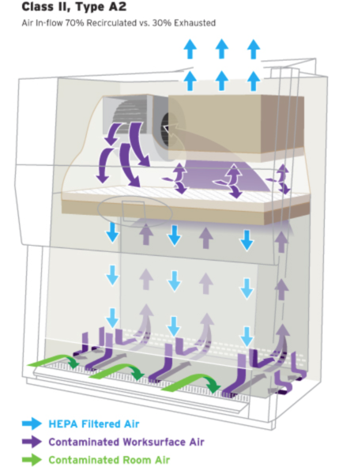
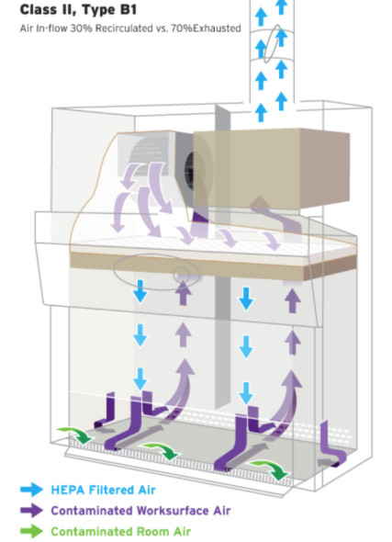

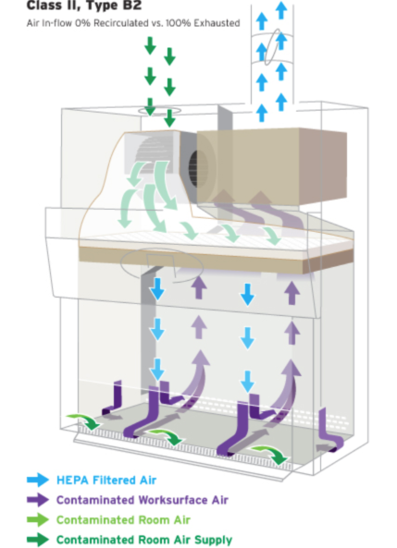
Note the flow of air. Do not block air vents

            - Reserve time in advance to have priority for use of the Biosafety Cabinet (BSC). (If you use sign-up sheets, describe the process here)

            - Turn on the blower in the cabinet at least 10 minutes before placing infectious materials into the hood.

            - Check the certification sticker and all biosafety cabinet monitors to verify that the biosafety cabinet is working properly. Biosafety cabinets must be certified prior to use. An NSF-certified contractor must certify these cabinets annually. Check the certification sticker on the front of the unit to verify your biosafety cabinet’s condition. If the re-certification date has passed contact EHS.

            - The biosafety cabinet air flow monitor should be checked to assure proper operation of the cabinet before placing any materials into it. Readings indicate relative pressure drop across the HEPA filter. Higher readings may, therefore, indicate filter clogging. Zero readings may indicate loss of filter integrity. In either of these cases, notify the Laboratory Manager or PI and EHS. University of Utah Facilities Management do not perform maintenance on biological safety cabinets. If the BSC needs to be serviced, contact EHS.

            - PPE must be worn at all times.

            - Prior to beginning work, the BSC should be decontaminated. Don appropriate PPE (fluid resistant lab coat, gloves, eye protection). Clean the inside surfaces of the BSC with (name of disinfectant) and follow with water or 70% ethanol (if using bleach or other EPA-approved disinfectant). DO NOT put head inside the cabinet. To reach the back of the cabinet use an extension, such as a Swiffer handle.
Note: due to its evaporative nature alcohol is not recommended as the primary disinfectant but can be used to wipe down previously disinfected surfaces or remove bleach/disinfectant residue.
Note: deionized water can cause stainless steel to corrode. Use distilled water instead.

            - Let blower run for 10 min to filter the cabinet air of any particulates.

            - DO NOT disrupt the airflow through the hood by placing ANY item on the grills or by opening the door to the corridor. Disrupting the airflow into the front grill allows contaminated air from inside the cabinet to blow into the lab or directly at the person sitting at the cabinet. It also allows non-sterile air from the room to blow into the biosafety cabinet over the experiments.

            - Organize the work surface for a clean-to-dirty work flow. Place clean pipets, flasks, and sterile media bottles at one side of the cabinet; place discard or kill pans containing disinfectant, biohazard waste containers, used flasks, spent cultures, and other wastes on the other side.

            - While working, keep all material and perform work at least 4 inches back from the front opening of the cabinet, and minimize rapid movements or activity.

            - In general, the interior of the hood should be considered to be a contaminated zone, even though every effort is made to keep the surfaces clean, as is consistent with accepted good microbiological practice and sterile technique.

            - After manipulating infectious agents, make sure all containers are tightly closed.

            - Plastic pipettes with a cotton plug shall be used for pipetting liquids containing viral particles. The electric pipettor shall be fitted with a 0.2 µm filter to prevent aerosol-based contamination.

            - A beaker or discard pan, containing a freshly prepared 1:10 solution of commercial bleach, shall be placed inside the biosafety cabinet during the cell culture work.

            - After pipetting liquid containing viral particles, the dilute bleach solution in the beaker shall be pipetted up and down the full length of the pipette or left in the pan. Serological pipettes and tips should be placed in a in a puncture resistant sharps container or other approved receptacle.

            - After decontamination, pipette tips shall be removed from the pipettor and temporarily left in the beaker containing bleach in the biosafety cabinet.

            - At the completion of the work, all materials to be removed from the biosafety cabinet must be decontaminated. Describe methods for decontamination.

            - At the completion of the work, the beaker containing the plastic tip pipettes shall be removed from the biosafety cabinet. Pipettes tips shall be lifted out of the beaker, the bleach solution allowed to drain back into the beaker, and the pipette tips placed in a puncture resistant sharps container or other approved receptacle. NOTE plastic pipette tips and serological pipettes are treated as sharps.

            - Small volumes of liquid waste containing viral particles shall be collected in a beaker containing undiluted bleach inside the biosafety cabinet. The final concentration of bleach should be at least 10% of the final volume (>0.5% hypochlorite). After completing work, wait at least 30 minutes before disposing down the drain.

            - Large volumes should be collected by vacuum aspiration into a flask containing an appropriate disinfectant, such as Wescodyne or bleach, up to 1 or 10% of the volume of the flask, respectively. NOTE: No untreated or non-disinfected biological agent-containing material should be allowed into any drain connected to the sanitary sewer system (e.g., from a sink).

              - Bleach in the vacuum traps must be changed at least twice per week or when the flask is half full. Wait at least 20 minutes after finishing work to discard waste.
              - Wescodyne is more stable and can be used for up to 3 months before it is discarded. Wescodyne-treated waste must be transferred to a sealed container marked “Unwanted materials”. When full or 6 months after your start date (whichever happens first), arrange pickup by EHS through the LMS website. NO DRAIN DISPOSAL unless approved by EHS.
              - The flask should be placed in a secondary container to prevent it from tipping over, be labeled with a biohazard sticker and the vacuum line should be protected by a hydrophobic (HEPA) filter. The vacuum filters must be replaced if clogged or if liquid makes contact with the filter. Examples include Whatman Vacu-guard and Pall Gelman Vacushield in-line disk filters. Used filters should be placed in the biohazard waste.

            - Turn off the house vacuum when not in use.

            - Clean the inside surfaces of the BSC with (name of disinfectant) after completion of work, and follow with water (if using bleach).
Note: alcohol should not be used as the primary disinfectant but can be used to remove bleach/disinfectant residue. If working with blood or OPIM, alcohol is not an EPA-approved disinfectant.

            - Allow the blower to run for at least 10 minutes following use.

            - The drip pan under the work surface must be cleaned at least monthly, or after spills, with (name of disinfectant).

            - The UV light is turned on between procedures (at least 30 minutes). UV lights must be turned off before work begins in the hood. Do not look directly at UV lights as this can cause eye damage.

During decontamination, a sign shall be placed stating that the biosafety cabinet is being decontaminated and shall not be used. Also, it shall be stated that the user (with contact information) shall be contacted if there are any questions or concerns.

UV light is effective only for decontaminating clean, solid surfaces with which it comes in contact. It is not effective in decontaminating the cabinet air flow. UV light is not effective against bacterial spores. UV germicidal light tubes should be replaced frequently (at least every 6 months for biosafety cabinets in use on a daily basis) to assure that they are emitting light at 254 nm and at an intensity appropriate for decontamination. Due to concerns over the effectiveness of these lights and the risks to individuals in the room, some Institutions, such as the NIH, have banned their use in BSCs. The University of Utah IBC strongly recommends that UV lights are not used as a method of decontamination: see Fact Sheet here.

NOTE: Any use of volatile solvents, such as absolute ethanol, should be kept to a minimum or done elsewhere. Dangerously high levels of volatile vapors can accumulate inside the cabinet and pose a threat of fire or explosion.

E.2. Incubators

E.2.a Incubators (these must be written specific to your lab)

A. Incubators are normally set at 37º C.

B. Temperature should be checked each day by all users.

C. Operation manuals are located (describe where these are).

D. If an alarm is sounding, check the panel for the identifying blinking light.
1. If there is no obvious reason for the alarm, contact the Lab Manager or PI.
2. The “CO₂ Low” (or High) message indicates a deviation from 5% CO₂. Check the hose from the wall to the unit.
3. The “tank farm” must be checked for empty tanks once/week.

- Regular cleaning is necessary to protect cells from contamination and to keep the incubator functioning properly. Guidelines include:
  - Change the incubator water (not just refill it, but empty and add fresh, sterile, distilled water) at least every other week. Commerical antimicrobial agents may be added to the the pan water to prevent microbial growth. Examples include Aquaguard-1 (Promokine), Aqua EZ Clean (T-Pro Biotechnology) and SigmaClean (Sigma Aldrich).
  - Do not use deionized water.
  - Clean the incubator one to two times per month (depending on the number of users). It is not necessary to autoclave everything; spray or wipe down the incubator with 70% ethanol, especially the water pan (do not spray ethanol on sensors). Allow to air dry.
  - Check the incubator once per week and discard unused cultures. If any room air vents are blowing onto the incubator, redirect the air if possible, as air conditioning ducts can contain mold.
  - Remove anything stored on top of the incubator and clean the top of the unit every two weeks to remove dust.
  - Wipe down the doors and handles with 70% ethanol.
  - Clean all spills immediately.

- Replace HEPA filters every six months to a year, depending on the number of users, cleanliness of the unit and laboratory and incubator design.
- Handle HEPA filters only by the external housing, without touching the filter medium.
- Before replacing a HEPA filter in a CO2 incubator, inspect the medium to ensure there are no breaks or tears.
- The HEPA filter should be located in the incubation chamber for best function and be easy to replace without using tools.

- Replace gas inlet filters (where the CO2 gas enters the incubator) every six months to one year.

- A quaternary ammonium disinfectant is best suited for disinfection. Some examples include Lysol No Rinse (Reckitt Benckiser), Conflikt (Decon Labs) and Fermacidal-D (Labotect). A 2% solution of the same quaternary ammonium disinfectant that is used to disinfect the incubator interior may be added to the water pan. Cleaners containing chlorine should be avoided, because chlorine bleach and derivatives with oxidizing activity can corrode stainless steel and copper and are toxic to cultured cells.

E.2.b Water bath

  - The water bath should be monitored for water level, and filled with distilled water only. Commerical antimicrobial agents may be added to the bath water to prevent microbial growth. Examples include Aquaguard-1 (Promokine), Aqua EZ Clean (T-Pro Biotechnology) and SigmaClean (Sigma Aldrich).
  - Do not use deionized water.

E.3. Centrifuges

E.3.a If there is a spill or breakage during centrifugation, stop the centrifuge, and all personnel should evacuate the room for at least 60 minutes. Upon re-entry personnel should don PPE, including eye and face protection. After opening the centrifuge buckets should be transferred to the BSC. The centrifuge and buckets should be disinfected by cleaning with (disinfectant) and then wiped down with 70% ethanol.

E.3.b. (describe lab specific procedures): See Appendix 1.

E.4. Autoclave

(describe procedures): see Autoclave Use and Testing SOP, found here.

E.5. Potentially Hazardous Equipment:
Provide a description of potentially hazardous equipment used in the laboratory. Examples include sonicators, grinders, blenders, lyophilizers, Bunsen burners, etc…

Add similar lists for each type of equipment used in the BSL-1 facility, such as microplate reader, etc. that may require disinfection/decontamination)

- Waste Disposal and Housekeeping

F.1. Waste Disposal (See Appendices 3 and 4 for detailed instructions)

F.1.a Contaminated waste is placed in containers which are closable, constructed to contain all contents and prevent leakage, appropriately labeled or color-coded (see Labels), and closed prior to removal to prevent spillage or protrusion of contents during handling.

F.1.b. Sharps containers will be disposed of by filling out the on-line pick up request at https://oehs.utah.edu/topics/lab-management-system. EHS personnel will pick up full containers and replace them with empty containers.

F.1.c Other regulated waste must be autoclaved before being disposed of in the municipal waste stream. Alternatively, EHS can dispose of biohazard waste for the lab. EHS can be contacted using the on-line pick up request.

F.1.d. Contaminated sharps are discarded immediately or as soon as possible in containers that are closable, puncture-resistant, leakproof on sides and bottoms, and labeled or color-coded appropriately. Sharps disposal containers are available through the EHS on-line pick up request at https://oehs.utah.edu/topics/lab-management-system.

F.1.e. Bins and pails (e.g., wash or emesis basins) are cleaned and decontaminated as soon as feasible after visible contamination.

Broken glassware that may be contaminated is picked up using a mechanical device such as tongs, forceps, or a brush and dustpan.

F.2 Laundry

The following articles, if contaminated, will require laundering:

The University of Utah School of Medicine can be used to clean contaminated clothing and other articles that require laundering. Linen Services can be found in the lower level of the Acute Care Building in the University Hospital, 801-581-2200.

The following laundering requirements must be met:

- Handle contaminated laundry as little as possible, with minimal agitation.
- Place wet contaminated laundry in leak-proof, labeled or color-coded containers before transport to the University Hospital Laundry.

Emergency Equipment (edit or delete this section as appropriate)

G.1 Fire Extinguisher, located (location of fire extinguisher).

G.1.a. Operation

- Fire extinguishers should be used only if the fire is small and confined to one small area! USE JUDGEMENT IN THIS! DO NOT CREATE A LIFE-THREATENING SITUATION WHILE TRYING TO EXTINGUISH A FIRE!

- To operate, pull the pin to release the handle.

- Stand at a safe distance from the fire (as directed on the fire extinguisher).

- Aim the nozzle at the base of the fire, squeeze the handle to discharge the agent, and sweep completely left and right until a few seconds after seeing no fire.

G.1.b. Maintenance

Fire extinguishers are inspected annually by EHS. Check the gauge periodically to ensure operational status. Call EHS at 801-581-6590 if you have any questions.

G.1.c. Training

EHS offers monthly fire extinguisher trainings to cover elements necessary for a fire and proper use of a fire extinguisher. Laboratory employees working with flammable and/or combustible materials are encouraged to enroll in this training. The following link will direct you to the EHS website to register for the training, http://training.ehs.utah.edu/class_details.jsp?offeringId=88.

G.2. Telephones are located (describe locations).

Repair and Service (edit or delete this section as appropriate)

(describe lab policy for decontaminating equipment before having service done on it)

Experimental Procedures
(include major protocols for lab procedures or refer to material in appendix if described there)

- Emergency Phone Numbers and Procedures

J.1 Emergency Phone Numbers
Fire and Medical Emergencies | 911
Police | 911
Laboratory PI Home Phone
Office Phone
Cell Phone
Laboratory Manager Home Phone
Office Phone
Cell Phone
Occupational Medicine | 801-213-9777
Campus Police Department | 801-585-2677
Department of Occupational and Environmental Health and Safety (Main Number) | 801-581-6590
Biosafety Officer (EHS) | 801-585-9325
Associate Biosafety Officer (EHS) | 801-585-3345

J.2 Emergency Procedures
In responding to an emergency situation, all persons must be aware of these basic concerns:

Emergency Equipment:

telephoneS are located (insert location).
fire extinguisher is located (insert location).
eyewash is located (insert location).
SAFETY showeR is located (insert location)

Order of Priority in an Emergency:

I. SAFETY FOR THE EMPLOYEE/STUDENT(S) IN THE LABORATORY.
Notify anyone else present in the lab.
Safety for persons in the lab must be the first consideration. The circumstances of the emergency will determine the feasibility of carrying out site control.

II. DANGER OF OUTSIDE CONTAMINATION (Site Control):
Do not exit building wearing contaminated clothing or protective outerwear (gown, gloves).
Leave biosafety cabinet on.
Place covers on open containers of viable agents.

K. Shipping and Transport

Packaging of (name of agent) for Shipping to Other Institutions
(list authorized person for shipping hazardous materials (including Dry ice)– specialized training is required for shipping hazardous materials including infectious agents, contact EHS for more information)

Version #:

Date Created:

Created by:

Approved by: PI Signature and Date
SOP ANNUAL REVIEW AND APPROVAL

New SOPs and protocols must be approved by the PI before initiation. Current SOPs and protocols will be reviewed by (name of PI) or Laboratory Manager every ( ) months.

ANNUAL REVIEW LOG
MONTH/YEAR | PRINTED NAME, SIGNATURE, DATE

TRAINING

All lab personnel must review these SOPs prior to starting work in the lab and at least annually thereafter. Copies of this record will be attached in BioRAFT laboratory registration annually.

TRAINING LOG
DATE | PRINTED NAME, SIGNATURE, DATE

Appendices

Appendix 1: Spills and Exposure Procedures

All spills or breaks involving Recombinant DNA or Synthetic Nucleic Acid Molecules and hazardous biological materials should be cleaned up using appropriate biosafety procedures, described below. If there is any doubt about what to do, call the PI (Telephone #), or the Biosafety Officer 1-6590, or the University’s internal emergency number: 5-2677.

The following items should be included in a biological spill kit:
- Disinfectant – Prepare a fresh 1:10 bleach solution. In other words, a pre-measured amount of bleach in a spray bottle is placed in the spill kit, but the cold water required to dilute the bleach is not added until right before use. Otherwise, use an EPA-registered disinfectant (effective against HIV and HBV) following manufacturer’s instructions. Examples are Cavicide, Cidex OPA and Clidox-S. Note the date of manufacture and/or expiration.
- Absorbent material (paper towel, absorbent powder)
- Personal protective equipment (e.g., disposable gloves (2 pairs), eye protection, face shield or surgical mask, lab coat, shoe covers). It is necessary to review the PPE in the spill kit on a regular basis to verify quality. Gloves can degrade due to exposure to UV or fluorescent lighting, temperature extremes, and the effects of time. At the first sign of degradation (e.g., discoloration, brittleness, stickiness, tearing), replace the gloves in the spill kit with new ones. Likewise, the strap on splash goggles can undergo similar degradative processes.
- Mechanical tools (forceps or tongs, broom and dustpan) – Dispose of biohazardous waste after spill response. Purchase inexpensive plastic tools for this purpose.
- Waste container (biohazard bags) – By assembling all of the spill materials in a bucket or other leak-proof and puncture-proof container, you will have a secondary container readily available for proper containment of your biohazard bag.

- Spills inside of a Biosafety Cabinet
  - Stop work.
  - If you are splashed by the material, change PPE. Always change gloves.
  - Keep the biosafety cabinet running.
  - Contain the spill by covering with paper towels (to avoid splashes or aerosols).
  - Prepare the disinfectant.
  - Saturate spill with XXXXXXX (fill in the appropriate decontaminant). Let sit for 20 minute exposure time.
    - For large spills (greater than 10ml) use undiluted bleach or disinfectant.
    - In the event of a spill into the drip pan/catch basin, add an equal volume of disinfectant and wait for 20 minutes to clean up the disinfected material.
    - Note: due to its evaporative nature alcohol is not recommended as the primary disinfectant but can be used to remove bleach/disinfectant residue.
    - If working with human blood or OPIM (such as human cell line) spills must be disinfected with an EPA-approved disinfectant (alcohol is not on the approved lists).
  - Wipe up spill, disposing of towels in biohazard bag.
  - Spray spill area with XXXXXXX (fill in the appropriate decontaminant). Allow to air dry.
  - Disinfect all other materials used in the biosafety cabinet by disinfecting the surface with XXXXXXX (fill in the appropriate decontaminant) with a 20 minute contact time. Do not attempt to disinfect contaminated cardboard or other paper items that absorb liquid: contaminated items should be disposed of.
  - If bleach or other corrosive disinfectant used, wipe spill area and disinfected equipment with alcohol or water.
  - Place all towels or absorbent materials into a designated container for biohazardous waste.
  - Remove PPE, discard disposable PPE as biohazardous waste and wash hands.
  - Run the biosafety cabinet for 10 minutes to purge the air before re-starting work.
  - If there was a chance of exposure to the spilled material, complete the “SPILLS OR EXPOSURE EVENT REPORTING PROCEDURE” form (below) and have the PI send to EHS.

- Spills outside of a Biosafety Cabinet
  - Stop work.
  - If you are splashed by the material, dispose of PPE and wash hands.
  - Ensure that any other people in the vicinity are notified that a spill has occurred and that the room should be evacuated. Post a “Do Not Enter” notice on the door. Notify the PI or lab supervisor.
  - If you need assistance with the spill clean-up, call EHS (1-6590).
  - Wait 60 minutes before re-entering the room to allow aerosols to settle.
  - Assemble Spill cleanup materials and don PPE, including lab coat, eye protection and face shield or mask, 2 pair of gloves, shoe covers. If the lab coat does not have cuffed sleeves, disposable sleeve covers should be worn.
  - Contain the spill by covering with paper towels (to avoid splashes or aerosols)
  - Saturate spill with XXXXXXX (fill in the appropriate decontaminant). Let sit for 20 minute exposure time.
    - For large spills (greater than 10ml) use undiluted bleach or disinfectant.
    - Wipe areas around the spill that may have splatter and any reusable equipment with XXXXXXX (fill in the appropriate decontaminant).
    - If working with human blood or OPIM (such as human cell line) spills must be disinfected with an EPA-approved disinfectant (alcohol is not on the approved lists).
  - Wipe up spill, disposing of towels in biohazard bag: if sharps may be present use tongs or a brush and pan and dispose in biohazard sharps container.
    - Work concentrically to clean up the absorbent material. Always work from the outer edge of the spill toward the center.
  - Spray spill area with XXXXXXX (fill in the appropriate decontaminant). Allow to air dry.
  - If bleach or other corrosive disinfectant used, wipe spill area and disinfected equipment with alcohol or water.
  - Remove PPE, discard disposable PPE as biohazardous waste and wash hands.
  - Remove the “Do Not Enter” sign and inform others that it is safe to re-enter the room.
  - Once the spill has been contained, complete the “SPILLS OR EXPOSURE EVENT REPORTING PROCEDURE” form (below) and have the PI send to EHS.

- Spills Inside of a Centrifuge Contained Within a Closed Cup, Bucket, or Rotor
  - Put on lab coat, gloves, and proper eye protection prior to opening centrifuge. Open carefully to assess the damage.
  - Prepare the disinfectant: consult the instructions of the centrifuge rotor to identify suitable disinfectants.
  - If the spill is contained within a closed cup, bucket, or rotor, spray the exterior with disinfectant and allow at least 20 minutes of contact time. Remove the carrier to the nearest biosafety cabinet (BSC).
    - Note, if possible, avoid using bleach on centrifuge rotors and buckets to avoid damaging the equipment. If bleach is used, ensure all surfaces are wiped down with soap and water after disinfection. Alternatively, use an EPA-registered disinfectant, such as Cidex or Cavicide.
  - Gather supplies needed, such as a sharps container for broken glass and bins filled with disinfectant and place into the BSC.
  - Open the centrifuge rotor or bucket inside of the BSC. Use a mechanical device (forceps, tongs, etc.) to remove broken glass and place directly into sharps container. Carefully remove any unbroken tubes and place into a bin filled with XXXXXXX (fill in the appropriate decontaminant) for at least 20 minutes. Wipe carrier/bucket with disinfectant.
  - After disinfection, carrier, bucket, or rotor must be washed with a mild soap and water.
  - Spray the interior of the centrifuge chamber with XXXXXXX (fill in the appropriate decontaminant), let sit for at least 20 minutes and then wipe down with soap and water.
  - Dispose of all clean-up materials (except sharps) in an appropriate biohazardous waste container. Dispose of sharps in a biohazard sharps container.
  - Remove PPE, discard disposable PPE as biohazardous waste and wash hands.

If you are concerned that the spill is not contained within the rotor or bucket:
    - Ensure that any other people in the vicinity are notified that a spill has occurred and the room should be evacuated. Post a “Do Not Enter” notice on the door. Notify the PI or lab supervisor.
    - If you need assistance with the spill clean-up, call EHS (801-581-6590)
    - Wait 60 minutes before re-entering the room to allow aerosols to settle.
    - Proceed with clean up as described above.

Note: Many centrifuge rotors can be disinfected by autoclaving. Check the manufacturer’s instructions.

- Exposure to skin or clothing
  - Stop work.
  - Take off contaminated clothing and wash affected area thoroughly with soap and water, but not so hard the skin is abraded.
  - If necessary, exit lab area and immediately take a shower. Wash thoroughly with soap and water, but not so hard the skin is abraded.
  - Notify the lab supervisor or PI.
  - If exposed to a biological agent, notify the Biosafety Officer and Proceed directly to RedMed Clinic, Redwood Occupational Medicine Clinic, or the University of Utah Hospital Emergency Room (if after 8pm).

- Penetrating wound
  - Stop Work.
  - Wash immediately with soap and water.
  - Notify lab supervisor or PI, who must notify the Biosafety Officer.
  - Proceed directly to RedMed Clinic, Redwood Occupational Medicine Clinic, or the University of Utah Hospital Emergency Room (if after 8pm).

- Eyes, or mucous membrane exposure
  - Stop work.
  - Immediately flush eyes or mucous membrane with water for 10-15 minutes.
  - Notify lab supervisor or PI, who must notify the Biosafety Officer.
  - Proceed directly to RedMed Clinic, Redwood Occupational Medicine Clinic, or the University of Utah Hospital emergency Room (if after 8pm).

- Emergency Spills: Environmental Risk
  - Stop work.
  - Ensure that any other people in the vicinity are notified that a spill has occurred and that the room should be evacuated. Post a “Do Not Enter” notice on the door. Notify the PI or lab supervisor.
  - Call EHS (801-581-6590). Provide information on the nature of the material spilled.
  - Take appropriate precautions to limit exposure or spread of spill to other areas.

NOTE: Spill Procedures must be clearly posted in the BSL-1 suite

Appendix 2: Post-exposure Standard Operating Procedure

Actions in the Event of an Exposure

Definition of Exposure
- Direct skin, eye or mucosal membrane exposure to the agent or materials potentially containing the agent, such as tissue culture media or cells, bodily fluids from infected animals.
- Parenteral inoculation by a syringe needle or other contaminated sharp (needlestick),
- Ingestion of liquid suspension of an infected material or by contaminated hand to mouth exposure, or
- Inhalation of infectious aerosols.

Information for Lab Personnel
- Remove exposed PPE taking care to avoid contact of unexposed areas to infectious agents on the PPE.

- Inform others in area about any biohazardous materials out of containment to prevent further exposure. If possible, contain with absorbent pads, decontaminate with bleach, and/or seal off the site. ALL exposed individuals should leave the area.

- Immediately wash affected areas with soap and water, or if exposure to eyes or mucous membranes occurred, immediately flush affected area with water for 10-15 minutes. See exposure procedures for further information.

- After washing, Notify lab supervisor or Principal Investigator of the exposure (PI’s 24-hour Emergency Contact Number: (XXX) XXX-XXXX).

- Go immediately to the RedMed Employee Health Clinic at the University Union Building or the Occupational Medical Clinic at the Redwood Health Center for medical evaluation and follow-up; contact information is below. After 5pm you will be seen by an Urgent Care Physician. After 8pm, or if the injury is serious/life threatening, go to the University of Utah Hospital Emergency Department or call an ambulance (911).

- Ensure that the physician is aware of all materials that were being used at the time of exposure (e.g., virus, bacteria, human tissue, animal tissue, other potentially infected material). Take a completed copy of the risk assessment and treatment options of this SOP with you!

- Follow up with the physician at Occupational Medicine, as requested.
RedMed Employee Health Clinic
200 Central Campus Dr.
Salt Lake City, UT 84112
Phone: (801) 213-3303
Hours: M-TH: 8:00AM – 5:00PM, Friday: 9:00AM – 3:30PM
Closed from 1:30 to 2:00PM

Redwood Health Center
Occupational Medicine Clinic
1525 West 2100 South
Salt Lake City, UT 84119
Phone: (801) 213-9777
Hours: M-F 8:00AM – 5:00PM

After Hours
Redwood Urgent Care
1525 West 2100 South
Salt Lake City, UT 84119
M-F 5:00PM – 8:00PM
Sat.-Sun.: 9:00AM – 8:00PM
(801) 213-9700

After 8 PM
Emergency Department at University Hospital
(main floor northeast side of the hospital)
50 N. Medical Drive
Salt Lake City, UT 84132
(801) 581-2292

- Post exposure prophylaxis must be initiated as soon as possible after exposure.

- Inform the Healthcare Provider of any medical conditions, such as pregnancy or immunosuppression, or drug treatment that you currently have or take. The Healthcare Provider must have this information to evaluate and develop a proper post treatment evaluation.

- Upon returning to work, fill out the Employers First Report of Injury E1 Form. This form can be downloaded from the human resources website under “Forms” (https://www.hr.utah.edu/forms/index.php).

- After medical care, ensure that the incident is immediately reported to the Biosafety Officer (801-581-6590).

- Have the PI/Supervisor complete a “SPILL OR EXPOSURE EVENT REPORT,” using the template below, and submit to the Biosafety Officer (801-581-6590).

Maps of Occupational Medicine Clinics
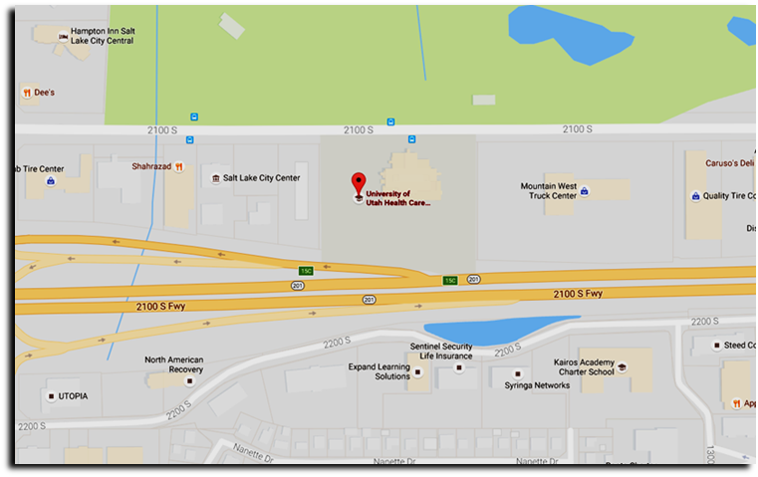
UNIVERSITY OF UTAH REDWOOD HEALTH CENTER OCCUPATIONAL MEDICINE
1525 W. 2100 S. Salt Lake City UT, 84119

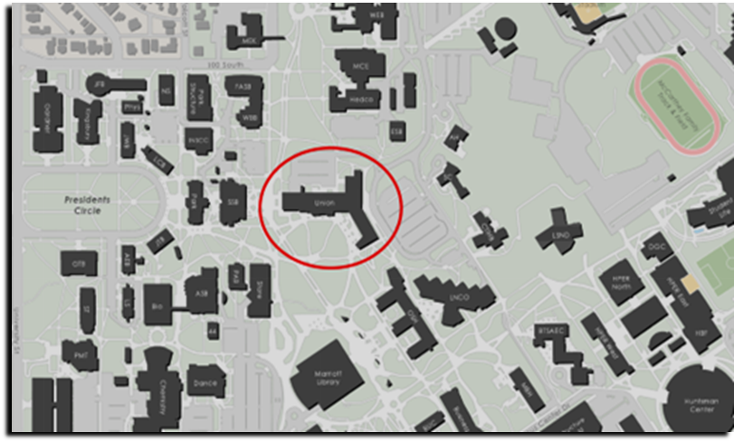
REDMED EMPLOYEE HEALTH CLINIC
200 Central Campus Dr. Salt Lake City, UT 84112

Appendix 3: Use and Disposal of Sharps

To prevent needle stick injuries:

- Do not recap needles by hand. RECAPPING OF NEEDLES IS PROBHIBETED.
- Do not remove needles from syringes by hand.
- Do not bend, break, or otherwise manipulate needles by hand.
- Avoid using needles whenever possible.
- Replace glass materials with plastic (such as Pasteur pipettes)
- Immediately after use, discard needle and syringe (whether contaminated or not) into puncture resistant sharps containers. RECAPPING OF NEEDLES IS PROHIBITED.
- Use a Food and Drug Administration (FDA)-cleared sharps container if you generate sharps waste (pictured below). A description of FDA-Cleared Sharps containers can be found here. FDA-cleared sharps disposal containers are made from rigid plastic, come marked with a line that indicates when the container should be considered full, which means it’s time to dispose of the container, and have the Universal Biohazard symbol.
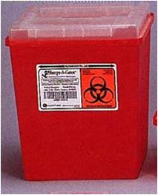
- Never discard sharps into regular trash.
- Never discard sharps into bags of biological waste.
- Use care and caution when cleaning up after procedures that require the use of syringes and needles.
- Do not overfill sharps containers. Close completely when 3/4 full, request pickup from the EHS through the Lab Management System (LMS) webpage at https://ehs.utah.edu/research-safety/lab-management-system.
- Locate sharps containers in areas in which needles are commonly used. Make containers easily accessible.
- Replacement sharps containers may be obtained through the LMS or can be from laboratory supply distributors such as VWR and ThermoFisher. Be sure to select sharps containers that withstand autoclaving.

In the event of a needle stick injury:

Wash the area thoroughly with soap and water. Notify supervisor immediately, report to the Occupational Medical Clinic at the Redwood Health Center and fill out an Incident Report Form, as soon as possible: see Appendix 2.

Contaminated Serological Pipets and Pipet Tips
Serological pipets (glass and plastic) and disposable pipet tips are considered puncture hazards and should be disposed of as sharps. Contaminated pipets and tips should be discarded in approved sharps containers, as described above.

Due to the large size of serological pipets, investigators disposing of large numbers of these can request 20 gallon hard-sided biohazard waste containers (pictured below) from EHS through the LMS. These will be picked up by EHS staff as for other biohazardous waste.

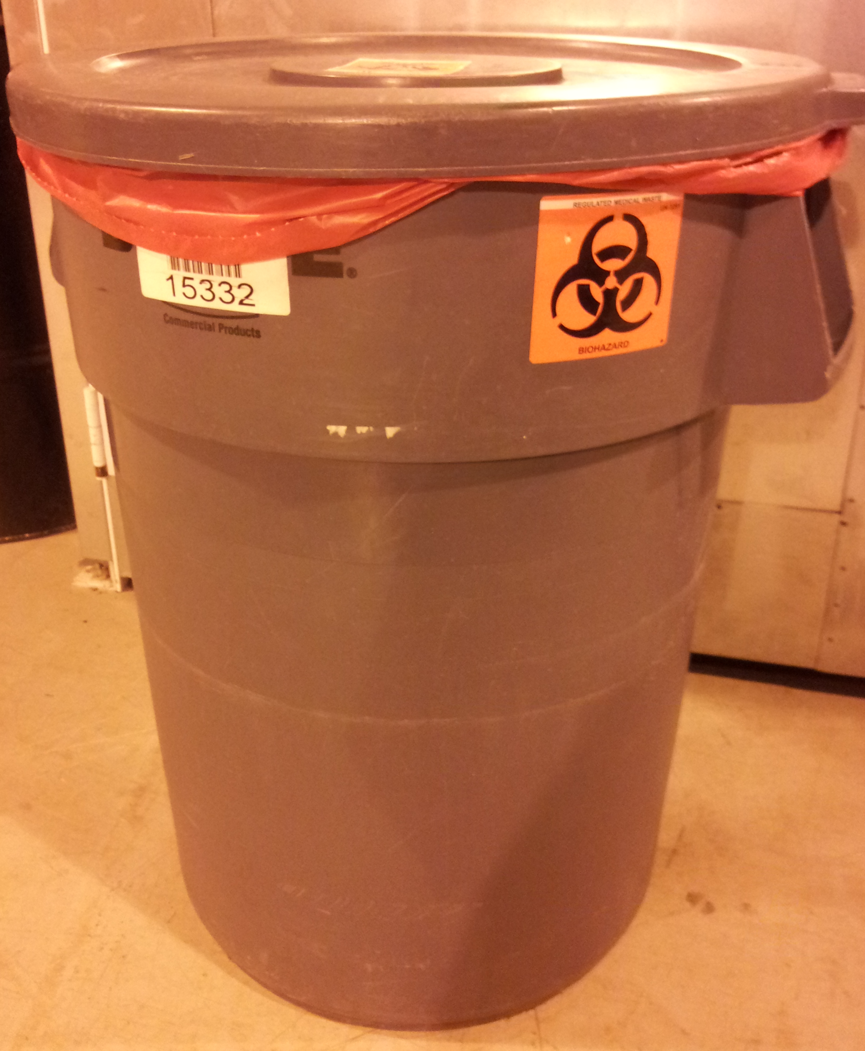
20 Gallon Waste Container

Decontaminated Serological Pipets and Pipet Tips
It is possible to decontaminate serological pipets and tips prior to disposal. Ensure that both the inside and outside of the pipets or tips are exposed to the approved disinfectant (e.g. a freshly prepared 1:10 dilution of bleach) for at least 20 minutes. However, serological pipets and disposable tips are still considered puncture hazards. Therefore, after removing the disinfectant, they can be disposed of in a Broken Glass box (rigid puncture resistant boxes lined with a plastic bag and labeled “Broken Glass”: pictured below), which can be obtained from your custodial staff or from EHS. Once they are 2/3 full they should closed with tape and disposed as regular trash by your custodians.
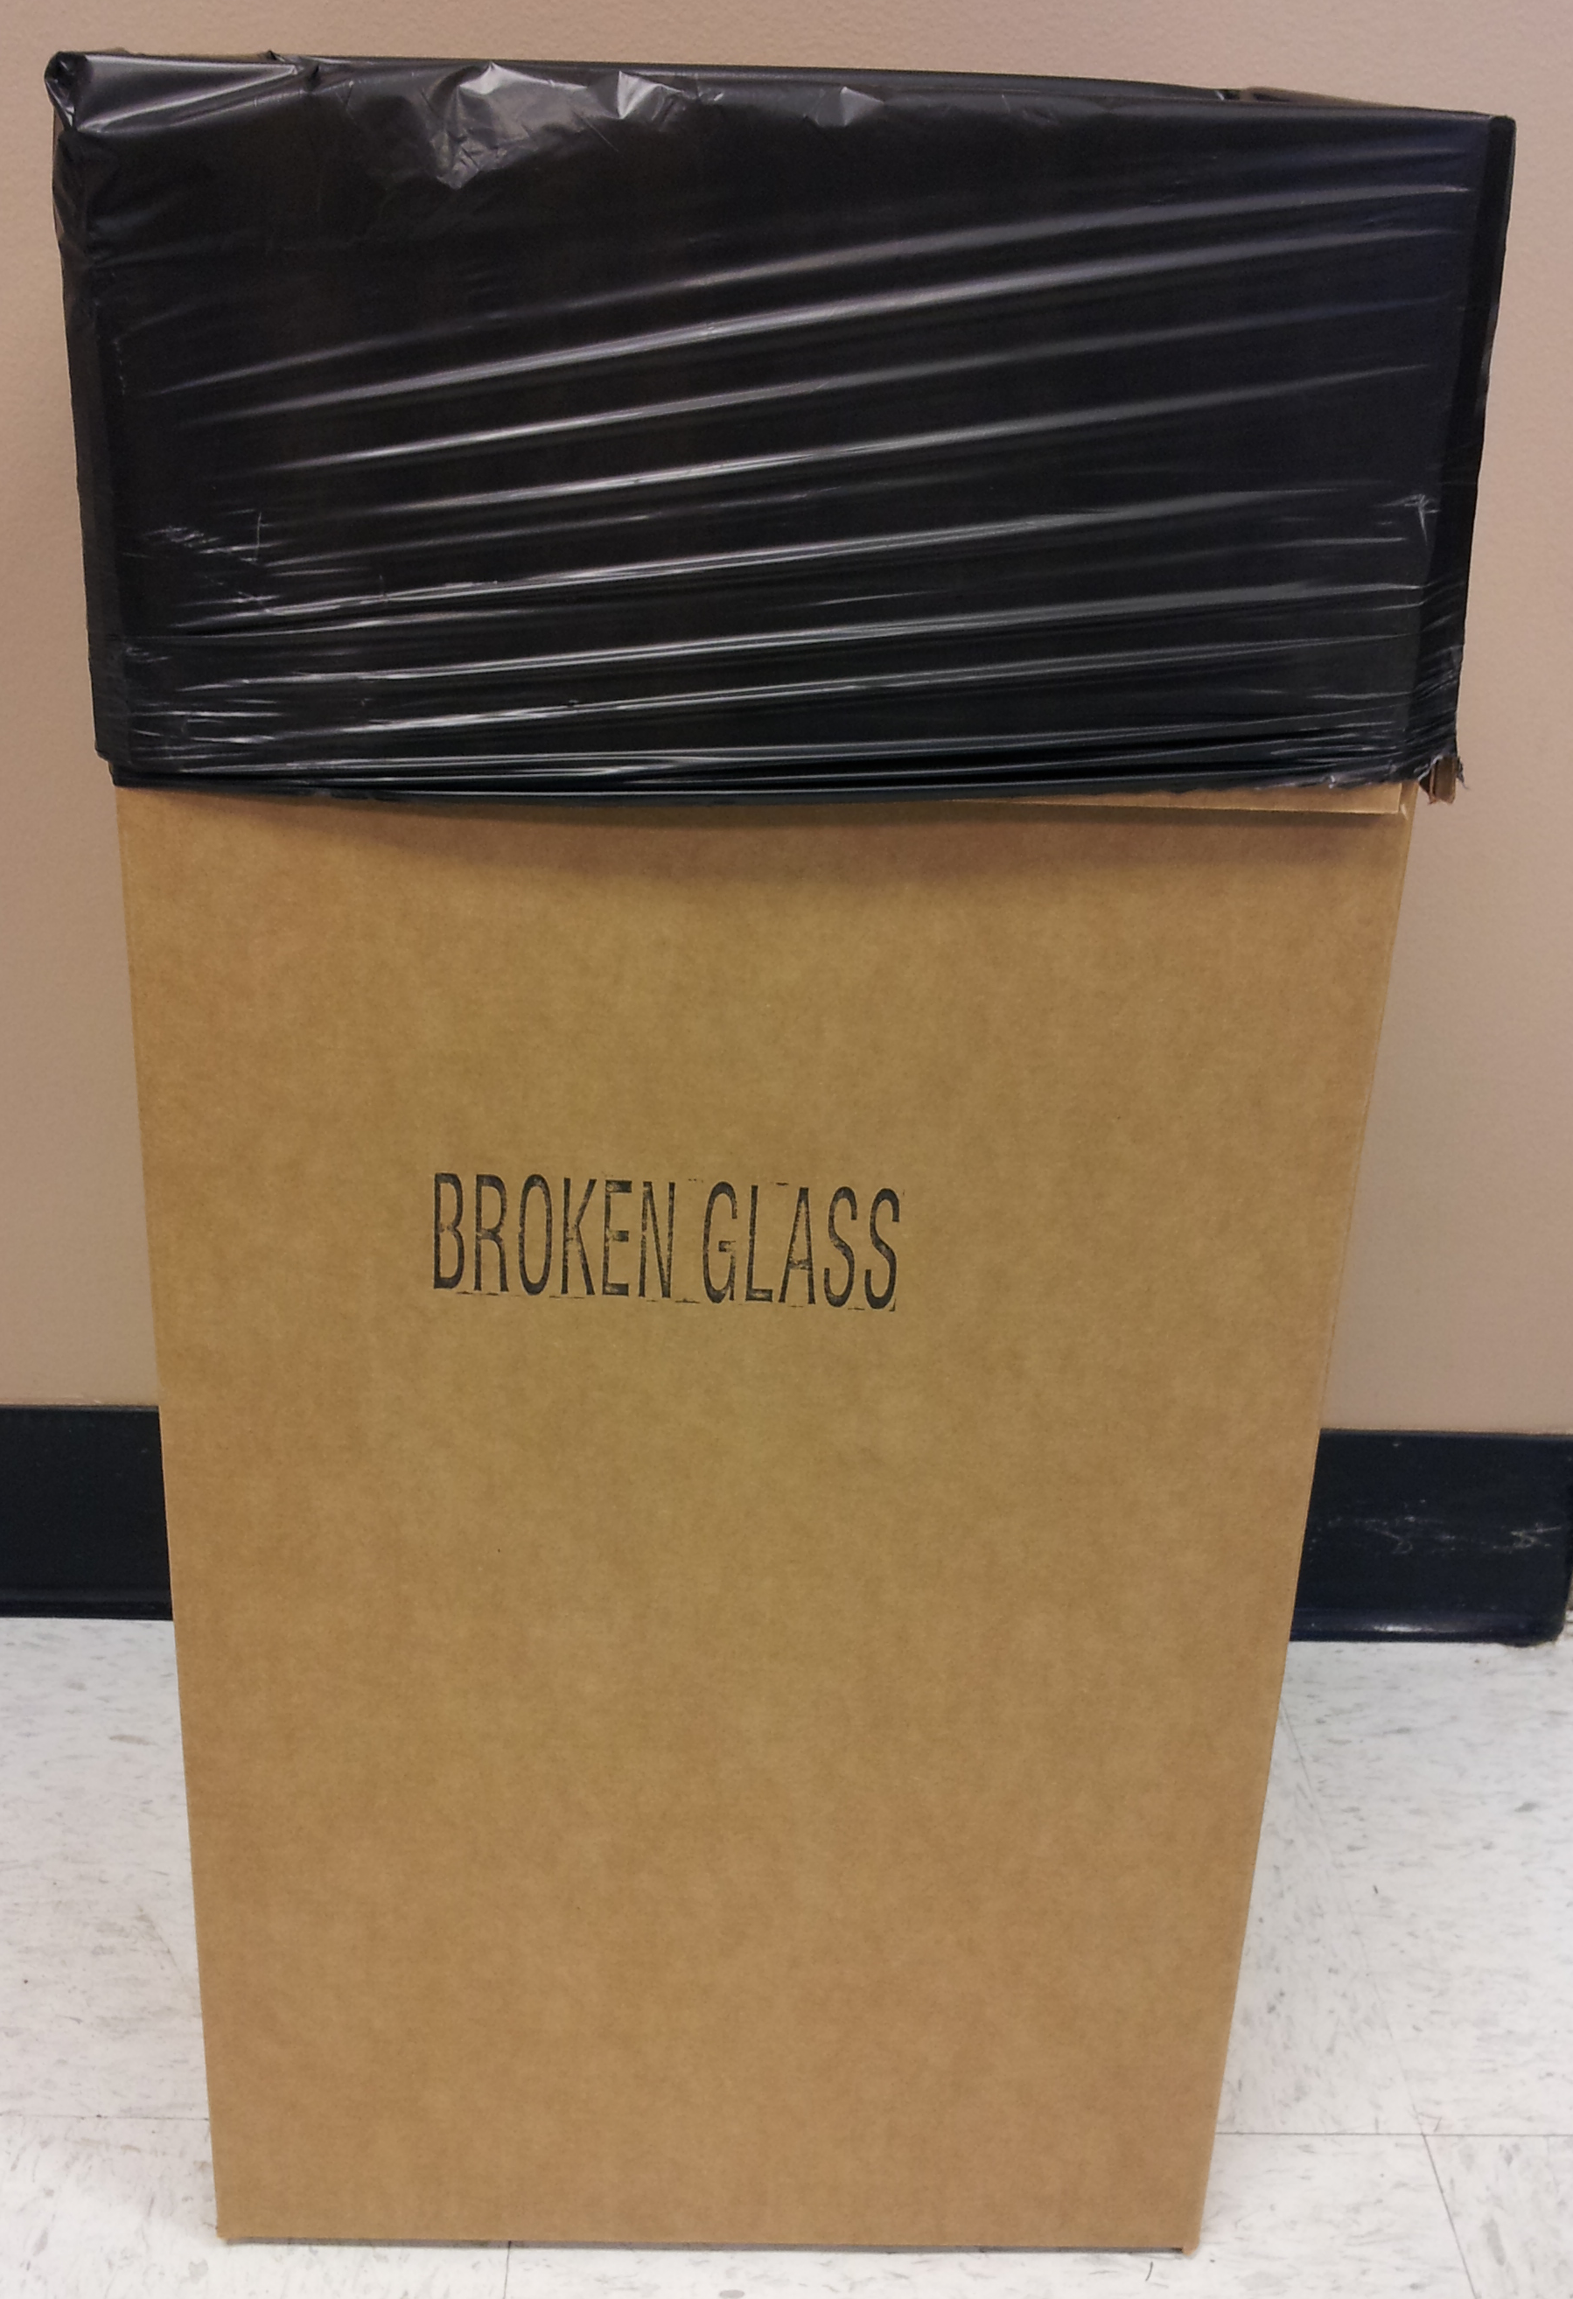
Broken Glass Box
Appendix 4: Disposal of Biohazardous Waste

Per the NIH Guidelines for Research Involving Recombinant or Synthetic Nucleic Acid Molecules, all contaminated liquid or solid wastes are decontaminated before disposal, including materials handled at BSL-1.

Biowaste Disposal – Solids
The Department of Occupational and Environmental Health and Safety (EHS) Lab Management System (LMS) allows research investigators to request hazardous material pickups by EHS staff and request empty containers. Please visit the LMS website for information.

Waste containers obtained from EHS are solid sided, leak proof, lined with red biohazard bags, and labeled with a biohazard symbol. Keep the container lid closed unless someone is working nearby and regularly adding waste to the container.

When the red bag is ¾ full, loosely tie or tape the bag closed. Secure the lid on the waste container and move it to a convenient storage location or transport it to a biohazardous waste storage room, if available. Biohazardous waste must be moved or transported inside a rigid, leak- resistant, labeled container with the lid closed. Request a pickup from your lab using the LMS.

If you have an autoclave available for disinfection of biohazardous waste, place a red biohazard bag in a solid puncture resistant container. Place a Ziploc bag or balloon containing water in the bag when it is about half full to generate steam during autoclaving. When the red bag is full, tie or tape the bag closed. Secure the lid on the waste container and move it to the autoclave room.

The bag should be removed and placed in a solid autoclave resistant tray: the bag should NEVER be placed directly on the floor. After the cycle, the bag may be disposed of as regular trash: indicators that the contents have been autoclaved must be present.

Biowaste Disposal – Liquids
Aspirated tissue culture media, or other liquid waste generated from BSL-1 experiments must be disinfected and then disposed. Bleach is typically used to disinfect liquids, but other agents, such as Wescodyne, may be used if effective.

If you use bleach:
- Ensure the final concentration exceeds 0.5% sodium hypochlorite (no less than one part bleach to 9 parts liquid).
- Ensure the bleach is fresh: in tissue culture media traps change at least twice weekly.
- Ensure the media is exposed to disinfectant for at least 20 minutes prior to disposal.
- Dispose down the sink

If you use Wescodyne:
- Ensure the final concentration exceeds 1% (no less than one part Wescodyne to 99 parts liquid).
- In tissue culture media traps change at least every 3 months (indicate the date of the last change on the flask).
- Ensure the media is exposed to disinfectant for at least 20 minutes prior to disposal.
- Collect waste into containers marked “Unwanted Materials” and date when you start collecting. When full or 6 months after your start date (whichever happens first), arrange pickup by EHS through the LMS website. NO DRAIN DISPOSAL unless approved by EHS.
If the container will be unattended (outside of your immediate control) then label it with the date, time and the words “Biohazardous liquid” and keep it in a secondary container (for example, a plastic tub) while it is disinfecting.

If you use other agents to decontaminate liquid cultures follow the instructions on the packaging. Contact the Biosafety Officer (801-581-6590) for advice on appropriate disinfectants and procedures for disposal of treated waste.

Mixed liquid and solid biohazardous waste
Mixed liquid and solid waste should be separated in a biosafety cabinet (decant the liquid from the solid). Manage the liquids and solids separately as detailed above.

State of Utah regulations for using Autoclaves for Treating Infectious Waste

Below are sections of the State of Utah Regulations for treating infectious waste that apply to the use of autoclaves. These regulations “R315. Environmental Quality, Waste Management and Radiation Control, Waste Management” came into effect April 2013.

R315-316-5. Infectious Waste Treatment and Disposal Requirements.

(4) Infectious waste may be sterilized by heating in a steam sterilizer to render the waste non-infectious.
(a) The operator shall have available, and shall certify in writing that he understands, written operating procedures for each steam sterilizer, including time, temperature, pressure, type of waste, type of container, closure of container, pattern of loading, water content, and maximum load quantity.
(b) Infectious waste shall be subjected to sufficient temperature, pressure and time to inactivate Bacillus stearothermophilus spores in the center of the waste load at a 6 Log₁₀ reduction or greater.
(c) Unless a steam sterilizer is equipped to continuously monitor and record temperature and pressure during the entire length of each sterilization cycle, each package of infectious waste to be sterilized shall have a temperature-sensitive tape or equivalent test material, such as chemical indicators, attached that will indicate if the sterilization temperature and pressure have been reached. Waste shall not be considered sterilized if the tape or equivalent indicator fails to indicate that a temperature of at least 250 degrees Fahrenheit (121 degrees Celsius) was reached and a pressure of at least 15 psi was maintained during the process.
(d) Each sterilization unit shall be evaluated for effectiveness with spores of B. stearothermophilus at least once each 40 hours of operation or each week, whichever is less frequent.
(e) A written log for each load shall be maintained for each sterilization unit which shall contain at a minimum:
(i) the time of day and the date of each load and the operator's name;
(ii) the amount and type of infectious waste placed in the sterilizer; and
(iii) the temperature, pressure, and duration of treatment.
Appendix 5: Safe Handling of Cryogenic Liquids

Danger! Vials immersed in liquid nitrogen may explode violently when removed! Wear face and eye protection! Plastic vials (even Nunc vials with silicon O-rings) used for storing cells in liquid nitrogen are designed to be used in the liquid nitrogen vapor phase. When immersed in the liquid phase, the liquid nitrogen frequently enters vials around the cold O-ring. When vials are removed to room temperature, the liquid nitrogen in the vial immediately begins to boil. Usually it escapes harmlessly past the seal. Occasionally (about 1 out of 1000 vials), the seal is too tight, and the pressure causes a violent rupturing of the vial, sending shards of sharp plastic rocketing in unpredictable directions with sufficient energy to lacerate the face and cause severe eye injury. When removing vials from liquid nitrogen, it is mandatory that you wear full face shields, pulled in to touch your chin so that shards can't fly under the shield. If they fit, wear goggles underneath the face shield.

IBC requires review at least every 12 months

