

University of Utah
Biosafety Manual and Standard Operating Procedures

Biosafety Level 2 Enhanced Laboratory

of
Dr. (name of PI)

(title)

(Institute or department and building, room location)

(date developed)
(annual review/revision date)

This document serves as a template for a Biosafety Manual and Standard Operating Procedures for BSL-2 enhanced laboratories at the University Of Utah. . It has been developed from earlier model Manuals and Standard Operating Procedures (SOPs), the University of Utah Exposure Control Template, Safety Manuals and SOPs developed at other Universities, including Arizona State University, University of Washington, University of California Los Angeles, University of California Berkeley, University of Iowa, and Duke University, and templates provided by the American Biological Safety Association.

This model reflects the requirements of the University of Utah Institutional Biosafety Committee for appropriate BSL-2 enhanced Biosafety manuals and SOPs and OSHA for a laboratory exposure control plan. PIs should customize this document for their laboratory requirements and incorporate into their Institutional Biosafety Committee (IBC) registration in BioRAFT.

Please edit or delete all highlighted sections and remove highlighting

University of Utah
Biosafety Level 2 enhanced Standard Operating Procedures
Table of Contents

- Purpose

- Background
B.1. Biosafety Level 2 Enhanced
B.2. Black Box Warnings
B.3. Bloodborne Pathogen Regulations
B.3.1 Roles and Responsibilities
B.4. Administrative Procedures
B.5. Training
B.6. Record Keeping

- Introduction to General Safety and Training for the BSL-2-enhanced Laboratory
C.1 General BSL-2 Laboratory Safety
C.2. Spills and Exposure Procedures
C.3. Post Exposure Procedures
C.4. Incident Reporting
C.5. Laboratory Signage

D. Standard Operating Procedures
D.1. Containment Requirements
D.1.a Laboratory Entry/Exit
D.1.b Specimen Transport
D.2. Personal Protective Equipment
D.3. Respiratory Protection

- Proper Use and Maintenance of Equipment
E.1. Biological Safety Cabinets
E.2. Incubators
E.3. Centrifuges
E.4. Autoclave
E.5. Potentially Hazardous Equipment

- Waste Disposal and Housekeeping
F.1. Waste Disposal
F.2. Laundry
F.3. Warning Labels

- Emergency Equipment
G.1. Fire Extinguishers
G.2. Telephone

- Repair and Service

- Experimental Procedures

J. Emergency Phone Numbers and Procedures
J.1. Emergency Phone Numbers
J.2. General Emergency Procedures

- Shipping and Transport

Appendices

These are provided as examples but incorporate information that the IBC requires and reviews prior to Registration approval. Please edit and/or delete appendices as applicable and update Table of Contents

- Spill and Exposure Procedures
- Post Exposure Procedures
- Spills and Exposure Event Reporting Procedure
- Hepatitis B Vaccine Declination
- Safe Sharp Review Log
- Lab Specific SOPs (containment and PPE, virus/pathogen/vector production, titering, replication competent virus testing, transduction of cells, animal injections, animal care, transport of materials to CCM, etc.)
Lentivirus SOP provided as example
- Testing Lentiviral Vector Stocks for Replication Competent Virus
- Viral Vector Plasmid Maps
- Gene editing Questionnaire
- Biological Toxins SOP Template
- Agent Summary Statement
- Post-Exposure Fact Sheet
- Use and Disposal of Sharps
- Disposal of Biohazardous Waste
- Safe Handling of Cryogenic Liquids
- Biosafety Level 2 Enhanced Self-Inspection Checklist
- Useful Websites and Resources
A Purpose

The procedures and standard operating procedures (SOPs) described in this manual apply to all research staff, hosted visitors and guests, volunteers, building staff, and service staff who enter the laboratory. This manual will be reviewed annually by the Principal Investigator or Laboratory Supervisor for changes or corrections to ensure that it is accurate.

Research involving recombinant/synthetic nucleic acids, infectious agents, creation of transgenic or knockout animals, acute biological toxins, unfixed non-human primate materials, or human blood, cells, or unfixed tissues must submit a research registration through BioRAFT to the Department of Environmental Health and Safety (EHS) at least every three years. This work may require prior review and approval by the Institutional Biosafety Committee, according to the NIH Guidelines for Research Involving Recombinant DNA Molecules. Since the university receives funding from NIH, all research at the University of Utah must comply with the NIH Guidelines.

This plan was designed as a supplement to the University of Utah Biosafety Manual to meet the requirements of the Biosafety in Microbiological and Biomedical Laboratories, 5th ed.

A risk assessment of biological agents should take into account both the intrinsic hazards of the agent as well as considerations of individuals handling the agents, addressing the potential for emergent hazards from rDNA work, and hazards associated with the vectors used for insertions. Agent hazards are those risks that are intrinsic to the agent being handled such as the following:
- Capability to infect and cause disease in a susceptible human host.
- Severity of the disease
- Infectious dose
- Availability of preventative measures
- Availability of effective treatments
- How the agent is transmitted (i.e. route of exposure)
- Quantity, concentration, and total volume used
- Stability in the environment
- Zoonotic concerns
- Allergenicity

Exposure sources in the laboratory are hazards that could result in the infection of researchers or the public through work with biological agents. Some of the more common hazard considerations include the following:
- Aerosol generation (e.g. pipetting, mixing, blending, grinding, sonicating, vortexing, centrifuging, shaking)
- Manipulation with sharps
- Animal handling
- Contact with blood, bodily fluids, or other potentially infectious material
- Ingestion of agents via contaminated work areas
- Eye-splashes from liquid nitrogen storage

When performing a risk assessment of laboratory procedures, all potential routes of exposure should be addressed. Most laboratory-acquired infections have resulted from inhalation of aerosols, splashes or sprays, and needlesticks. It is good practice to look for potential exposures via ingestion, inoculation, inhalation, and contamination of skin and mucous membranes and attempt to identify safer alternatives and risk mitigation strategies.

Background

Review of this Manual is mandatory for all employees and staff working in the BSL-2 enhanced laboratory of Dr. (name of PI). The Manual has been customized to provide lab-specific provisions to identify and protect all personnel who may be at risk of exposure. This Manual must be updated at least annually, and whenever there are changes in laboratory procedures that may change a worker’s exposure. A copy of this Manual must remain in the lab, and must be accessible to lab personnel.

This Manual applies to work with (name of agent(s)). .
- Risk Assessment
Insert Description Here: include consideration of parent and recombinant agent pathogenicity, virulence, infectious dose, route of transmission and exposure sources, genetic alterations that alter the pathogenicity, host range, availability of vaccines and prophylactic measures, and stability.
- Signs and Symptoms of Infection
Insert Description Here
- Prophylaxis and Treatment Options
Insert Description Here
- Methods of Disinfection and Inactivation
Insert Description Here
For disinfecting blood or other potentially infectious materials covered by the OSHA bloodborne pathogen standard, an EPA-approved must be used: https://www.epa.gov/pesticide-registration/selected-epa-registered-disinfectants

Check expiration dates on commercial disinfectants: stock bottles of bleach should be discarded no later than one year after the date of manufacture or 6 months after purchase, whichever comes first. Note dilutions of bleach should be made fresh at least twice per week.

Individuals who are immunocompromised (e.g. individuals with immunologic conditions or are being treated with immunosuppressive agents, pregnant woman, individuals with AIDS) should be advised of the risk of working with this agent and it is recommended that they consult with a healthcare provider.

B.1 Biosafety Level 2 Enhanced

Biosafety Level 2 enhanced (BSL-2 enhanced, sometimes referred to as BSL-2+) is a term frequently used to describe laboratories where work with microorganisms is conducted in a BSL-2 laboratory with biosafety practices and procedures that are typically found at BSL-3. BSL-2 enhanced is not a recognized containment level in biosafety guidance documents such as the Centers for Disease Control and Prevention’s (CDC) Biosafety in Microbiological and Biomedical Laboratories (BMBL) or the National Institutes of Health’s (NIH) Guidelines for Recombinant DNA Research. However, the NIH’s Biosafety Considerations for Research with Lentiviral Vectors refer to “enhanced BL2 containment”.

The use of BSL-3 practices and procedures in a BSL-2 laboratory allows for research work with microorganisms, including viral vectors, to take place in an environment where the safety practices are enhanced over and above the practices required at BSL-2. BSL-enhanced is not appropriate for RG3 pathogens that are infectious via the inhalation route. At a minimum, such pathogens must be utilized in a BSL-3 laboratory with BSL-3 practices.

There is no standardized list of microorganisms, viral vectors or research projects that should be conducted at BSL-2 enhanced. Each decision to use BSL-3 practices in a BSL-2 laboratory must be made via the risk assessment process. The risk assessment serves to guide the selection of appropriate biosafety levels and microbiological practices, safety equipment, and facility safeguards that will contribute to preventing a laboratory exposure.

As outlined in the BMBL, the steps of the risk assessment process include:
1. Identify agent hazards and perform an initial assessment of risk.
2. Identify laboratory procedure hazards.
3. Make a determination of the appropriate biosafety level and select additional precautions as indicated by the risk assessment.
4. Evaluate the proficiencies of staff regarding safe practices and the integrity of safety equipment.
5. Review the risk assessment with a biosafety professional, subject matter expert, and the Institutional Biosafety Committee (IBC).

The risk assessment process must be applied to every new or revised research project. Examples of when BSL-2 enhanced may be appropriate include:
• Viral vectors encoding oncogenes, toxins or genes of unknown function, or that produce products that reduce or knockout the expression of tumor suppressors.
• Drug-resistant Risk Group Two (RG2) bacteria such as methicillin resistant Staphylococcus aureus (MRSA).
• Low titer and small volumes of Human Immunodeficiency Virus (HIV), an RG3 agent.
• High concentrations (>10⁶ PFU/mL) of RG2 viruses.
• Work with greater than 10 liters of an RG2 agent.

Significant differences from standard BSL-2 practices can include:
- A sharps policy is implemented and sharps (e.g., glass Pasteur pipettes, needles) are not allowed. Plasticware is substituted for glassware.
- All work is performed in a BSC.
- Lab personnel must participate if medical surveillance is required per direction of IBC and Occupational Medicine physician.
- The PI must provide training to lab personnel who may not have experience working with the materials to be used with BSL-3 practices, e.g., an apprentice program may be established for personnel where they shadow more experienced personnel and are not allowed to work independently until they demonstrate proficiency.
- Create a “Spill Kit” and store within the lab. Consider a yearly “shut down” for a few days to accommodate servicing and maintenance activities.
- Disposable, solid-front, fluid-resistant gowns rather than front opening gowns.
- Two pairs of gloves.
- Safety glasses with side-shields should be worn while in the lab.
- Other BSL-3 practices, based on the risk assessment by the PI and IBC.

B.2. Black Box Warnings
The IBC has adopted a series of “Black Box Warnings” for agents that would typically require BSL-2 enhanced containment. This phrase is required by the Food and Drug Administration as the strictest warning put in the labeling of prescription drugs or drug products when there is reasonable evidence of an association of a serious hazard with the drug. It is also used by agencies to highlight a higher than standard risk. If the laboratory is proposing any of the following agents, please add the following statement to the Biosafety Manual, using a bolded and enlarged font, ensuring it is clearly identifiable by laboratory personnel:
- Black box warning (lentivirus expressing oncogene): The viral vectors used in this research pose a greater risk to laboratory workers than typical viral vectors. This research includes one or more lentivirus/retrovirus vectors that infect human cells efficiently, and that express proven or potential oncogenic proteins or other proteins that alter the cell cycle. Accidental human exposure to these vectors may increase the risk of tumor formation.
- Black box warning (lentivirus expressing small RNA molecule): The viral vectors used in this research pose a greater risk to laboratory workers than typical viral vectors. This research includes one or more lentivirus/retrovirus vectors that infect human cells efficiently, and that express small RNA molecules intended to reduce or eliminate expression by targeted genes. These molecules may inhibit expression of tumor suppressors through a targeted or off-target effect. Accidental human exposure to these vectors may increase the risk of tumor formation.
- Black box warning (HIV pseudovirus): The viral vectors used in this research pose a greater risk to laboratory workers than typical viral vectors. This research includes a pseudovirus vector system with a low genetic barrier to the generation of replication-competent HIV virus. Accidental human exposure to these vectors could result in HIV infection.
- Black box warning (HIV infectious molecular clone): The viral vectors used in this research pose a greater risk to laboratory workers than typical viral vectors. This research includes a plasmid capable of producing replication-competent HIV virus if expressed in a human cell. Accidental human exposure to these vectors could result in HIV infection.
- Black box warning (VSV-G pseudotyped HIV infectious molecular clone): The viral vectors used in this research pose a greater risk to laboratory workers than typical viral vectors. This research includes a viral vector capable of producing HIV infection in the event of an accidental exposure. Furthermore, the viral vector has the VSV-G envelope protein on its surface. This protein makes the vector capable of infecting a wider range of human cells, so may make it more likely to result in infection in the event of an accidental exposure. Accidental human exposure to these vectors could result in HIV infection.
- Black box warning (CRISPR/Cas system on a single vector): The viral vectors used in this research pose a greater risk to laboratory workers than typical viral vectors. This research includes a CRISPR(clustered regularly interspaced short palindromic repeat)/Cas system capable of editing human chromosomal DNA. Both components of the system (gRNA and Cas9) are expressed on the same viral vector. This increases the risk for damage to chromosomal DNA with potential oncogenic effects. Accidental human exposure to these vectors may increase the risk of tumor formation.

B.3. Bloodborne Pathogen Regulations

Laboratories working with human blood and other potentially infectious materials (OPIM), including human and non-human primate cell lines, must comply with OSHA's Occupational Exposures to Bloodborne Pathogens in Title 29 Code of Federal Regulations 1910.1030 and as revised in 2001 by the Needlestick Safety and Prevention Act P.L. 106-430. One requirement is to develop and implement an Exposure Control Plan (ECP), which is reviewed annually. This Biosafety manual has been adapted to serve as an ECP. However, practices that can be performed at lower containment (BSL-2 vs BSL-2 enhanced) should be clearly delineated and the containment and PPE requirements described in a separate section.

This plan is designed to eliminate employee exposure to bloodborne pathogens. All human blood and OPIM are considered to be infectious for Human Immunodeficiency Virus (HIV), Hepatitis B virus (HBV), and other bloodborne pathogens, and will be treated as if infectious, i.e. with universal precautions.

The ECP is a key document to assist the lab in implementing and ensuring compliance with the standard, thereby protecting employees. The ECP must be reviewed annually and include a “Sharps Injury Log” (Appendix 3) if sharps are used in the laboratory. Although sharps are not allowed in th BSL-2+ laboratory they may be used in other areas of the lab covered by the ECP. This ECP must address:

Employee exposure determination
Methods of control to prevent worker exposure
Provisions for hepatitis B vaccination
Post-exposure evaluation & follow-up
Employee training and hazard communication
Solicitation of input from employees regarding identification, evaluation, and selection of effective engineering and work practice controls
Annual Review of Safe Sharp devices
Recordkeeping

This manual will serve as the ECP.

B.3.1. Roles and Responsibilities
  - (Name of Individual) is responsible for the implementation of this ECP.

  - (Name of Individual) will maintain, review, and update this ECP at least annually, and whenever necessary to include new or modified tasks and procedures.

  - Those employees who have occupational exposure to blood or OPIM must comply with the procedures and work practices outlined in this ECP.

  - (Name of Individual) will maintain and provide all necessary personal protective equipment (PPE), engineering controls (e.g., sharps containers), labels, and red bags as required by the standard. This will include ensuring that adequate supplies of the aforementioned equipment are available in the appropriate sizes.

  - (Name of Individual) will be responsible for documentation of annual consideration and implementation of appropriate engineering controls, including safer sharp alternatives (Appendix 5). NOTE: Sharps are not allowed when BSL2+ procedures/containment are being followed, but may be used on other occasions within the BSL2 suite.

  - (Name of Individual) will be responsible for solicitating input from employees regarding identification, evaluation, and selection of effective engineering and work practice controls.

  - (Name of Individual) will be responsible for ensuring that all medical actions required are performed and that appropriate employee health and OSHA records are maintained.

  - (Name of Individual) will be responsible for ensuring that an annual review of safe sharp alternatives (Appendix 5).

  - (Name of Individual) will be responsible for training, documentation of training, and making the written ECP available to employees, OSHA, and NIOSH representatives.

B.4. Administrative Procedures

It is the responsibility of each lab member to carefully consider every action taken in the BSL-2-enhanced lab and its potential impact on possible exposure or contamination, and to follow established Standard Operating Procedures (SOPs) and protocols diligently and without variance.

All employees will read and adhere to the University of Utah Biosafety Manual and to this SOP Manual for Dr. (name of PI) laboratory. All employees will use pertinent sections in the Biosafety in Microbiological and Biomedical Laboratories, CDC-NIH, 5th edition as a guideline and reference (http://www.cdc.gov/biosafety/publications/bmbl5/index.htm).

All employees will attend the University of Utah EHS courses in Bloodborne Pathogen/Biosafety Level 2 Training annually.

All employees working in the lab will be will be offered (vaccination available?). All employees who have potential exposure to blood or other potentially infectious materials, including human and non-human primate cell lines, will be offered the Hepatitis B vaccine, at no cost to the employee. The vaccine will be offered within 10 working days of their initial assignment to work involving the potential for occupational exposure to blood or other potentially infectious materials following completion of the EHS Bloodborne Pathogens training.

The hepatitis B vaccination series is available at no cost after training and within 10 days of initial assignment to employees identified in the exposure determination section of this plan. Vaccination is encouraged unless: 1) documentation exists that the employee has previously received the series, 2) antibody testing reveals that the employee is immune, or 3) medical evaluation shows that vaccination is contraindicated.

However, if an employee chooses to decline vaccination, the employee must sign a declination form. Employees who decline may request and obtain the vaccination at a later date at no cost. Documentation of refusal of the vaccination is kept (describe location). Hepatitis B vaccination will be coordinated and paid for through EHS, as provided by the Student Health Clinic.

No employee will be trained to work in the lab without the express permission of Dr. (name of PI).

New SOPs and protocols must be approved by the PI before initiation. Changes to SOPs and protocols that include new agents, risks or change the basis of IBC approved protocols must be submitted for review by the IBC.

Current Manuals, SOPs and protocols will be reviewed and/or revised by Dr. (name of PI) or Laboratory Manager every ( ) months.

B.5. Training

All personnel who work in the laboratory must receive adequate instruction from their supervisor prior to beginning work. Some training is required annually. Each lab will require different trainings (edit as applicable). The minimum requirements for qualification to work in the (name of PI) BSL-2-enhanced lab are:
- Initial and Annual EHS Bloodborne Pathogen training,
- Initial EHS Biosafety Level 2 Training: repeated every 3 years
- Initial EHS Animal Biosafety Level 2 Training: repeated very 3 years
- Initial and Annual Laboratory Specific Training (Risks associated with the hazards/agents used in the lab, SOPs, Spill and Exposure Procedures) including annual review of this manual
- Hands on training with BSL-3 practices. An apprentice program may be established for personnel where they shadow more experienced personnel and are not allowed to work independently until they demonstrate proficiency.
- Shipping Training: Training is required to commercially transport infectious materials, as well as shipping anything on dry ice. Contact EHS to schedule a training class. Must be repeated very 2 years.
- (List as many as you need)

This document will provide the basis of training in conjunction with EHS training, through RATS, and hands-on training provided by the PI or Lab Manager.

Dr. (name of PI) will provide information and arrange for training at the time of an individual's initial assignment to the lab. Dr. (name of PI) will arrange for refresher training at least annually and when there are any changes in processes or procedures. Documentation of training will be uploaded to the laboratory registration in BioRAFT.

For more information concerning training, also see the University of Utah Biosafety Manual on the IBC web site (https://ibc.utah.edu/biosafety-policies.php).

B.6. Record Keeping

a. Training Records

Training records are completed for each employee upon completion of EHS Bloodborne Pathogens, Biosafety Level 2, Animal Biosafety Level 2, and Shipping training. EHS training records will be kept for at least three years at EHS (Bldg. 605 and include: Dates of the training sessions, content of the training sessions, the name of the person(s) conducting the training, and names of all persons attending the training sessions. Employee training records are provided by EHS upon request to the employee or the employee's authorized representative within 15 working days. Such requests should be made to EHS (Bldg. 605).

b. Medical Records

Medical records are maintained for each employee with occupational exposure in accordance with 29 CFR 1910.1020, "Access to Employee Exposure and Medical Records." Medical records, under most circumstances, will be maintained by the Department of Occupational Medicine.

c. OSHA Recordkeeping

Human resources will evaluate all incident reports to determine if cases meet OSHA’s Recordkeeping Requirements (29 CFR 1904). All percutaneous injuries from contaminated sharps are also recorded in the Sharps Injury Log (Appendix 3).

C. General Safety and Training for the BSL-2-enhanced Laboratory

C.1 General BSL-2-enhanced Laboratory Safety

Work with the agent will be performed in (insert building and room number). Practices must adhere to the standards described in the University of Utah Biosafety Manual (https://ibc.utah.edu/biosafety-policies.php). These include:

- Access to the laboratory must be restricted to authorized personnel only

- Laboratory employees must immediately notify the laboratory manager or PI in case of an accident, injury, illness, or overt exposure associated with laboratory activities.

- No eating, drinking, smoking, handling contact lenses, or applying cosmetics in the lab at any time.

- No use of headphone and/or cell phones/iPODs etc., while in the BSL-2-enhanced lab.

- No animals (pets) or minors (persons under the age of 18) will be allowed to enter the lab at any time.

- Food, medications, or cosmetics shall not be brought into the lab for storage or later use. Food is stored outside in areas designated specifically for that purpose.

- No open shoes or sandals are allowed in the laboratory: the entire foot must be covered up to the ankle.

- No bare legs or arms.

- Personnel must wear a solid front/rear closing lab coat (or gown) with tight cuffs, safety glasses or goggles, and two pairs of gloves. For work with high risk agents transmissible by inhalation, personnel should wear an N95 respirator (see Section D.3.). Lab coats must be left in the lab. Upon entering the tissue culture facility, personnel must immediately don a gown or laboratory coat with long sleeves. Disposable sleeves with tight cuffs are available for personnel to use when using a lab coat with loose cuffs.

- All skin defects such as cuts, abrasions, ulcers, areas of dermatitis, etc. should be covered with an occlusive bandage.

- Mouth pipetting is prohibited; mechanical pipetting devices are to be used at all times.

- All procedures are to be performed carefully to minimize the creation of splashes or aerosols. Aerosols containing RG2/BSL-2 enhanced agents pose an increased risk of exposure to personnel. Solutions containing RG2/BSL-2 enhanced agents will be enclosed in capped containers during agitation (vortexing, shaking, centrifugation, etc.). If agitation is performed outside of a safety cabinet, two levels of containment are required (i.e. capped tube enclosed in plastic bag or Tupperware). After agitation, containers will only be opened in a biosafety cabinet to prevent exposure to personnel from aerosols. Human cells/tissue will be homogenized inside a biosafety cabinet. Centrifugation of hazardous materials must be performed using centrifuge safety caps or sealed rotors: these should loaded and unloaded in the BSC.

- Centrifuge materials containing infectious agents in durable, shatter resistant, closable tubes. Use a centrifuge with sealed rotors/heads or screw capped safety cups. After centrifugation, open the rotors and tubes within a BSC.

- Cover countertops where hazardous materials are used with plastic backed disposable paper to absorb spills and dispose of them daily or following a spill.

- Wipe work surfaces with an appropriate disinfectant (name of disinfectant) after experiments and immediately after spills. Follow manufacturer instructions for contact time.

- Decontaminate all contaminated or potentially contaminated materials by appropriate methods before disposal

- Follow all manufacturer’s instructions and SOPs when using any of the laboratory equipment.

- Hand washing with soap is required (i) after handling materials involving organisms containing recombinant DNA molecules including viruses, (ii) after handling animals, (iii) after working with human cells, (iv) after removing PPE, and (v) whenever exiting the laboratory.

- Sharps and glass (e.g., Pasteur pipettes) are generally prohibited in BSL-2-enhanced procedures, unless absolutely unavoidable. Consultation must be performed with EHS to assess risks and changes to the BSL-2-enhanced protocol prior to their use. Clear justification must be provided to the IBC justifying the use of sharps prior to IBC approval. Although plastic pipette tips are considered puncture hazards they may be used in BSL-2-enhanced protocols.

- All sharps must be placed in a rigid, puncture resistant, closable and leakproof container, which is labeled with the word "Sharps" and the biohazard symbol. Food containers (e.g., empty coffee cans) are not permissible as sharps containers. All sharps must be handled with extreme caution. The clipping, breaking, and recapping of needles is not permitted. Sharps containers should not be filled more than 2/3. See Appendix 13.

- Fluorescence activated cell sorting (FACS) can produce aerosols and special precautions must be performed. BSL-2+ samples that only require analysis must be fixed in 4% paraformaldehyde prior to running on a cell sorter whenever possible. For sorting BSL-2+ cells, permission must first be obtained from the FACS operator prior to scheduling the run. The FACS operator must be informed about the type of cells being run and the hazards of the cells. Adapt the SOP found here.

- All cultures, stocks, and other regulated wastes are decontaminated by autoclaving or disinfection before disposal. NOTE: No untreated or non-disinfected biological agent-containing material should be allowed into any drain connected to the sanitary sewer system (e.g., from a sink). Materials to be decontaminated outside of the immediate laboratory are placed in a durable, leakproof container and closed for transport from the laboratory.

- Liquid waste, decontaminated with bleach for at least 20 minutes, from humans or animals can be disposed of directly by flushing down a sanitary sewer. Liquid waste decontaminated with alternative chemicals, such as Wescodyne, may have to be disposed of as hazardous waste: contact the Biosafety Officer for advice. Pick up for hazardous waste can be arranged through the Lab Management System.

- Contaminated solid waste includes cloth, plastic and paper items that have been exposed to agents infectious or hazardous to humans, animals, shall be placed in biohazard bags and decontaminated by autoclaving. After autoclaving the waste can be disposed in the regular trash: please ensure that there is clear indication that the material has been autoclaved, such as using autoclave tape.

- Alternatively, EHS can dispose of biohazard waste for the lab. EHS can be contacted using the on-line pick up request via the Lab Management System. All contaminated waste shall be placed in a biohazard bag inside of a leak proof, puncture resistant, sealable biohazard waste container. The container must be labeled with a biohazard symbol. Double or triple bagging may be required to avoid rupture or puncture of the bags. Contaminated Pasteur pipettes and plastic pipette tips are considered sharps and need to be disposed of in a sharps container. Do not overfill the container. Biohazard waste containers should not be filled more than 2/3 full.

C.3 Spills and Exposure Procedures

See Appendix 1

C.4. Post-exposure Procedures

See Appendix 2

C.5. Incident Reporting
An employee with a work-related injury or illness must complete the Employer’s First Report of Injury or Illness Form, Form 122, and submit it to the Benefits Department within 24 hours. This form can be accessed by clicking on “Forms” at www.hr.utah.edu or by calling Benefits at 801- 581-7447. The Benefits Department is located at 250 East 200 South, Suite 125 Salt Lake City, UT 84111. All exposures will be reported to EHS 801-581-6590. EHS will ensure that all OSHA reportable cases are reported to UOSH.

Identify and document the source individual (unless it is established that the source is unknown).

After obtaining consent, collect exposed employee's blood as soon as feasible after exposure incident, and test blood for HBV and HIV serological status.

If the employee does not give consent for HIV serological testing during collection of blood for baseline testing, preserve the baseline blood sample for at least 90 days; if the exposed employee elects to have the baseline sample tested during this waiting period, perform testing as soon as feasible.

Complete an Incident report form (https://oehs.utah.edu/incidentnear-miss-report).

C.7. Laboratory Signage
Permanent yellow warning signs containing the biohazard symbol and BSL-2 enhanced designation are posted at the entrance to rooms where Risk Group 2 agents are used or stored. This system is intended for rooms where the use of BSL-2 enhanced containment is expected to continue over a long time period without frequent total room decontamination. This door sign outside of the laboratory is posted and managed by EHS. Biosafety level 2 enhanced labs should have the following permanently-affixed decals: Biohazard symbol, “BSL-2 enhanced” designation, and Exit Requirements, including reminders to remove PPE and wash hands prior to exiting. The types agents worked with in the lab are listed but not specifically identified. If any changes need to be made to the sign, including emergency contacts, please log in and update the information in BioRAFT. EHS will post any changes to the sign after IBC approval and completion of an EHS inspection.

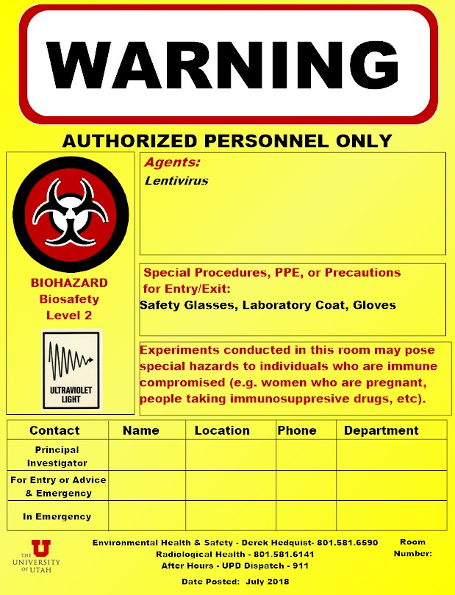

D. Standard Operating Procedures (edit or delete this section as appropriate)

D.1. Containment Requirements

D.1.a - Laboratory Entry/Exit

Entering the lab to begin work

A. Put on protective PPE (see Section D.2.).

B. Gather all materials for the experiment.

Exiting Laboratory

Before exiting the lab, be sure that the hood and work area are clean, all contaminated waste materials are disposed of properly, and stocks have been returned to the proper storage area. Remove PPE and wash your hands.

D.1.b Specimen Transport

Transport of biological materials to another building or lab within the same building should be done in a sealed, leakproof container labeled with the universal biohazard sticker. If the samples are infectious, use a secondary container and label it with the contents and a contact person/phone number.

D.2. Personal Protective Equipment (PPE)
The following personal protective equipment (PPE) will be required when working in the BSL-2-enhanced laboratory:
- Rear closing, fluid resistant disposable or onsite-laundered lab coat: if sleeve cuffs are not tight, disposable sleeve covers are required
- Gloves (2 pairs): nitrile/latex/other
- Safety glasses or goggles
- (describe additional PPE requirements)

Staff should not have exposed arms, ankles legs or feet. Shorts and open shoes or sandals are not permitted in the BSL-2-enhanced laboratory. All personal protective equipment will be cleaned, laundered, repaired, replaced and/or disposed of by the employer at no cost to employees. Immediately (or as soon as feasible) remove garments penetrated by blood or other infectious material. All personal protective equipment will be removed prior to leaving the work area.

Disposable gloves are not to be washed or decontaminated for re-use and are to be replaced as soon as practical when they become contaminated. If they are torn, punctured, or when their ability to function as a barrier is compromised, they need to be replaced as soon as feasible. Utility gloves may be decontaminated for re-use provided that the integrity of the glove is not compromised. Utility gloves are to be discarded if they are cracked, peeling, torn, punctured, or exhibit other signs of deterioration or when their ability to function as a barrier is compromised.

Masks in combination with eye protection devices, such as goggles or glasses with solid side shields, or chin length face shields, are required to be worn whenever splashes, spray, splatter, or droplets of blood or other potentially infectious materials may be generated and eye, nose, or mouth contamination can be reasonably anticipated.

D.3. Respiratory protection (edit or delete this section as appropriate)

In a setting where there is a high risk of exposure to an agent that is contracted through aerosolization, employees will be required to wear an N95 respirator. Medical surveillance, a written respiratory protection plan, and fit testing/training must be conducted before personnel wear N95 respiratory protection. Contact EHS to schedule fit testing.

E. Proper Use of Equipment (edit or delete this section as appropriate)

Equipment that has become contaminated with blood or other potentially infectious materials shall be examined prior to servicing or shipping and shall be decontaminated as necessary unless decontamination of the equipment is not feasible. BSC decontamination prior to servicing or transport (i.e. removal from the laboratory) must be performed by a certified vendor. Contact EHS (1-6590) for assistance.

E.1. Biological Safety Cabinets

Diagram of airflow in a Biosafety Cabinet (Keep the image of the type of cabinet(s) you use)
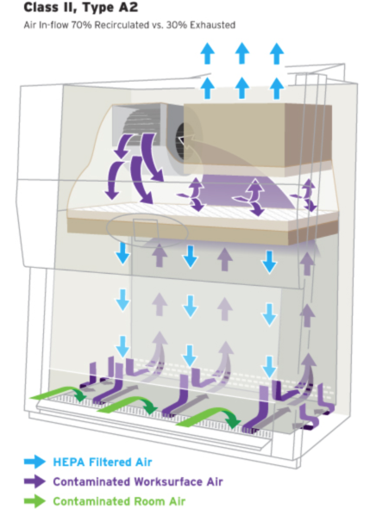
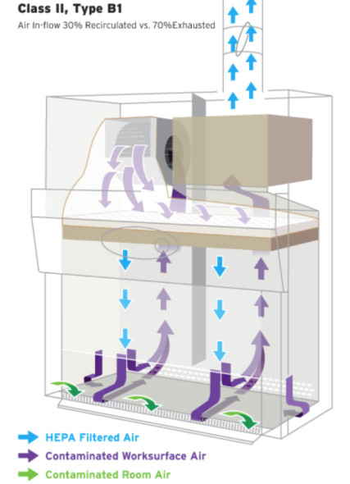

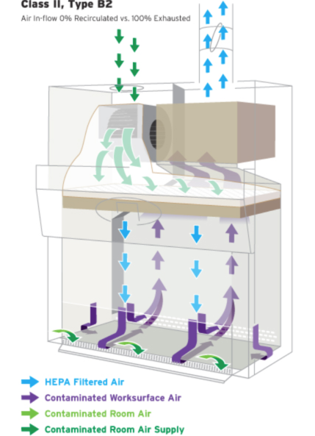

Note the flow of air. Do not block air vents

            - Reserve time in advance to have priority for use of the Biosafety Cabinet (BSC). (If you use sign-up sheets, describe the process here)

            - Turn on the blower in the cabinet at least 10 minutes before placing infectious materials into the hood.

            - Check the certification sticker and all biosafety cabinet monitors to verify that the biosafety cabinet is working properly. Biosafety cabinets must be certified prior to use. An NSF-certified contractor must certify these cabinets annually. Check the certification sticker on the front of the unit to verify your biosafety cabinet’s condition. If the re-certification date has passed contact EHS.

            - The biosafety cabinet air flow monitor should be checked to assure proper operation of the cabinet before placing any materials into it. Readings indicate relative pressure drop across the HEPA filter. Higher readings may, therefore, indicate filter clogging. Zero readings may indicate loss of filter integrity. In either of these cases, notify the Laboratory Manager or PI and EHS. University of Utah Facilities Management do not perform maintenance on biological safety cabinets. If the BSC needs to be serviced, contact EHS.

            - PPE must be worn at all times.

            - Prior to beginning work, the BSC should be decontaminated. Don appropriate PPE (rear closing, fluid resistant lab coat, gloves, eye protection). Clean the inside surfaces of the BSC with (name of disinfectant) and follow with water or 70% ethanol (if using bleach or other EPA-approved disinfectant). DO NOT put head inside the cabinet. To reach the back of the cabinet use an extension, such as a Swiffer handle.
Note: due to its evaporative nature alcohol is not recommended as the primary disinfectant but can be used to wipe down previously disinfected surfaces or remove bleach/disinfectant residue.
Note: deionized water can cause stainless steel to corrode. Use distilled water instead.

            - Let blower run for 10 min to filter the cabinet air of any particulates.

            - DO NOT disrupt the airflow through the hood by placing ANY item on the grills or by opening the door to the corridor. Disrupting the airflow into the front grill allows contaminated air from inside the cabinet to blow into the lab or directly at the person sitting at the cabinet. It also allows non-sterile air from the room to blow into the biosafety cabinet over the experiments.

            - Organize the work surface for a clean-to-dirty work flow. Place clean pipets, flasks, and sterile media bottles at one side of the cabinet; place discard or kill pans containing disinfectant, biohazard waste containers, used flasks, spent cultures, and other wastes on the other side.

            - While working, keep all material and perform work at least 4 inches back from the front opening of the cabinet, and minimize rapid movements or activity.

            - In general, the interior of the hood should be considered to be a contaminated zone, even though every effort is made to keep the surfaces clean, as is consistent with accepted good microbiological practice and sterile technique.

            - After manipulating infectious agents, make sure all containers are tightly closed.

            - Plastic pipettes with a cotton plug shall be used for pipetting liquids containing viral particles. The electric pipettor shall be fitted with a 0.2 µm filter to prevent aerosol-based contamination. Plastic Pasteur pipettes will be used to aspirate media using a vaccum system.

            - A beaker or discard pan, containing a freshly prepared 1:10 solution of commercial bleach, shall be placed inside the biosafety cabinet during the cell culture work.

            - After pipetting liquid containing viral particles, the dilute bleach solution in the beaker shall be pipetted up and down the full length of the pipette or left in the pan. Serological pipettes and tips should be placed in a in a puncture resistant sharps container or other approved receptacle.

            - After decontamination, pipette tips shall be removed from the pipettor and temporarily left in the beaker containing bleach in the biosafety cabinet.

            - At the completion of the work, all materials to be removed from the biosafety cabinet must be decontaminated. Describe methods for decontamination.

            - At the completion of the work, the beaker containing the plastic tip pipettes shall be removed from the biosafety cabinet. Pipettes tips shall be lifted out of the beaker, the bleach solution allowed to drain back into the beaker, and the pipette tips placed in a puncture resistant sharps container or other approved receptacle. NOTE plastic pipette tips and serological pipettes are treated as sharps.

            - Small volumes of liquid waste containing viral particles shall be collected in a beaker containing undiluted bleach inside the biosafety cabinet. The final concentration of bleach should be at least 10% of the final volume. After completing work, wait at least 30 minutes before disposing down the drain.

            - Large volumes should be collected by vacuum aspiration, using a plastic pipette, into a flask containing an appropriate disinfectant, such as Wescodyne or bleach, up to 1 or 10% of the volume of the flask, respectively. NOTE: No untreated or non-disinfected biological agent-containing material should be allowed into any drain connected to the sanitary sewer system (e.g., from a sink).

              - Bleach in the vacuum traps must be changed at least twice per week or when the flask is half full. Wait at least 20 minutes after finishing work to discard waste.
              - Wescodyne is more stable and can be used for up to 3 months before it is discarded. Wescodyne-treated waste must be transferred to a sealed container marked “Unwanted materials”. When full or 6 months after your start date (whichever happens first), arrange pickup by EHS through the LMS website. NO DRAIN DISPOSAL.
              - The flask should be placed in a secondary container to prevent it from tipping over, be labeled with a biohazard sticker and the vacuum line should be protected by a hydrophobic (HEPA) filter. The vacuum filters must be replaced if clogged or if liquid makes contact with the filter. Examples include Whatman Vacu-guard and Pall Gelman Vacushield in-line disk filters. Used filters should be placed in the biohazard waste.

            - Turn off the house vacuum when not in use.

            - Clean the inside surfaces of the BSC with (name of disinfectant) after completion of work, and follow with water (if using bleach).
Note: alcohol should not be used as the primary disinfectant but can be used to remove bleach/disinfectant residue. If working with blood or OPIM, alcohol is not an EPA-approved disinfectant.

            - Allow the blower to run for at least 10 minutes following use.

            - The drip pan under the work surface must be cleaned at least monthly, or after spills, with (name of disinfectant).

            - The UV light is turned on between procedures (at least 30 minutes). UV lights must be turned off before work begins in the hood. Do not look directly at UV lights as this can cause eye damage.

During decontamination, a sign shall be placed stating that the biosafety cabinet is being decontaminated and shall not be used. Also, it shall be stated that the user (with contact information) shall be contacted if there are any questions or concerns.

UV light is effective only for decontaminating clean, solid surfaces with which it comes in contact. It is not effective in decontaminating the cabinet air flow. UV light is not effective against bacterial spores. UV germicidal light tubes should be replaced frequently (at least every 6 months for biosafety cabinets in use on a daily basis) to assure that they are emitting light at 254 nm and at an intensity appropriate for decontamination. Due to concerns over the effectiveness of these lights and the risks to individuals in the room, some Institutions, such as the NIH, have banned their use in BSCs. The University of Utah IBC strongly recommends that UV lights are not used as a method of decontamination: see Fact Sheet here.

NOTE: Any use of volatile solvents, such as absolute ethanol, should be kept to a minimum or done elsewhere. Dangerously high levels of volatile vapors can accumulate inside the cabinet and pose a threat of fire or explosion.

E.2. Incubators

E.2.a Incubators (these must be written specific to your lab)

A. Incubators are normally set at 37º C.

B. Temperature should be checked each day by all users.

C. Operation manuals are located (describe where these are).

D. If an alarm is sounding, check the panel for the identifying blinking light.
1. If there is no obvious reason for the alarm, contact the Lab Manager or PI.
2. The “CO₂ Low” (or High) message indicates a deviation from 5% CO₂. Check the hose from the wall to the unit.
3. The “tank farm” must be checked for empty tanks once/week.

- Regular cleaning is necessary to protect cells from contamination and to keep the incubator functioning properly. Guidelines include:
  - Change the incubator water (not just refill it, but empty and add fresh, sterile, distilled water) at least every other week. Commerical antimicrobial agents may be added to the the pan water to prevent microbial growth. Examples include Aquaguard-1 (Promokine), Aqua EZ Clean (T-Pro Biotechnology) and SigmaClean (Sigma Aldrich).
  - Do not use deionized water.
  - Clean the incubator one to two times per month (depending on the number of users). It is not necessary to autoclave everything; spray or wipe down the incubator with 70% ethanol, especially the water pan (do not spray ethanol on sensors). Allow to air dry.
  - Check the incubator once per week and discard unused cultures. If any room air vents are blowing onto the incubator, redirect the air if possible, as air conditioning ducts can contain mold.
  - Remove anything stored on top of the incubator and clean the top of the unit every two weeks to remove dust.
  - Wipe down the doors and handles with 70% ethanol.
  - Clean all spills immediately.

- Replace HEPA filters every six months to a year, depending on the number of users, cleanliness of the unit and laboratory and incubator design.
- Handle HEPA filters only by the external housing, without touching the filter medium.
- Before replacing a HEPA filter in a CO2 incubator, inspect the medium to ensure there are no breaks or tears.
- The HEPA filter should be located in the incubation chamber for best function and be easy to replace without using tools.

- Replace gas inlet filters (where the CO2 gas enters the incubator) every six months to one year.

- A quaternary ammonium disinfectant is best suited for disinfection. Some examples include Lysol No Rinse (Reckitt Benckiser), Conflikt (Decon Labs) and Fermacidal-D (Labotect). A 2% solution of the same quaternary ammonium disinfectant that is used to disinfect the incubator interior may be added to the water pan. Cleaners containing chlorine should be avoided, because chlorine bleach and derivatives with oxidizing activity can corrode stainless steel and copper and are toxic to cultured cells.

E.2.b Water bath

  - The water bath should be monitored for water level, and filled with distilled water only. Commerical antimicrobial agents may be added to the bath water to prevent microbial growth. Examples include Aquaguard-1 (Promokine), Aqua EZ Clean (T-Pro Biotechnology) and SigmaClean (Sigma Aldrich).
  - Do not use deionized water.

E.3. Centrifuges

E.3.a. Potentially hazardous material should only be centrifuged in buckets with sealed lids

E.3.b Centrifuge buckets/rotors should be loaded and unloaded in the BSC.

E.3.c If there is a spill or breakage during centrifugation, stop the centrifuge, and all personnel should evacuate the room for at least 60 minutes. Upon re-entry personnel should don PPE, including eye and face protection and/or face shield for high risk pathogens spread by aerosolization personnel should wear an approved respirator (see E.5.). After opening the centrifuge buckets should be transferred to the BSC. The centrifuge and buckets should be disinfected by cleaning with (disinfectant) and then wiped down with 70% ethanol.

E.3.d. (describe lab specific procedures): See Appendix 1.

E.4. Autoclave

(describe procedures): see Autoclave Use and Testing SOP, found here.

E.5. Potentially Hazardous Equipment:
Provide a description of potentially hazardous equipment used in the laboratory. Examples include sonicators, grinders, blenders, lyophilizers, Bunsen burners, etc…

Add similar lists for each type of equipment used in the BSL-2-enhanced facility, such as microplate reader, etc. that may require disinfection/decontamination)

- Waste Disposal and Housekeeping

F.1. Waste Disposal (See Appendices 13 and 14 for detailed instructions)

F.1.a Contaminated waste is placed in containers which are closable, constructed to contain all contents and prevent leakage, appropriately labeled or color-coded (see Labels), and closed prior to removal to prevent spillage or protrusion of contents during handling.

F.1.b. Sharps containers will be disposed of by filling out the on-line pick up request at www.ehs.utah.edu. EHS personnel will pick up full containers and replace them with empty containers.

F.1.c Other regulated waste must be autoclaved before being disposed of in the municipal waste stream. Alternatively, EHS can dispose of biohazard waste for the lab. EHS can be contacted using the on-line pick up request.

F.1.d. Contaminated sharps are discarded immediately or as soon as possible in containers that are closable, puncture-resistant, leakproof on sides and bottoms, and labeled or color-coded appropriately. Sharps disposal containers are available through the EHS on-line pick up request at www.ehs.utah.edu.

F.1.e. Bins and pails (e.g., wash or emesis basins) are cleaned and decontaminated as soon as feasible after visible contamination.

Broken glassware that may be contaminated is picked up using a mechanical device such as tongs, forceps, or a brush and dustpan.

F.2 Laundry

The following articles, if contaminated, will require laundering:

The University of Utah School of Medicine can be used to clean contaminated clothing and other articles that require laundering. Linen Services can be found in the lower level of the Acute Care Building in the University Hospital, 801-581-2200.

The following laundering requirements must be met:

- Handle contaminated laundry as little as possible, with minimal agitation.
- Place wet contaminated laundry in leak-proof, labeled or color-coded containers before transport to the University Hospital Laundry.

F.3. Warning Labels

F.3.a The universal biohazard symbol will be used to mark regulated waste containers, refrigerators containing biological agents, blood or Other Potentially Infectious Material (OPIM), contaminated equipment, specimen containers, and specimen transport containers. The universal biohazard symbol must be located at the entrance to all laboratory rooms where blood or OPIM is used. Red bags can be used as a substitute for bags marked with the universal biohazard symbol for regulated waste only.

F.3.b. (Name of Individual) will ensure warning labels are affixed or red bags are used as required if regulated waste or contaminated equipment is brought into the facility.

Emergency Equipment (edit or delete this section as appropriate)

G.1 Fire Extinguisher, located (location of fire extinguisher).

G.1.a. Operation

- Fire extinguishers should be used only if the fire is small and confined to one small area! USE JUDGEMENT IN THIS! DO NOT CREATE A LIFE-THREATENING SITUATION WHILE TRYING TO EXTINGUISH A FIRE!

- To operate, pull the pin to release the handle.

- Stand at a safe distance from the fire (as directed on the fire extinguisher).

- Aim the nozzle at the base of the fire, squeeze the handle to discharge the agent, and sweep completely left and right until a few seconds after seeing no fire.

G.1.b. Maintenance

Fire extinguishers are inspected annually by EHS. Check the gauge periodically to ensure operational status. Call EHS at 581-6590 if you have any questions.

G.1.c. Training

EHS offers monthly fire extinguisher trainings to cover elements necessary for a fire and proper use of a fire extinguisher. Laboratory employees working with flammable and/or combustible materials are encouraged to enroll in this training. The following link will direct you to the EHS website to register for the training, http://training.ehs.utah.edu/class_details.jsp?offeringId=88.

G.2. Telephones are located (describe locations).

Repair and Service (edit or delete this section as appropriate)

(describe lab policy for decontaminating equipment before having service done on it)

Experimental Procedures
(include major protocols for lab procedures or refer to material in appendix if described there)
See Appendix 6 for examples

- Emergency Phone Numbers and Procedures

J.1 Emergency Phone Numbers
Fire and Medical Emergencies | 911
Police | 911
Laboratory PI Home Phone
Office Phone
Cell Phone
Laboratory Manager Home Phone
Office Phone
Cell Phone
Occupational Medicine | 801-213-9777
Campus Police Department | 801-585-2677
Department of Occupational and Environmental Health and Safety (Main Number) | 801-581-6590
Biosafety Officer (EHS) | 801-585-9325
Associate Biosafety Officer (EHS) | 801-585-3345

J.2 Emergency Procedures
In responding to an emergency situation, all persons must be aware of these basic concerns:

Emergency Equipment:

telephoneS are located (insert location).
fire extinguisher is located (insert location).
eyewash is located (insert location).
SAFETY showeR is located (insert location)

Order of Priority in an Emergency:

I. SAFETY FOR THE EMPLOYEE/STUDENT(S) IN THE LABORATORY.
Notify anyone else present in the lab.
Safety for persons in the lab must be the first consideration. The circumstances of the emergency will determine the feasibility of carrying out site control.

II. DANGER OF OUTSIDE CONTAMINATION (Site Control):
Do not exit building wearing contaminated clothing or protective outerwear (gown, gloves).
Leave biosafety cabinet on.
Place covers on open containers of viable agents.

K. Shipping and Transport

Packaging of (name of agent) for Shipping to Other Institutions
(list authorized person for shipping hazardous materials (including Dry ice)– specialized training is required for shipping hazardous materials including infectious agents, contact EHS for more information)

NOTE: Category A Infectious Substances have to be shipped by EHS.

Version #:

Date Created:

Created by:

Approved by: PI Signature and Date
BIOSAFTEY MANUAL ANNUAL REVIEW AND APPROVAL

New SOPs and protocols must be approved by the PI before initiation. Current SOPs and protocols will be reviewed by (name of PI) or Laboratory Manager every ( ) months.

ANNUAL REVIEW LOG
MONTH/YEAR | PRINTED NAME, SIGNATURE, DATE

TRAINING

All lab personnel must review these SOPs prior to starting work in the lab and at least annually thereafter. Copies of this record will be attached in BioRAFT laboratory registration annually.

TRAINING LOG
DATE | PRINTED NAME, SIGNATURE, DATE

Appendices

Appendix 1: Spills and Exposure Procedures

All spills or breaks involving Recombinant DNA or Synthetic Nucleic Acid Molecules and hazardous biological materials should be cleaned up using appropriate biosafety procedures, described below. If there is any doubt about what to do, call the PI (Telephone #), or the Biosafety Officer 1-6590, or the University’s internal emergency number: 5-2677.

The following items should be included in a biological spill kit:
- Disinfectant – Prepare a fresh 1:10 bleach solution. In other words, a pre-measured amount of bleach in a spray bottle is placed in the spill kit, but the cold water required to dilute the bleach is not added until right before use. Otherwise, use an EPA-registered disinfectant (effective against HIV and HBV) following manufacturer’s instructions. Examples are Cavicide, Cidex OPA and Clidox-S. Note the date of manufacture and/or expiration.
- Absorbent material (paper towel, absorbent powder)
- Personal protective equipment (e.g., disposable gloves (2 pairs), eye protection, face shield or surgical mask, lab coat, shoe covers). It is necessary to review the PPE in the spill kit on a regular basis to verify quality. Gloves can degrade due to exposure to UV or fluorescent lighting, temperature extremes, and the effects of time. At the first sign of degradation (e.g., discoloration, brittleness, stickiness, tearing), replace the gloves in the spill kit with new ones. Likewise, the strap on splash goggles can undergo similar degradative processes.
- Mechanical tools (forceps or tongs, broom and dustpan) – Dispose of biohazardous waste after spill response. Purchase inexpensive plastic tools for this purpose.
- Waste container (biohazard bags) – By assembling all of the spill materials in a bucket or other leak-proof and puncture-proof container, you will have a secondary container readily available for proper containment of your biohazard bag.

- Spills inside of a Biosafety Cabinet
  - Stop work.
  - If you are splashed by the material, change PPE. Always change gloves.
  - Keep the biosafety cabinet running.
  - Contain the spill by covering with paper towels (to avoid splashes or aerosols).
  - Prepare the disinfectant.
  - Saturate spill with XXXXXXX (fill in the appropriate decontaminant). Let sit for 20 minute exposure time.
    - For large spills (greater than 10ml) use undiluted bleach or disinfectant.
    - In the event of a spill into the drip pan/catch basin, add an equal volume of disinfectant and wait for 20 minutes to clean up the disinfected material.
    - Note: due to its evaporative nature alcohol is not recommended as the primary disinfectant but can be used to remove bleach/disinfectant residue.
    - If working with human blood or OPIM (such as human cell line) spills must be disinfected with an EPA-approved disinfectant (alcohol is not on the approved lists).
  - Wipe up spill, disposing of towels in biohazard bag.
  - Spray spill area with XXXXXXX (fill in the appropriate decontaminant). Allow to air dry.
  - Disinfect all other materials used in the biosafety cabinet by disinfecting the surface with XXXXXXX (fill in the appropriate decontaminant) with a 20 minute contact time. Do not attempt to disinfect contaminated cardboard or other paper items that absorb liquid: contaminated items should be disposed of.
  - If bleach or other corrosive disinfectant used, wipe spill area and disinfected equipment with alcohol or water.
  - Place all towels or absorbent materials into a designated container for biohazardous waste.
  - Remove PPE, discard disposable PPE as biohazardous waste and wash hands.
  - Run the biosafety cabinet for 10 minutes to purge the air before re-starting work.
  - If there was a chance of exposure to the spilled material, complete the “SPILLS OR EXPOSURE EVENT REPORTING PROCEDURE” form (below) and have the PI send to EHS.

- Spills outside of a Biosafety Cabinet
  - Stop work.
  - If you are splashed by the material, dispose of PPE and wash hands.
  - Ensure that any other people in the vicinity are notified that a spill has occurred and that the room should be evacuated. Post a “Do Not Enter” notice on the door. Notify the PI or lab supervisor.
  - If you need assistance with the spill clean-up, call EHS (1-6590).
  - Wait 60 minutes before re-entering the room to allow aerosols to settle.
  - Assemble Spill cleanup materials and don PPE, including lab coat, eye protection and face shield or mask, 2 pair of gloves, shoe covers. If the lab coat does not have cuffed sleeves, disposable sleeve covers should be worn.
  - Contain the spill by covering with paper towels (to avoid splashes or aerosols)
  - Saturate spill with XXXXXXX (fill in the appropriate decontaminant). Let sit for 20 minute exposure time.
    - For large spills (greater than 10ml) use undiluted bleach or disinfectant.
    - Wipe areas around the spill that may have splatter and any reusable equipment with XXXXXXX (fill in the appropriate decontaminant).
    - If working with human blood or OPIM (such as human cell line) spills must be disinfected with an EPA-approved disinfectant (alcohol is not on the approved lists).
  - Wipe up spill, disposing of towels in biohazard bag: if sharps may be present use tongs or a brush and pan and dispose in biohazard sharps container.
    - Work concentrically to clean up the absorbent material. Always work from the outer edge of the spill toward the center.
  - Spray spill area with XXXXXXX (fill in the appropriate decontaminant). Allow to air dry.
  - If bleach or other corrosive disinfectant used, wipe spill area and disinfected equipment with alcohol or water.
  - Remove PPE, discard disposable PPE as biohazardous waste and wash hands.
  - Remove the “Do Not Enter” sign and inform others that it is safe to re-enter the room.
  - Once the spill has been contained, complete the “SPILLS OR EXPOSURE EVENT REPORTING PROCEDURE” form (below) and have the PI send to EHS.

- Spills Inside of a Centrifuge Contained Within a Closed Cup, Bucket, or Rotor
  - Put on lab coat, gloves, and proper eye protection prior to opening centrifuge. Open carefully to assess the damage.
  - Prepare the disinfectant: consult the instructions of the centrifuge rotor to identify suitable disinfectants.
  - If the spill is contained within a closed cup, bucket, or rotor, spray the exterior with disinfectant and allow at least 20 minutes of contact time. Remove the carrier to the nearest biosafety cabinet (BSC).
    - Note, if possible, avoid using bleach on centrifuge rotors and buckets to avoid damaging the equipment. If bleach is used, ensure all surfaces are wiped down with soap and water after disinfection. Alternatively, use an EPA-registered disinfectant, such as Cidex or Cavicide.
  - Gather supplies needed, such as a sharps container for broken glass and bins filled with disinfectant and place into the BSC.
  - Open the centrifuge rotor or bucket inside of the BSC. Use a mechanical device (forceps, tongs, etc.) to remove broken glass and place directly into sharps container. Carefully remove any unbroken tubes and place into a bin filled with XXXXXXX (fill in the appropriate decontaminant) for at least 20 minutes. Wipe carrier/bucket with disinfectant.
  - After disinfection, carrier, bucket, or rotor must be washed with a mild soap and water.
  - Spray the interior of the centrifuge chamber with XXXXXXX (fill in the appropriate decontaminant), let sit for at least 20 minutes and then wipe down with soap and water.
  - Dispose of all clean-up materials (except sharps) in an appropriate biohazardous waste container. Dispose of sharps in a biohazard sharps container.
  - Remove PPE, discard disposable PPE as biohazardous waste and wash hands.

If you are concerned that the spill is not contained within the rotor or bucket:
    - Ensure that any other people in the vicinity are notified that a spill has occurred and the room should be evacuated. Post a “Do Not Enter” notice on the door. Notify the PI or lab supervisor.
    - If you need assistance with the spill clean-up, call EHS (801-581-6590)
    - Wait 60 minutes before re-entering the room to allow aerosols to settle.
    - Proceed with clean up as described above.

Note: Many centrifuge rotors can be disinfected by autoclaving. Check the manufacturer’s instructions.

- Exposure to skin or clothing
  - Stop work.
  - Take off contaminated clothing and wash affected area thoroughly with soap and water, but not so hard the skin is abraded.
  - If necessary, exit lab area and immediately take a shower. Wash thoroughly with soap and water, but not so hard the skin is abraded.
  - Notify the lab supervisor or PI.
  - If exposed to BSL-2/RG2 (or above) agent, notify the Biosafety Officer and Proceed directly to RedMed Clinic, Redwood Occupational Medicine Clinic, or the University of Utah Hospital Emergency Room (if after 8pm).

- Penetrating wound
  - Stop Work.
  - Wash immediately with soap and water.
  - Notify lab supervisor or PI, who must notify the Biosafety Officer.
  - Proceed directly to RedMed Clinic, Redwood Occupational Medicine Clinic, or the University of Utah Hospital Emergency Room (if after 8pm).

- Eyes, or mucous membrane exposure
  - Stop work.
  - Immediately flush eyes or mucous membrane with water for 10-15 minutes.
  - Notify lab supervisor or PI, who must notify the Biosafety Officer.
  - Proceed directly to RedMed Clinic, Redwood Occupational Medicine Clinic, or the University of Utah Hospital emergency Room (if after 8pm).

- Emergency Spills: Environmental Risk
  - Stop work.
  - Ensure that any other people in the vicinity are notified that a spill has occurred and that the room should be evacuated. Post a “Do Not Enter” notice on the door. Notify the PI or lab supervisor.
  - Call EHS (801-581-6590). Provide information on the nature of the material spilled.
  - Take appropriate precautions to limit exposure or spread of spill to other areas.

NOTE: Spill Procedures must be clearly posted in the BSL-2-enhanced suite
Appendix 2: Post-exposure Standard Operating Procedure

Complete for each of the agents/viral vectors in the laboratory

Date:
PI Name:
Name of Agent:
Mode(s) of Transmission of Parental Agent (e.g. for recombinant lentivirus vectors describe modes of transmission of HIV):
Signs and Symptoms of Exposure/Infection with this Agent (e.g. for recombinant lentivirus vectors describe signs and symptoms of exposure/infection with HIV):

Assessment of Additional Risks
 | Yes | No
Is this agent replication-defective?
Could the agent integrate into the genome?
Does the agent encode a transgene that could lead to an increased risk of oncogenesis?
e.g. Does the transgene encode an oncogene?
Could the transgene inactivate a tumor suppressor?
Has the agent been modified to alter drug resistance?
If yes, explain:

Is the agent propagated in cell lines?
- If yes, are the cell lines human or primate?
- If yes, are there any hazards associated with the cells?

Vaccination and Treatment Options
 | Yes | No
Is there a Vaccine available to protect against this agent?
If yes, have personnel been offered vaccination?
Are there Post Exposure Prophylaxis options for this agent?

If yes, describe:

Copy and complete the three tables for each type of agent/viral vector in the laboratory

Actions in the Event of an Exposure

Definition of Exposure
- Direct skin, eye or mucosal membrane exposure to the agent or materials potentially containing the agent, such as tissue culture media or cells, bodily fluids from infected animals.
- Parenteral inoculation by a syringe needle or other contaminated sharp (needlestick),
- Ingestion of liquid suspension of an infected material or by contaminated hand to mouth exposure, or
- Inhalation of infectious aerosols.

Information for Lab Personnel
- Remove exposed PPE taking care to avoid contact of unexposed areas to infectious agents on the PPE.

- Inform others in area about any biohazardous materials out of containment to prevent further exposure. If possible, contain with absorbent pads, decontaminate with bleach, and/or seal off the site. ALL exposed individuals should leave the area.

- Immediately wash affected areas with soap and water, or if exposure to eyes or mucous membranes occurred, immediately flush affected area with water for 10-15 minutes. See exposure procedures for further information.

- After washing, Notify lab supervisor or Principal Investigator of the exposure (PI’s 24-hour Emergency Contact Number: (XXX) XXX-XXXX).

- Go immediately to the RedMed Employee Health Clinic at the University Union Building or the Occupational Medical Clinic at the Redwood Health Center for medical evaluation and follow-up; contact information is below. After 5pm you will be seen by an Urgent Care Physician. After 8pm, or if the injury is serious/life threatening, go to the University of Utah Hospital Emergency Department or call an ambulance (911).

- Ensure that the physician is aware of all materials that were being used at the time of exposure (e.g., virus, bacteria, human tissue, animal tissue, other potentially infected material). Take a completed copy of the risk assessment and treatment options of this SOP with you!

- Follow up with the physician at Occupational Medicine, as requested.
RedMed Employee Health Clinic
200 Central Campus Dr.
Salt Lake City, UT 84112
Phone: (801) 213-3303
Hours: M-TH: 8:00AM – 5:00PM, Friday: 9:00AM – 3:30PM
Closed from 1:30 to 2:00PM

Redwood Health Center
Occupational Medicine Clinic
1525 West 2100 South
Salt Lake City, UT 84119
Phone: (801) 213-9777
Hours: M-F 8:00AM – 5:00PM

After Hours
Redwood Urgent Care
1525 West 2100 South
Salt Lake City, UT 84119
M-F 5:00PM – 8:00PM
Sat.-Sun.: 9:00AM – 8:00PM
(801) 213-9700

After 8 PM
Emergency Department at University Hospital
(main floor northeast side of the hospital)
50 N. Medical Drive
Salt Lake City, UT 84132
(801) 581-2292

- Post exposure prophylaxis must be initiated as soon as possible after exposure.

- Inform the Healthcare Provider of any medical conditions, such as pregnancy or immunosuppression, or drug treatment that you currently have or take. The Healthcare Provider must have this information to evaluate and develop a proper post treatment evaluation.

- Upon returning to work, fill out the Employers First Report of Injury E1 Form. This form can be downloaded from the human resources website under “Forms” (https://www.hr.utah.edu/forms/index.php).

- After medical care, ensure that the incident is immediately reported to the Biosafety Officer (801-581-6590).

- Have the PI/Supervisor complete a “SPILL OR EXPOSURE EVENT REPORT,” using the template below, and submit to the Biosafety Officer (801-581-6590).

Adapted from the UCLA Post Exposure SOP template (https://ucla.app.box.com/v/ehs-bio-pep-sop-general)

Maps of Occupational Medicine Clinics
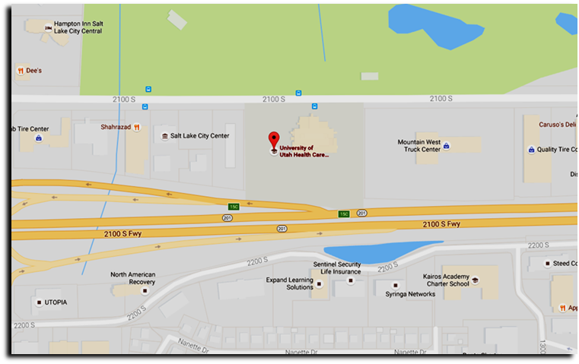
UNIVERSITY OF UTAH REDWOOD HEALTH CENTER OCCUPATIONAL MEDICINE
1525 W. 2100 S. Salt Lake City UT, 84119

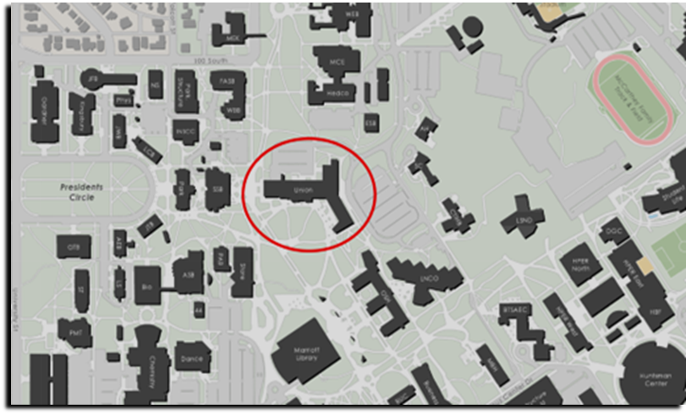
REDMED EMPLOYEE HEALTH CLINIC
200 Central Campus Dr. Salt Lake City, UT 84112

Appendix 3: SPILLS OR EXPOSURE EVENT REPORTING PROCEDURE

Any significant problems, violations of the NIH Guidelines, or any significant research-related accidents and illnesses must be reported to the IBC so that a report can be sent to the NIH Office of Science Policy (OSP) within 30 days. Certain types of accidents must be reported on a more expedited basis. Spills or accidents in BL2 laboratories resulting in an overt exposure must be immediately reported to the IBC and OSP. Spills or accidents occurring in high containment (BL3 or BL4) laboratories resulting in an overt or potential exposure must be immediately reported to OSP.

Any spill or accident involving recombinant or synthetic DNA research of the nature described in the previous paragraph or that otherwise leads to personal injury or illness or to a breach of containment must be reported to the IBC and OSP. These kinds of events might include skin punctures with needles containing recombinant or synthetic DNA, the escape or improper disposition of a transgenic animal, or spills of high-risk recombinant materials occurring outside of a biosafety cabinet. Failure to adhere to the containment and biosafety practices articulated in the NIH Guidelines must also be reported to IBC and OSP.

In addition, exposure to Infectious Agents or Other Potentially Infected Material should be reported to the IBC.

Minor spills of low-risk agents not involving a breach of containment that were properly cleaned and decontaminated generally do not need to be reported. If the investigator, or other institutional staff are uncertain whether the nature or severity of the incident warrants reporting, contact the Biosafety Officer who can assist in making this determination, with guidance from OSP, if necessary.

Please complete the form below and submit to the Biosafety Officer (801-581-6590).

SPILL OR EXPOSURE EVENT REPORT

If a spill or exposure to Recombinant DNA or Synthetic Nucleic Acid Molecules, Infectious Agents or Other Potentially Infected Material occurs in your laboratory, please complete the following information and provide to the Biosafety Officer at biosafety@ehs.utah.edu. This will serve as a record of the event and be used for NIH OSP reporting, if necessary.

Incident Investigation Report
Instructions: The supervisor of the employee is requested to complete this form thoroughly within 24 hours after the event, although some investigations may take longer. If you have questions contact EHS at 1-6590
Employee Name: |  |  | Date of Incident:
Employee Job Title: |  |  | Date Reported:
Employee Dept.: |  |  | Investigation Date:
Supervisor Name: |  |  | Building:
Supervisor Job Title: |  |  | Room #:
Injury Type (strain, cut, etc.): |  |  | Body Part:
Preliminary Root Cause Analysis For Consideration (check all that apply)
Contributing Actions |  |  | Contributing Conditions
Use of safety devices |  | Recapped needle | Housekeeping |  |  |  | Exposure
Use of PPE |  | Material Handling | Condition of surface |  |  |  | Noise
Equipment condition |  | Use of tools | Ergonomic issue |  |  |  | Chemicals
Appropriate equipment use |  | Warning method | Guards/barriers |  |  |  | Fire/explosion hazard
Procedural issues |  | Type of clothing | Tools/equipment |  |  |  | Radiation
Speed of operation |  | Authorization issue | Tools/Equipment not available |  |  |  | Sharp object
Lifting technique |  | Awareness | Lighting/Temp/Ventilation |  |  |  | Inclement weather
Operator skill |  | Lost balance | Work area |  |  |  | Training
Other:
Root Cause Narrative: Based on your analysis, please describe what caused this incident. (If more in-depth analysis is needed, use the 5-Why process below).
5-Why Root Cause Analysis
By repeatedly asking the question “Why” (five is a good rule of thumb), you can peel away the layers of symptoms which can lead to the root cause of a problem. Example: Someone slipped and fell. (the problem)
- Why? - The floor was wet. (first why)
- Why? - The weather was bad and people tracked snow into the building. (second why)
- Why? - The floor tile was not slip-resistant and did not absorb moisture. (third why)
- Why? - The floor mats that are normally put out during bad weather were not put down. (fourth why)
- Why? - The person that puts out floor mats during bad weather was absent that day and no one assumed his duties. (fifth why, a root cause)
Why 1:
Why 2:
Why 3:
Why 4:
Why 5:
Possible Corrective Actions For Consideration (check those items that will help prevent recurrence)
Isolate & guard the hazard |  | Procedure change |  | Gloves |  |  | Hard hat
Automate a manual process |  | Safety training |  | Respirator |  |  | Face shield
Design out/remove hazard |  | Add signs/warning labels |  | Safety glasses |  |  | Cut/Puncture resistant clothing
Ventilation |  | Improve housekeeping |  | Safety shoes
 |  | New/different tools/equip |  | Hearing protection |  |  | Lab Coat
Other:

Incident Description: Please provide a detailed description of the incident. If possible, have the employee re-create the incident; including who, what, when, where, and why. If more space is needed use blank pages for additional description. Attach photos, if appropriate.
Agent (Recombinant Lentivirus, recombinant adenovirus, etc);
Gene encoded by vector:
Known Oncogene or predicted to increase risk of oncogenesis (Y or N):
Amount exposed (pfu, µl, etc: if known):
Did the affected individuals need medical treatment and, if so, where were they treated?
Narrative of post exposure/spill response (please describe disinfectant agents, washing of exposed sites, PPE worn during clean up, etc.) and whether the employee visited an Occupational Medicine clinic

For work involving recombinant or synthetic nucleic acids:
Is the work NIH funded?
If yes, please provide the grant number, NIH funding institute or center, NIH program officer contact information (name, email etc):

If the incident involves a sharps injury, complete a sharps injury log:

Sharps Injury Log

Laboratory Name:________________ Year 2_____

Date | Case/  Report # | Type of Device (e.g. syringe, suture needle) | Brand Name of Device | Work Area where injury occurred (e.g. Geriatrics, Lab) | Brief description of how incident occurred (i.e., procedure being done, action being performed (disposal, injection, etc.), body part injured)

29 CRF 1910.1030, OSHA’s Bloodborne Pathogens Standard, in paragraph (h)(5), requires an employer to establish and maintain a Sharps Injury Log for recording all percutaneous injuries in a facility occurring from contaminated sharps. The purpose of the Log is to aid in the evaluations of devices being used in healthcare and other facilities and to identify problem devices or procedures requiring additional attention or review. This log must be kept in addition to the injury and illness log required by 29 CFR 1904. The Sharps Injury Log should include all sharps injuries occurring in a calendar year. The Log must be retained for five years following the end of the year to which it relates. The Log must be kept in a manner that preserves the confidentiality of the affected employee.

Appendix 4: Hepatitis B Virus Vaccination Attestation/Declination Form*
OSHA has stated that employers are required to maintain an accurate copy of each employee's hepatitis B vaccination status, including the dates of all the hepatitis B vaccinations [29 CFR 1910.1030(h)(1)(ii)(B)]. Your Principal Investigator/Supervisor must keep a copy of your Vaccination Status or Declination with their laboratory Exposure Control Plan.

I understand that all employees who are reasonably anticipated to come into contact with human blood or OPIM during their normal duties must complete this form. I acknowledge that I have been provided with a copy of the CDC Hepatitis B Vaccine Information Statement. I have read and understood the information provided to me. Please check any of the boxes that apply:

- I have already received the hepatitis B vaccination series. Please list the date (or approximate date) of each vaccination and provide proof of vaccinations to your Principal Investigator/Supervisor, who should keep this on file:

1st dose: (Month / Year)
2nd dose: (Month / Year)
3rd dose: (Month / Year)
Titer: (Month / Year)

Please note, that if you currently receiving the vaccine series, complete the dates for the doses that you have received and, once additional doses have been administered, update the form and provide copies to your Principal Investigator AND EHS (Biosafety@OEHS.utah.edu).

- I have undergone antibody testing that has revealed I am already immune to hepatitis B virus:

Date or Approximate Date: (Month / Year)

- I have been informed that the hepatitis B virus vaccine is contraindicated for medical reasons:

Date or Approximate Date: (Month / Year)

If none of the above boxes is checked, complete the options on the next page:

- I would like to receive the hepatitis B vaccination series. The University of Utah has provided me with information on how to receive the vaccination free-of-charge through the University of Utah Student Health Services. I understand this includes three injections at prescribed intervals over a 6-month period. I understand that there is no guarantee that I will become immune to hepatitis B and that I might experience an adverse side effect as the result of the vaccination. I acknowledge that I must provide proof of vaccinations to my employer as they are received. Contact EHS at 801-581-6590 to arrange vaccination.

Complete this section when vaccinated and provide to your Principal Investigator/supervisor and EHS:
1st dose: (Month / Year)
2nd dose: (Month / Year)
3rd dose: (Month / Year)
Titer: (Month / Year)

- I do not wish to receive the hepatitis B vaccine. I understand that due to my occupational exposure to blood or OPIM I may be at risk of acquiring hepatitis B virus (HBV) infection. I have been given the opportunity to be vaccinated with hepatitis B vaccine, at no charge to myself. However, I decline hepatitis B vaccination at this time. I understand that by declining this vaccination, I continue to be at risk of acquiring hepatitis B, a serious disease. If in the future I continue to have occupational exposure to blood or OPIM and I want to be vaccinated with hepatitis B vaccine, I can receive the vaccination series at no charge to me.

Employee Name (print):

Employee Signature:

Employee's Department (print):

University of Utah Employee E Mail (print):

Principal Investigator/Supervisor (print):

Principal Investigator/Supervisor e mail (print):

Date:

Original: Maintained by PI/Supervisor or Designee
Copy: Employee and EHS
* Pursuant to 29 CFR 1910.1030(f)(2)
Appendix 5: Safe Sharp Review Log

The Needlestick Safety and Prevention Act (the Act) (Pub. L. 106-430) was signed into law on November 6, 2000. Because occupational exposure to bloodborne pathogens from accidental sharps injuries in healthcare and other occupational settings continues to be a serious problem, Congress required modification of OSHA's Bloodborne Pathogens standard (29 CFR 1910.1030) to set forth in greater detail (and make more specific) OSHA's requirement for employers to identify, evaluate and implement safer medical devices such as needleless systems and sharps with engineered sharps protections. All laboratories working with blood or OPIM and with sharps must complete and document an annual review of the availability of safer alternatives. If safer viable alternatives are identified they must be adopted.

This form (or equivalent) must be completed on an annual basis by any University of Utah Facility/laboratory that performs sharps-related procedures on human samples or other potentially infectious material. Contact the BioSafety Office at (801) 581-6590 if you have questions or need further information. ). NOTE: Sharps are not allowed when BSL2+ procedures/containment are being followed, but may be used on other occasions within the BSL2 suite.

Reviewer’s Name: Job Title:

Department/Clinic: Date:

Supervisor/PI Name: Telephone #:

In accordance with OSHA’s application of the “Needlestick Safety & Prevention Act”, all sharps that are being used where there is exposure to human blood or OPIM must be reviewed on an annual basis. This includes all needles, syringes with needles, scalpels, capillary tubes, and lancets. During your annual review of devices, you must inquire about new or prospective safer options.

The purpose of this form is to document:
- Sharps devices currently in use;
- The criteria used in the selection of the safer sharps devices in use, and;
- Annual consideration of new safer sharps devices.

Complete the table below as completely as possible to document the sharps devices that are being used. Use multiple pages if necessary.

This review form must be maintained with your safety records.

 | Device #1 | Device #2 | Device #3
Name of Sharps Device

Manufacturer

Model/Size in Use

Procedures Performed

*Safer Sharps Device?
(Y/N)
Description of Safety Feature
Justification for Selection (must consider newly marketed safer sharps devices

*A justification must be documented (below) for any device that does not meet the criteria of a safer sharps device (see Sharps with engineered sharps injury protection definition below). Acceptable justifications include, but are not limited to:
- Use of a safer sharps device will jeopardize patient or employee safety.
- Use of a safer sharps device is medically inadvisable.
- Market unavailability of an appropriate safer sharps device.

Note that cost is not typically an acceptable justification.

Sharps with engineered sharps injury protection: This includes non-needle sharps or needle devices containing built-in safety features that are used for collecting fluids or administering medications or other fluids, or other procedures involving the risk of sharps injury. This description covers a broad array of devices, including:
- Syringes with a sliding sheath that shields the attached needle after use;
- Needles that retract into a syringe after use;
- Shielded or retracting catheters
- Intravenous medication (IV) delivery systems that use a catheter port with a needle housed in a protective covering.
Description of procedure and justification for not using safer sharps device:

Appendix 6 Model Lentivirus Protocol

This protocol is an example of a comprehensive SOP for generating and using recombinant lentiviral particles. It is provided as an example of a well-written and thorough SOP. Replace with your own lab SOPs

- Containment:
All manipulations will be performed in a type II Biological Safety Cabinet at BSL2 enhanced levels of containment. The following personal protective equipment (PPE) will be required:
- Disposable rear closing lab coat: if sleeve cuffs are not tight, disposable sleeve covers must be worn.
- Two pairs of Gloves
- Safety glasses or goggles.
- Long pants and closed shoes

- Preparation of Concentrated Lentiviral Particles

1. Expand HEK 293T cells in DMEM media supplemented with 10% FBS (heat inactivated) in 10 cm tissue culture dishes. The cells are cultured at 37 °C in 5% CO₂.
For unknown reasons, high passage HEK 293T cells do not produce high titer lentivirus. It is best to obtain a fresh stock of HEK 293T from ATCC rather than acquire stocks from other laboratories. Also, cryopreserve early passage cells and thaw a fresh stock for the generation of high titer lentivirus.
- Aspirate the media and wash each plate with 5 ml of PBS.
- Add 1 ml/plate of trypsin and incubate for 2-5 min. Gently pipette up and down to mix the trypsin solution.
- Add 10 ml/plate of DMEM media supplemented with 10% FBS (heat inactivated) and determine the number of cells per ml using a hemocytometer.
- Plate 4-7 x 10⁶ cells into each 10 cm tissue culture dish and adjust the volume of each plate to 10 ml with DMEM media supplemented with 10% FBS (heat inactivated). Culture the cells overnight at 37°C in 5% CO₂.
Alternatively a confluent 10cm plate of HEK293T cells can be re-plated at a 1:10 dilution and cultured for 2-5 days until they are approximately 90% confluent. A typical procedure utilizing 24 10cm plates yields approximately 0.9-1.2 ml of a solution containing between 5.0 x10⁷ to 5.0 x10⁸ infectious units/ml (IU/ml).
- Aspirate the media and add 8 ml/plate of DMEM media supplemented with 10% FBS (heat inactivated) that has been pre-warmed to 37°C and culture for 2 h.
- Prepare PEI at 1 mg/ml (w/v) in deionized sterile water.
The transfection procedure described in this protocol is optimized for PEI (Huh et al., 2007). The PEI solutions can be aliquoted into 1.5 ml microcentrifuge tubes and stored at -20°C for up to a year. If a different transfection reagent will be used, optimization will be necessary.
- Add 720 µl of the 1 mg/ml (w/v) PEI solution to 11.28 ml of OPTI-MEM media in a 50 ml conical tube, which yields a solution sufficient to transfect 24 plates (30 µg of PEI per plate in 500 µl of OPTI-MEM).
The volume can be adjusted depending on the number of plates utilized.
- Prepare a solution of plasmids in a separate 15 ml conical tube, which is enough to transfect 24 plates, by adding 120 µg of pHIV-Luc-ZsGreen (5 µg/plate), 40.8 µg of pMDLg/pRRE (1.7 µg/plate), 40.8 µg of pRSV-Rev (1.7 µg/plate), and 40.8 µg of pCMV-VSV-G (1.7 µg/plate) to a final volume of 12 ml of OPTI-MEM media (500 µI/plate).
It is important to utilize plasmid solutions at >0.5 µg/µl since lower concentrations can dilute the media/DNA solution and decrease the transfection efficiency. In addition, to achieve high viral titers, it is necessary to mix all four plasmids together before mixing with the PEI solution.
- Add 12 ml of the plasmids/OPTI-MEM to the 12 ml of PEI/OPTI-MEM and mix. Incubate the solution for 30 min at room temperature.
- Add 1 ml/plate dropwise of the PEI and plasmid OPTI-MEM solution, gently swirl the plates and culture cells with solution for 24 h at 37 °C in 5% C0₂.
- Every time before working with solutions containing virus, place a large beaker containing >50 ml of bleach in a biosafety cabinet to disinfect any media and pipettes (make sure the final concentration of bleach is >10% before removing it from the biosafety cabinet).
Appropriate personal protection equipment are required. Tubes containing virus can only be opened in a biosafety cabinet. Sealed tubes must he sprayed with 70% ethanol solution before removal from the biosafety cabinet.
- Remove the media from each plate and transfer it to the beaker containing bleach. Add 8 ml/plate of DMEM media containing 10% FBS (heat inactivated) that has been pre-warmed to 37°C and incubate overnight at 37°C in 5% CO₂.
- 48 h post transfection, remove the media from each plate and transfer it to a 50 ml conical tube on ice. Immediately add 8 ml/plate of fresh pre-warmed DMEM media containing 10% FBS (heat inactivated) to each plate and culture overnight at 37 °C in 5% CO₂.
The transfection efficiency can be estimated at this stage by using a tissue culture microscope with fluorescence capability and observing the percent of cells fluorescent for Zsgreen. It is advisable that this is performed on an extra plate of cells that are fixed with 4% paraformaldehyde, to inactivate the lentivirus, prior to microscopy. Continue with the concentration procedure only if >50% of the cells are fluorescent. If <50% of the cells are transfected, optimize the transfection procedure before proceeding.
- Centrifuge the 50 ml conical tubes containing the media for 10 min at 2,500 x g at 4°C to pellet any large debris.
- Pass the supernatant through a 0.45 µm cellulose acetate filter and transfer 32 ml (about 4 plates worth) to each of the six ultracentrifuge tubes. Place tubes in titanium buckets on ice. Balance bucket pairs by adjusting the weight with DMEM media (this is done in the biosafety cabinet until the buckets are sealed).
- To pellet the virus, ultra-centrifuge the solution for 1 h 45 min at 112,000 x g at 4 °C using a swinging bucket rotor.
- Carefully remove the supernatant and transfer it to a beaker containing bleach. Immediately (do not let the pellet dry) add 150 µl of DMEM/F12 media to each centrifuge tube on ice. Gently pipette up and down without creating bubbles to dissolve the pellet. Place the ultracentrifuge tubes in a 50 ml conical tube and cap the conical tube to prevent evaporation of the solution. Store the conical tubes at 4 °C overnight.
- The following day, collect the second round of media from the plates (72 h post transfection) and process it in the same manner as steps 14-17.
Add bleach at a final concentration of 10% to the plates, incubate at room temperature for 20 minutes in the biosafety cabinet, and discard plates and media.
- After the ultracentrifugation step 17, remove the supernatant. Resuspend the pellets by transferring the DMEM/F12 solution containing the concentrated virus that was collected 48 h post transfection to each tube. Gently pipette up and down to dissolve the pellet. Place the ultracentrifuge tubes in a 50 ml conical vial to prevent evaporation and incubate at 4 °C for 2 h to ensure the virus is completely dissolved.
- Pipette up and down to resuspend the pellets, being careful to limit bubbles. Combine all of the resuspended pellets into one tube and gently pipet to mix. Aliquot 50-100 µl of the concentrated virus into 500 µl microfuge tubes and store at -80 °C.
The virus solutions are aliquoted to minimize freeze/thaws, which can significantly reduce the number of IU/ml. The virus solutions can be stored for up to 1 year at -80 °C.

- Determining Infectious Units (IU)lml by FACS
- All manipulations will be performed in a type II Biological Safety Cabinet at BSL2 levels of containment. See Section E.1 of this manual for detailed instructions on the use of a BSC.
- The following personal protective equipment (PPE) will be required:
  - Solid Front Lab coat.
  - Double Gloves
  - Safety glasses or goggles.
  - Long pants and closed shoes
- Expand HEK 293T cells in DMEM media supplemented with 10% FBS (heat inactivated) in 10 cm tissue culture dishes.
- Aspirate the media and wash each plate with 5 ml of PBS.
- Add 1 ml/plate of trypsin and incubate for 2-5 min at 37°C in 5% CO₂. Gently pipette up and down to mix the trypsin solution.
- Add 10 ml /plate of DMEM supplemented with 10% FBS (heat inactivated) and determine the number of cells per ml using a hemocytometer.
- Plate 2.0 x 10⁵ cells in each well of a 6 well tissue culture plate and adjust the volume to 3 ml/well with DMEM media supplemented with 10% FBS (heat inactivated). Culture the cells overnight at 37 °C in 5% CO₂.
- Aspirate the media from four wells of the 6 well plate and ad d 1 ml/ well of DMEM media supplemented with 10% FBS ( heat inactivated) that has been pre-warmed to 37°C
- Aspirate the media from the remaining two wells of the 6 well plate and carefully wash with 2 ml/well of PBS so the cells do not detach.
- Add 0.5 ml of trypsin to each of the two wells and incubate for 2-5 min at 37 °C in 5% CO₂. Gently pipette up and down to mix the trypsin solution.
- Add 0.5 ml/well of DMEM media supplemented with 1 0% FBS and determine the number of cells present in each well independently using a hemocytometer. Calculate the average number of cells present in each of the two wells. This number will be used to determine the IU/ml.
- Thaw an aliquot of concentrated virus in the biosafety cabinet.
- Dilute the virus solution 1:10 in DMEM medium supplemented with 10% FBS (heat inactivated). For example, add 8 µl of virus solution to 72 µl of media.
- Add different amounts of the diluted virus to each of the remaining four wells as described below, gently mix and culture overnight.
  - No virus control
  - 1 µl of diluted virus (1:10,000 final dilution)
  - 10 µI of diluted virus (1: 1,000 final dilution)
d) 50 µI of diluted virus (1:200 final dilution)
The final dilution values are based upon the use of a 1:10 initial dilution of the virus and 1 ml of media in each well. Different dilutions are required since a sample containing <15% ZsGreen positive cells determined by FACS is required to more accurately calculate the IU/ml.
- Remove the media 24 h post infection and aspirate into bleach. Add 3 ml/well of DMEM media supplemented with 10% FBS that has been pre-warmed to 37°C and culture for 2 additional days.
- Remove the media 72 h post infection and aspirate into bleach. Carefully wash the wells with 2 ml/well of PBS so the cells do no detach.
- Add 0.5 ml/well of trypsin and incubate for 2-5 min. Gently pipette up and down to mix the trypsin solution.
- Transfer the cell suspension to a 15 ml conical tube on ice. Wash each well with 1 ml of HBSS containing 2% FBS and transfer this solution to the respective 15 ml conical vial.
- Add paraformaldehyde to a final concentration of 2% to each tube and incubate at 4 °C for 20 minutes to inactivate any residual virus that may be present.
- Centrifuge the cells for 5 min at 400 x g at 4 °C.
- Aspirate the supernatant and carefully resuspend the pellet with 1 ml of HBSS containing 2% FBS
- Centrifuge the cells for 5 min at 400 x g at 4 °C
- Aspirate the supernatant and carefully resuspend the pellet with 250 µl of HBSS containing 2% FBS
- Pass the cell suspension through a 100 µm cell strainer and transfer to a FACS tube
- Setup the gates and detector voltages, and analyze samples using the sequential gates described below.
  - SSC vs. FSC: eliminate debris and gate only single cells
  - FLl (ZsGreen) histogram: determine percent ZsGreen positive cells
- Calculate the IU/ml using the formula below.
IU/ml = (average # of cells/well) * (% ZsGreen positive cells/100) *(virus dilution)
The average # of cells/well was determined above in step 9. We typically use a dilution where the cells are <15% Zs Green positive. Titers ranging from 5 x 10⁷ to 5 x 10⁸ IU/ml are commonly achieved using this protocol.
- Decontaminate all materials in the Biosafety Cabinet prior to removal from the cabinet and decontaminate the cabinet as described in Section E.1 of this manual.
- Remove all PPE. Discard disposable PPE as biohazardous waste and disinfect safety glasses.
- Wash hands prior to leaving the BSL-2 suite.

- Transduction of cells
  - All manipulations will be performed in a type II Biological Safety Cabinet at BSL2 levels of containment. See Section E.1 of this manual for detailed instructions on the use of a BSC.
  - The following personal protective equipment (PPE) will be required:
    - Solid Front Lab coat.
    - Double Gloves
    - Safety glasses or goggles.
    - Long pants and closed shoes
  - Seed 250,000 cells per well in a 6-well plate in 0.5 ml of medium.
For suspension infections, use ultra-low attachment plates, and for monolayer infections, use regular tissue culture-treated plates. The best method of infection must be determined empirically for each tumor. For monolayer infections, allow the cells to attach for 24-48 hr prior to adding virus.
  - Add polybrene to a final concentration of 1-4 µg/ml. The actual concentration should be empirically determined using the target cells. Add concentrated lentivirus using a multiplicity of infection (MOI) of 5-20 viral particles/target cell. Add additional medium to bring the final volume to 1 ml per well.
The multiplicity of infection may also have to be optimized for different cells.
  - Replace the virus-containing medium with fresh medium after overnight incubation.
  - Remove the virus medium and add 2 ml of fresh medium.
  - The cells should be handled using BSL-2 procedures until at least 72 hours has passed following infection and medium has been exchanged using at least five washes (50-Fold dilution with each wash).
  - Incubate at 37°C with 5% CO₂. Expression of virus proteins (e.g. ZsGreen) should be detectable by fluorescence microscopy after 72 hours. Feed the cells every day by exchanging the medium. Expand the cells until a sufficient number are obtained for transplantation.
  - Decontaminate all materials in the Biosafety Cabinet prior to removal from the cabinet and decontaminate the cabinet as described on Page XX of this manual.
  - Remove all PPE. Discard disposable PPE as biohazardous waste and disinfect safety glasses.
  - Wash hands prior to leaving the BSL-2 suite.

- Transplantation of lentivirus-transduced cells into mice
  - The following personal protective equipment (PPE) are required:
      - Solid Front Lab coat.
      - Double Gloves
      - Safety glasses or goggles.
      - Long pants and closed shoes
  - Transduced cells should be considered potentially infectious and handled under BSL-2 procedures until they have undergone at least five washes (50-Fold dilution with each wash).
  - Transduced cells will not be transplanted until Step 1 is performed and at least 72 hours has passed following the infection procedure.
  - Cells should be transplanted under ABSL1 conditions following procedures approved by IACUC and by the IBC.
Appendix 7. Testing Lentiviral Vector Stocks for Replication Competent Virus

RCV Test Protocol:

- Harvest fresh vector-infected supernatant (vector stock)
- Clear cells from growth medium by low-speed centrifugation.
- Filter medium through 0.45 µm-pore-size cellulose acetate filters.

- Transduce SupT1* lymphocytes
  - Plate SupT1* cells into a 6 well plate at 10⁵ cells/well in presence of 8 µg/ml of Polybrene (to enhance virus detection) and add 2 ml of RPMI-1640 Medium supplemented with 10% FBS (heat inactivated).
  - Infect SupT1* cells with serial dilutions of vector stock (starting with > 1 mL of unconcentrated supernatant or concentrated equivalent)

- Grow SupT1* cells for 3 weeks or longer (passage as necessary)
  - Harvest supernatant as per above in Step 1.
  - Perform ELISA assay for p24 antigen.
  - Record results for each batch (expressed as infectious units/mL).

Several alternative sensitive end-point assays rather than the ELISA-based p24 Gag antigen assay have been described, including a product enhanced reverse transcriptase (PERT) assay that involves the vector’s reverse transcriptase, a PCR-based assay that detects Psi-Gag sequences from a recombination event between vector and packaging constructs, and PCR-based assays to detect the VSV-G Env used for pesudotyping. All represent acceptable methods for RCV testing.
Appendix 8. Viral Vector Maps

Attach copies of viral packaging and transfer plasmids
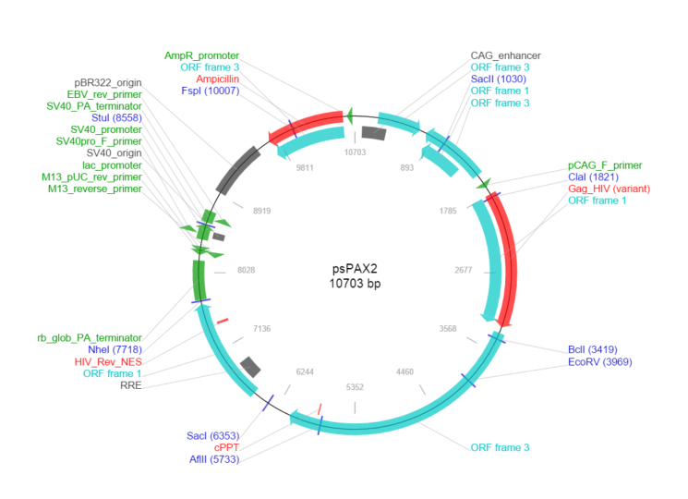

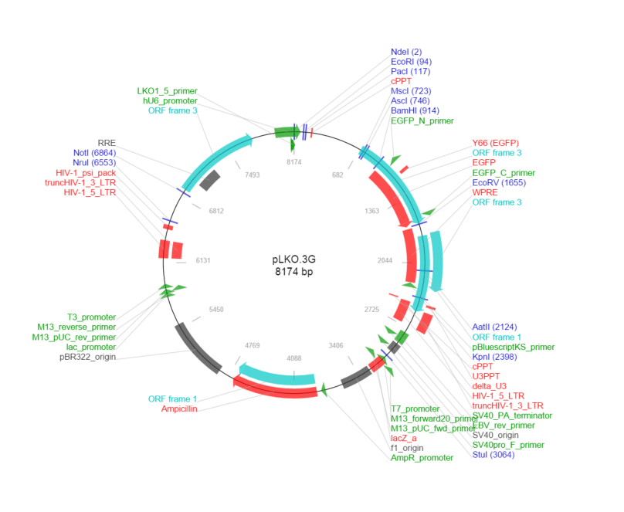
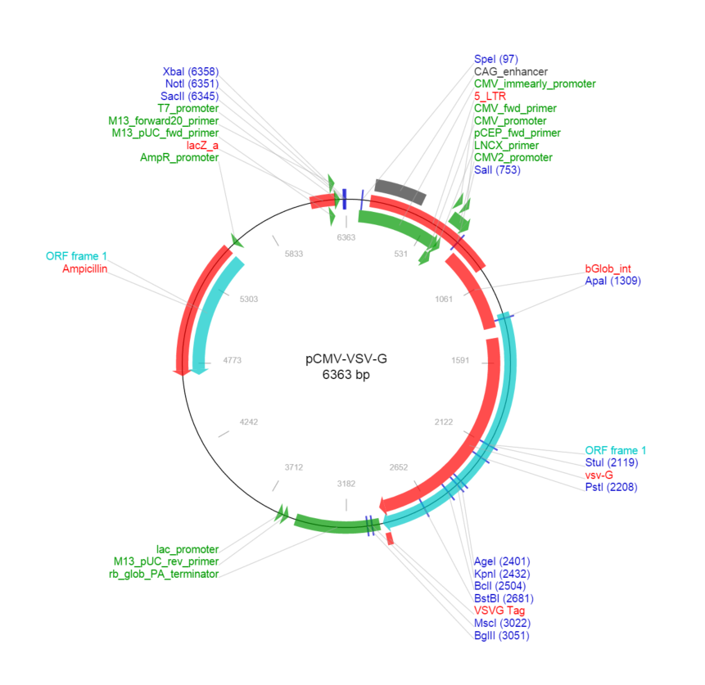

Appendix 9: Gene Editing Questionnaire

- Please specify which gene editing technology is being used (CRISPR/Cas9, Zinc Finger nucleases, TALENS, Meganucleases, other?).
- How is the gene editing technology being delivered to cells (e.g., nanoparticles, plasmid, lentivirus, adeno-associated virus, etc.)?
- What are the gene targets for these experiments?
- Are any of the targets oncogenes, tumor suppressors, or genes involved in cell cycle regulation?
- Are you targeting embryos or germ line cells?
- Are you planning research using gene editing technologies in humans, human embryos, or human germ cells?
(No gene editing of the germ line, human embryos or germ cells for clinical application is allowed. Gene editing of human embryos and germ cells for scientific purpose may be allowed, but must be evaluated on a case-by-case basis by the appropriate federal and local scientific review committees.)
- Please identify the cell types, tissues and/or organisms that are being targeted.
Answer the following questions for studies involving CRISPR/Cas9:
- Are the guide RNA (gRNA) and nuclease encoded on the same plasmid, viral vector or other delivery vehicle? If yes, describe.
- For gene editing research involving viral vectors, have potential off target effects by your gRNA been identified in the human genome? This is helpful in assessing the risk of potential exposure in the event of an incident. The IBC recommends GT Scan (http://bioinformatics.csiro.au/gt-scan/), but other utilities may be used. Please identify which utility you have used and provide a list of off target genes (with up to 3 mismatches).
- Are you performing a “gene drive” experiment?
(A “gene drive” is established when Cas9 and gRNA are flanked by homology arms that match DNA sequences surrounding the genome of the gRNA target site. When such a system is introduced into the germ line of a sexually reproducing species, genomic alterations are continually transmitted to offspring. (Reference: Akbari, Omar S., et al. "Safeguarding Gene Drive Experiments in the Laboratory." Science 349.6251 (2015): 927-9)?
- Does the construct encoding either Cas9 or gRNA also contain DNA with homology to genomic DNA that flanks the gRNA target site? If so, answer the questions below.
  - Will the experiment introduce this construct into the germ line of an organism?
  - Will the experiment result in a transgenic, sexually reproducing organisms?
  - If the answer is yes to both 11 and 11a, provide a complete description of your experiment.
Appendix 10: Biological Toxin SOP
[Customize text in parentheses and brackets to specific procedures and equipment in your laboratory. Please refer to the Biosafety in Microbiological and Biomedical Laboratories, Appendix I: Guidelines for work with Toxin of Biological Origin for more information, https://www.cdc.gov/biosafety/publications/bmbl5/bmbl5_appendixi.pdf#x2013.]

Standard Operating Procedures for [Toxin]
#1 Chemicals/Hazards | [Obtain specific toxin hazard information from MSDS/SDS.]  CAS number: [XXX]  Routes of exposure: [XXX]  How exposure might occur: [XXX]  Target organs: [XXX]  Signs/symptoms of exposure: [XXX]
#2 Prior to Work | Hazardous chemical and specific SOP training will be provided to personnel working with toxin and any other personnel authorized or required to be in the laboratory during toxin work.  Appropriate inactivation method(s) for [toxin] will be determined and supplies for inactivation and spill cleanup of [toxin] will be readily available.  [List vaccinations or antitoxins required or recommended for toxin]. If vaccinations or antitoxins are required, contact Occupational and Environmental Health and Safety at 801-581-6590.
#3 Environmental/  Ventilation Controls | Work with [toxin] will be performed in a [chemical fume hood/Biological Safety cabinet (BSC)]. List the type of BSC to be used (e.g. Class II, Type A2).  In-line HEPA filters will be used on vacuum lines.  Safety centrifuge cups or sealed rotors will be used if centrifuging materials containing [toxin], and the outside surfaces will be routinely decontaminated after each use.
#4 Personal Protective Equipment (PPE) | The following PPE will be worn when working with [toxin]: [Customize list]  - Laboratory coat or gown with long cuffed sleeves  - Disposable lab coat  - Disposable sleeves  - Safety glasses with side shields or chemical safety goggles  - Face protection such as a face shield if splash/spatter possible  - Gloves [type] that are impervious to [toxin] and diluent  - Respiratory protection [if aerosol hazard is present] If respirators are used the worker must be enrolled in the Respiratory protection program; contact EHS for information (http://d2vxd53ymoe6ju.cloudfront.net/wp-content/uploads/sites/4/20160922155338/Resp-Prot-Program-rev.2016.pdf).  Gloves must be changed immediately if contaminated, torn, or punctured.
#5 Special Handling Procedures & Storage Requirements | HANDLING  Prep  - Sign will be posted on the room door when toxin is in use stating: “Toxins in Use -- Authorized Personnel Only.”  - All preparation of [toxin] will be performed over plastic-backed absorbent pads in a [fume hood/BSC]. Pads will be disposed of immediately upon contamination and after completion of tasks.  - Describe how toxin will be prepared: [Example: Vials of [toxin] will be purchased in pre-weighed powder form and then reconstituted in a [fume hood/biological safety cabinet (BSC)]. Weighing the [toxin] is not necessary as reconstitution will occur in the purchased vial and then aliquoted into vials with caps.]  Use  - Only needle locking (Luer-Lock type) syringes or disposable syringe units will be used for injection or aspiration of [toxin].  - A sharps container will be in the immediate vicinity for safe sharps disposal.  - Containers will be decontaminated before they are removed from [fume hood/BSC].  - The [fume hood/BSC] will be decontaminated upon completion of tasks with [decontaminant and concentration] for [contact time].  - All potentially contaminated disposable items will be placed in a hazardous waste bag and decontaminated before disposal.  - Hands will be washed upon completion of tasks.  STORAGE  - [Toxin] will be stored in locked [freezer/refrigerator/cabinet/box/other] in [secure location room #].  TRANSPORT  - [Toxin] will be transported in labeled and sealed non-breakable secondary containers.
#6 Spill and Accident Procedures  [Specific cleaning, decontamination agents (and contact times)/equipment and waste disposal procedures must be determined.] | All spills will be cleaned by properly protected and trained personnel only. Wash hands thoroughly after completing any spill clean-up. If you are not trained or comfortable cleaning up a spill, call EHS for assistance at 801-581-6590. If it is an emergency (risk of exposure to others such as an on-going toxin release), call 911.  Liquid spills:  Personnel cleaning up a liquid spill will wear a lab coat/gown with cuffed sleeves (or disposable sleeves), goggles, and two pairs of nitrile gloves. Cover spill with absorbent paper towels and apply [inactivating agent + concentration], starting at the perimeter and working towards the center, allowing [XX min] contact time to deactivate [toxin]. Clean the spill area with [inactivating agent], then soap and water. The decontaminated spill waste will be double bagged and disposed of in the biohazard waste container.  Powder spills inside of [fume hood/BSC]:  Personnel cleaning up a powder spill will wear a lab coat/gown with cuffed sleeves (or disposable sleeves), goggles, and two pairs of nitrile gloves. Gently cover powder spill with dampened absorbent paper towels to avoid raising dust. Apply [inactivating agent + concentration], starting at the perimeter and working towards the center, allowing [XX min] contact time to deactivate [toxin]. Clean the spill area with [inactivating agent], then soap and water. The decontaminated spill waste will be double bagged and disposed of in the biohazard waste container.  Powder spills outside of a [fume hood/BSC]:  Remove all personnel from the room and restrict access; do not attempt to clean up the spill unless personnel are authorized to use a respirator. If personnel are not cleared to use a respirator, report the spill by notifying EHS (at 801-581-6590). Tell them that a spill has occurred, and you need EHS to assist with the spill cleanup.  Be prepared to provide the following information:  - Name and phone number of knowledgeable person that can be contacted: [emergency contact name and phone number]  - [Toxin name], concentration and amount spilled, liquid or solid spill  - Number of injured, if any  - Location of spill  This information can also be used in reporting to the Emergency Department after potential exposure.  Personnel cleaning up a powder spill will wear a lab coat/gown with cuffed sleeves [or disposable sleeves], goggles, two pairs of nitrile gloves and a respirator. Gently cover powder spill with dampened absorbent paper towels to avoid raising dust. Apply [inactivating agent + concentration], starting at the perimeter and working towards the center, allowing [XX min] contact time to deactivate [toxin]. Clean the spill area with [inactivating agent], then soap and water. The decontaminated spill waste will be double bagged and disposed of in the biohazard waste container.  For questions on spill cleanup, contact EHS at 801-581-6590 for guidance.  Wash hands thoroughly after completing any spill clean-up.
EXPOSURE PROCEDURES  In Case of Emergency | - Provide First Aid Immediately  - For sharps injury (needlestick or subcutaneous exposure), scrub exposed area thoroughly for 15 minutes using warm water and soap.  - For skin exposure, wash the area with soap and water. For large exposures, use the nearest safety shower for 15 minutes. Stay under the shower and remove clothing. Use a clean lab coat or spare clothing for cover-up.  - For eye exposure, use the eye wash for 15 minutes while holding eyelids open.  - For inhalation, move out of contaminated area. Get medical help.  - Get Help  - Call 911 or go to nearest Emergency Department (ED). Give details of exposure, i.e. agent, dose, route of exposure, time since exposure. Bring to the ED the MSDS/SDS and this SOP.  - Notify your supervisor as soon as possible for assistance.  - Secure area before leaving.  - Report Incident to Occupational and Environmental Health & Safety  - If serious accident, hospitalization or fatality, notify EHS immediately after providing first aid and/or getting help.  - Call at 801-581-6590.
#7 Waste Disposal and Cleaning | Any waste [toxin] will be decontaminated or autoclaved as appropriate before disposal or given to EHS for disposal whenever possible.  Work space surfaces must be wiped down after completion of tasks with [inactivating agent + concentration] during the length of the experiment. Absorbent pads will be replaced after completion of tasks or immediately if contaminated. Used and potentially contaminated absorbent pads, PPE, etc. will be placed in a hazardous waste bag and autoclaved.  If in-lab inactivation is not possible for [toxin] waste, it must be managed as hazardous chemical waste. Be aware that some form of treatment in the lab may be required before it can be managed as chemical waste. Contact EHS at 801-581-6590 for disposal instructions. For chemical waste pick up complete a request through the lab management system (http://oehs.utah.edu/topics/lab-management-system).
#8 Special Precautions for Use of [Toxin] in Animals  (This section must be completed if working with toxin in animals)  Identify where animals will be injected, housed and any special precautions/warnings for animal handlers. | Use of toxins in animals will be documented and approved by IACUC.  [Give detailed procedures for safely completing tasks, containment, decontamination information, and any special disposal requirements.]  [Animals will be anesthetized or placed into a restraining apparatus before procedures using [toxin] are performed. Once the animal has been properly fitted into the restraining apparatus, the syringe will be loaded just prior to injection.]  After procedures are complete, the restraining apparatus and surrounding work station will be decontaminated [inactivating agent + concentration]. All reusable lab equipment will be autoclaved.  [Give any special disposal requirements]
#9 Approval Required | The protocol must be approved by the Institutional Biosafety Committee prior to commencement. All staff working with [toxin] must be trained on this SOP prior to starting work. They must also be trained on the [toxin] MSDS/SDS, and it must be readily available in the laboratory. All training must be documented and maintained by the PI.
#10 Decontamination | All surfaces will be decontaminated with [inactivating agent + concentration] after removing the plastic backed pads. All reusable lab equipment will be autoclaved. Note that some disinfecting agents may not deactivate [toxin].
#11 Designated Area | All work with [toxin] must be done in a designated laboratory, work space and [fume hood/BSC]. Signage must be placed on door to room when [toxin] is used. This work will be conducted in [Room #]

Appendix 11: Agent Summary Statement

The BMBL contains summary statements for many bacteria, viruses, and zoonotics. If your agent is listed in the BMBL‘s Agent Summary Statements section (http://www.cdc.gov/biosafety/publications/bmbl5/index.htm), you may find it useful to paste it into the biosafety manual. Data on Salmonella typhimiruim is provided as an example

Salmonella typhimiruim

Salmonellae are gram-negative enteric bacteria associated with diarrheal illness in humans. They are motile oxidase-negative organisms that are easily cultivated on standard bacteriologic media, although enrichment and selective media may be required for isolation from clinical materials. Recent taxonomic studies have organized this genus into two species, S. enterica and S. bongori, containing more than 2500 antigenically distinct subtypes or serotypes. S. enterica contains the vast majority of serotypes associated with human disease. S. enterica serotypes Typhimurium and Enteritidis (commonly designated S. Typhimurium and S. Enteritidis) are the serotypes most frequently encountered in the United States. This summary statement covers all pathogenic serotypes except S. Typhi.

Occupational Infections
Salmonellosis is a documented hazard to laboratory personnel. Primary reservoir hosts include a broad spectrum of domestic and wild animals, including birds, mammals, and reptiles, all of which may serve as a source of infection to laboratory personnel. Case reports of laboratory-acquired infections indicate a presentation of symptoms (fever, severe diarrhea, abdominal cramping) similar to those of naturally-acquired infections, although one case also developed erythema nodosum and reactive arthritis.

Natural Modes of Infection
Salmonellosis is a food borne disease of worldwide distribution. An estimated 5 million cases of salmonellosis occur annually in the United States. A wide range of domestic and feral animals (poultry, swine, rodents, cattle, iguanas, turtles, chicks, dogs, cats) may serve as reservoirs for this disease, as well as humans. The most common mode of transmission is by ingestion of food from contaminated animals or contaminated during processing. The disease usually presents as an acute enterocolitis, with an incubation period ranging from 6 to 72 hours.

Laboratory Safety and Containment Recommendations
The agent may be present in feces, blood, urine, and in food, feed, and environmental materials. Ingestion or parenteral inoculation are the primary laboratory hazards. The importance of aerosol exposure is not known. Naturally or experimentally infected animals are a potential source of infection for laboratory and animal care personnel, and for other animals

Strict compliance with BSL-2 practices, containment equipment, and facilities are recommended for all activities utilizing known or potentially infectious clinical materials or cultures. This includes conducting procedures with aerosol or high splash potential in primary containment devices such as a BSCs or safety centrifuge cups. Personal protective equipment should be used in accordance with a risk assessment, including splash shields, face protection, gowns, and gloves. The importance of proper gloving techniques and frequent and thorough hand washing is emphasized. Care in manipulating faucet handles to prevent contamination of cleaned hands or the use of sinks equipped with remote water control devices, such as foot pedals, is highly recommended. Special attention to the timely and appropriate decontamination of work surfaces, including potentially contaminated equipment and laboratory fixtures, is strongly advised. ABSL-2 facilities and practices are recommended for activities with experimentally infected animals.

Special Issues
Transfer of Agent Importation of this agent may require CDC and/or USDA importation permits. Domestic transport of this agent may require a permit from USDA/APHIS/VS. A DoC permit may be required for the export of this agent to another country. See Appendix C of the BMBL for additional information.

Appendix 12: Post-Exposure Fact Sheet

This is an example of a post exposure procedure for working with pathogenic organisms: edit as necessary. Relevant information can be found in Pathogen Safety Data Sheets (PSDSs), technical documents that describe the hazardous properties of a human pathogen and recommendations for work involving these agents in a laboratory setting. These documents have been produced by the Public Health Agency of Canada (the Agency) as educational and informational resources for laboratory personnel working with these infectious substances. PSDSs can be found at http://www.phac-aspc.gc.ca/lab-bio/res/psds-ftss/index-eng.php

Post-Exposure Procedures:
Salmonella typhimiruim

Characteristics: Family Enterobacteriaceae; gram negative rod; motile, aerobic and facultatively anaerobic; serological identification of somatic and flagellar antigens; over 2000 serotypes capable of causing disease.

Incubation Period: Six to 72 hours, usually about 12-36 hours

Symptoms: Salmonellosis is an acute gastroenteritis; acute infectious disease with sudden onset of abdominal pain, diarrhea, nausea and vomiting; may progress to more serious septicemia, includes focal infections, abscesses, endocarditis, pneumonia; may also cause typhoid like enteric fever; some cases develop reactive arthritis (Reiter's syndrome) which may become chronic

Infectious Dose: 100 - 1,000 organisms - ingestion; varies with multiple factors

What is a potential exposure? Ingestion, needlestick or cut with contaminated sharp object, splash to the eye, contact with broken skin.

Post-Exposure Treatment: Skin exposure / Percutaneous: Wash affected area with antibacterial soap and water (apply antiseptic (3% H₂O₂) if available), report to the Occupational Medical Clinic at the Redwood Health Center. Mucous membrane exposure (splash to eye): flush eyes for 15 minutes using eyewash, then report to Occupational Medical Clinic. Ingestion: Report to the Occupational Medical Clinic. Antibiotic therapy may be required. If the Health Center is closed, go to the University of Utah Hospital Emergency Room.

If symptoms appear with no known incidence of exposure: Seek medical attention and inform the health care provider of the microorganisms used in the workplace.

Prevention: Biosafety level 2 practices, containment equipment, and facilities; wear lab coat and gloves; frequent handwashing is essential. Never eat in the lab. Caution should be used with sharps.

Reporting: Make note of the date and time of the incident and any relevant details. Inform principal investigator, fill out an Incident Report Form (https://ehs.utah.edu/incident-report), and contact EHS (1-6590). If recombinant, the incident must be reported to NIH Office of Biotechnology Activities.

Appendix 13: Use and Disposal of Sharps

To prevent needle stick injuries:

- Do not recap needles by hand. RECAPPING OF NEEDLES IS PROBHIBETED.
- Do not remove needles from syringes by hand.
- Do not bend, break, or otherwise manipulate needles by hand.
- Avoid using needles whenever possible.
- Replace glass materials with plastic (such as Pasteur pipettes)
- Immediately after use, discard needle and syringe (whether contaminated or not) into puncture resistant sharps containers. RECAPPING OF NEEDLES IS PROHIBITED.
- Use a Food and Drug Administration (FDA)-cleared sharps container if you generate sharps waste (pictured below). A description of FDA-Cleared Sharps containers can be found here. FDA-cleared sharps disposal containers are made from rigid plastic, come marked with a line that indicates when the container should be considered full, which means it’s time to dispose of the container, and have the Universal Biohazard symbol.
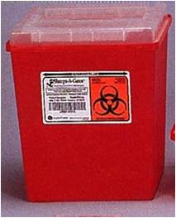
- Never discard sharps into regular trash.
- Never discard sharps into bags of biological waste.
- Use care and caution when cleaning up after procedures that require the use of syringes and needles.
- Do not overfill sharps containers. Close completely when 3/4 full, request pickup from the EHS through the Lab Management System (LMS) webpage at https://ehs.utah.edu/research-safety/lab-management-system.
- Locate sharps containers in areas in which needles are commonly used. Make containers easily accessible.
- Replacement sharps containers may be obtained through the LMS or can be from laboratory supply distributors such as VWR and ThermoFisher. Be sure to select sharps containers that withstand autoclaving.

In the event of a needle stick injury:

Wash the area thoroughly with soap and water. Notify supervisor immediately, report to the Occupational Medical Clinic at the Redwood Health Center and fill out an Incident Report Form, as soon as possible: see Appendix 2.

Contaminated Serological Pipets and Pipet Tips
Serological pipets (glass and plastic) and disposable pipet tips are considered puncture hazards and should be disposed of as sharps. Contaminated pipets and tips should be discarded in approved sharps containers, as described above.

Due to the large size of serological pipets, investigators disposing of large numbers of these can request 20 gallon hard-sided biohazard waste containers (pictured below) from EHS through the LMS. These will be picked up by EHS staff as for other biohazardous waste.

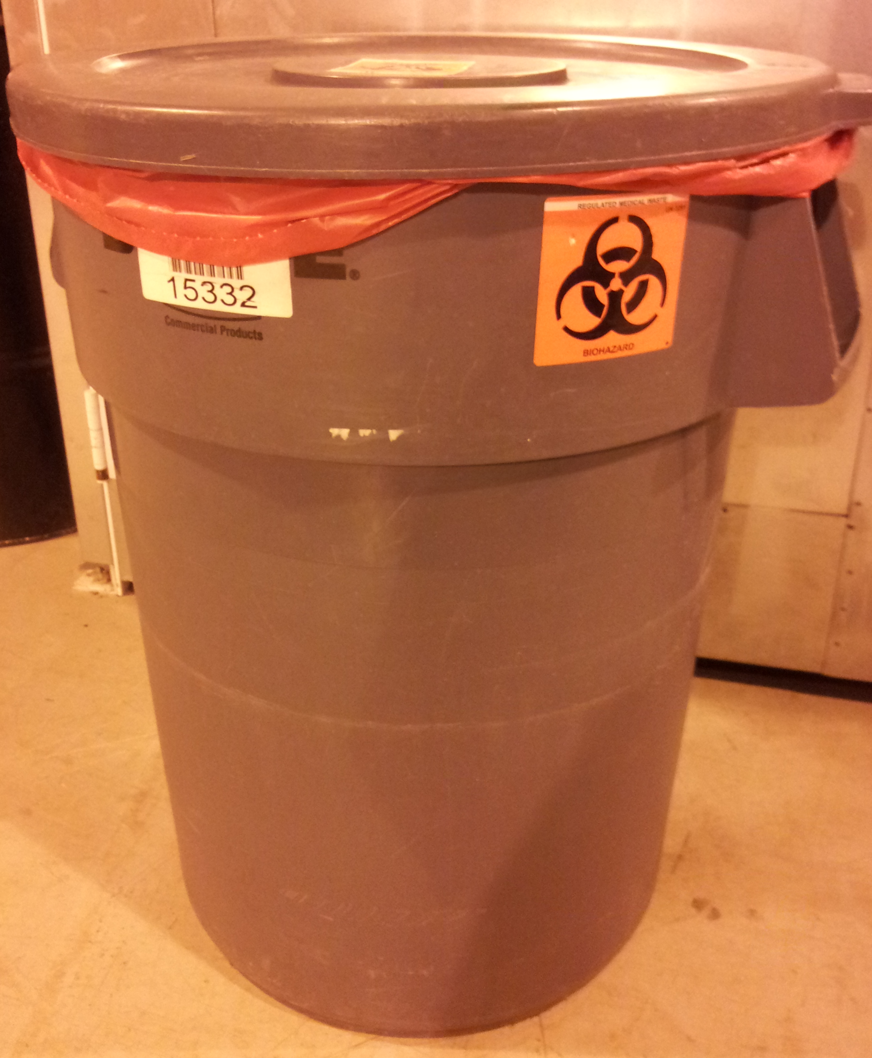
20 Gallon Waste Container

Decontaminated Serological Pipets and Pipet Tips
It is possible to decontaminate serological pipets and tips prior to disposal. Ensure that both the inside and outside of the pipets or tips are exposed to the approved disinfectant (e.g. a freshly prepared 1:10 dilution of bleach) for at least 20 minutes. However, serological pipets and disposable tips are still considered puncture hazards. Therefore, after removing the disinfectant, they can be disposed of in a Broken Glass box (rigid puncture resistant boxes lined with a plastic bag and labeled “Broken Glass”: pictured below), which can be obtained from your custodial staff or from EHS. Once they are 2/3 full they should closed with tape and disposed as regular trash by your custodians.
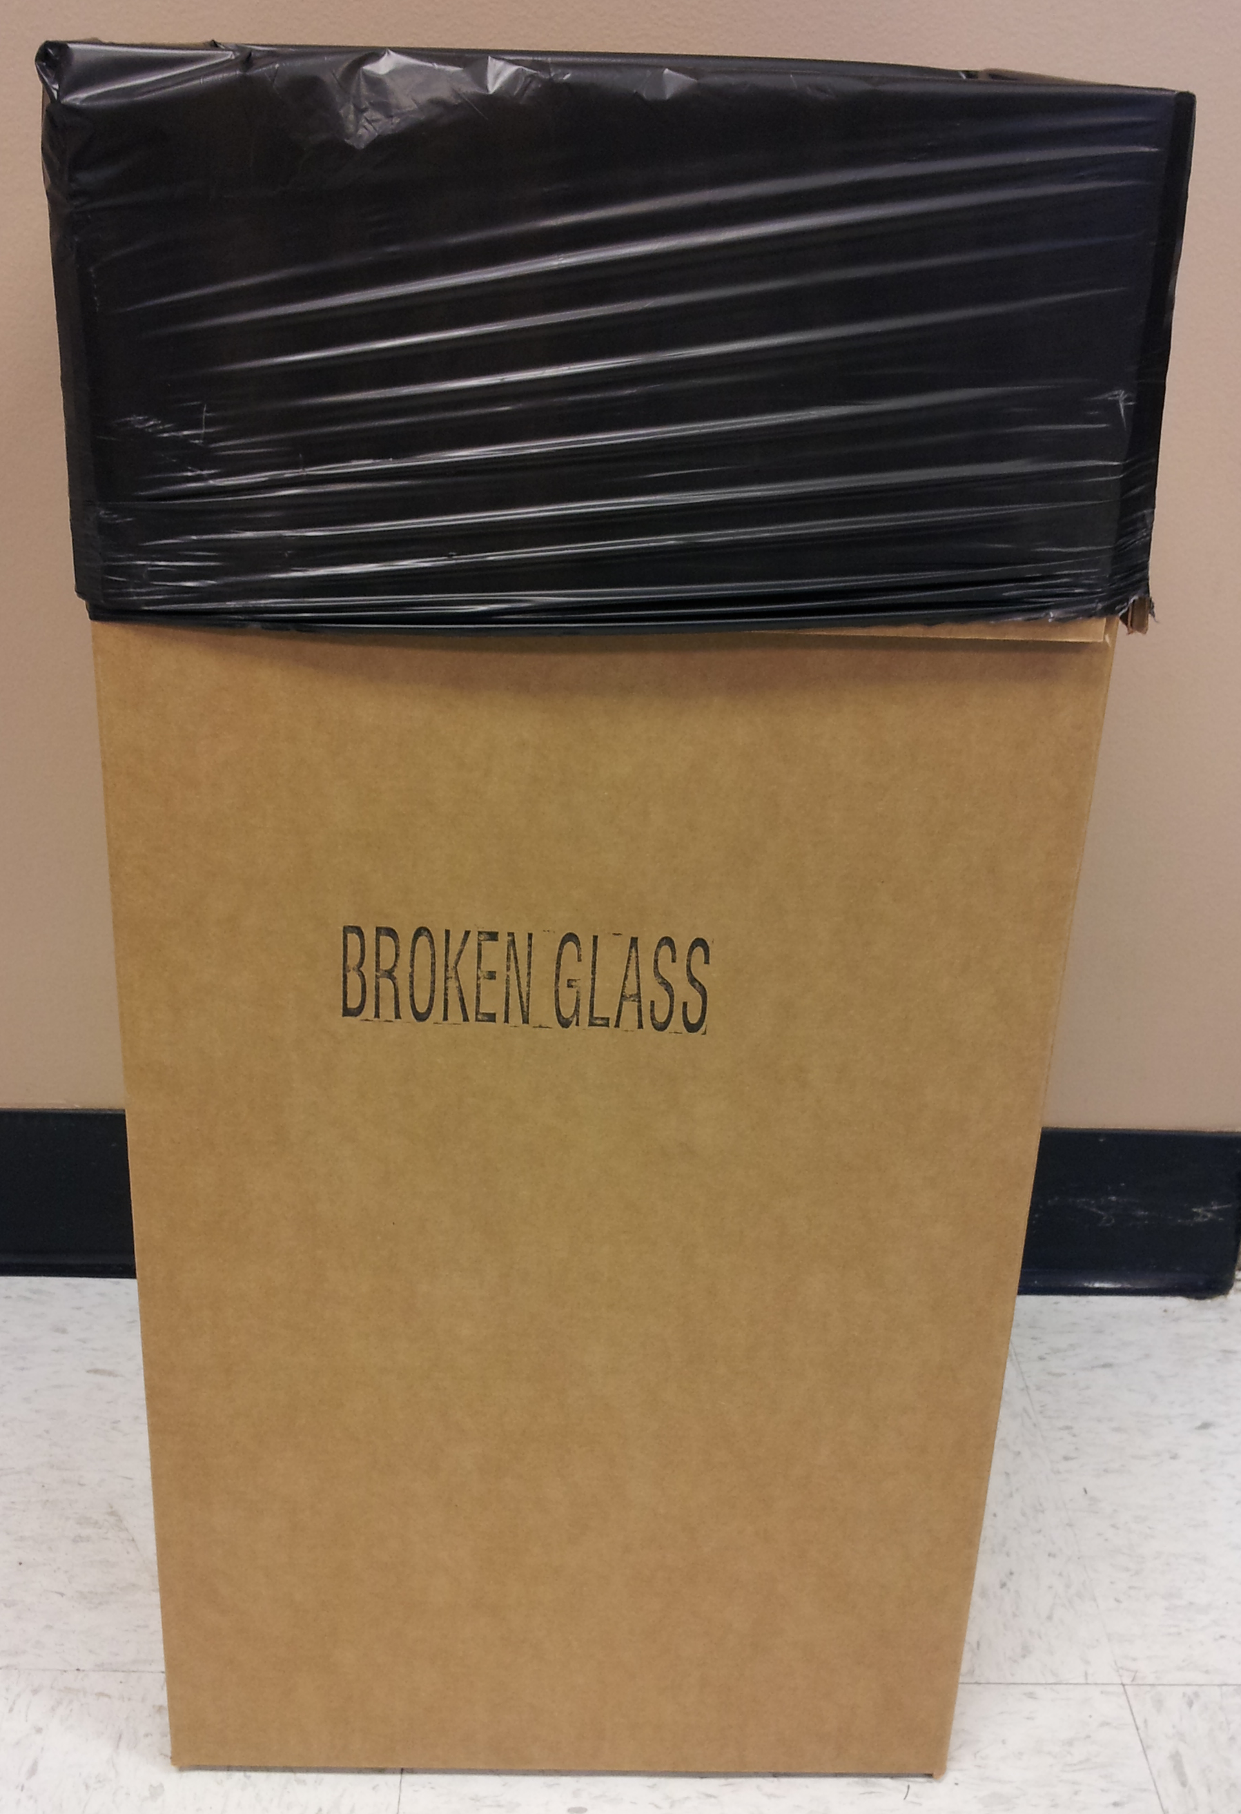
Broken Glass Box
Appendix 14: Disposal of Biohazardous Waste

Biowaste Disposal – Solids
The Department of Environmental Health and Safety (EHS) Lab Management System (LMS) allows research investigators to request hazardous material pickups by EHS staff and request empty containers. Please visit the LMS website for information.

Waste containers obtained from EHS are solid sided, leak proof, lined with red biohazard bags, and labeled with a biohazard symbol. Keep the container lid closed unless someone is working nearby and regularly adding waste to the container.

When the red bag is ¾ full, loosely tie or tape the bag closed. Secure the lid on the waste container and move it to a convenient storage location or transport it to a biohazardous waste storage room, if available. Biohazardous waste must be moved or transported inside a rigid, leak- resistant, labeled container with the lid closed. Request a pickup from your lab using the LMS.

If you have an autoclave available for disinfection of biohazardous waste, place a red biohazard bag in a solid puncture resistant container. Place a Ziploc bag or balloon containing water in the bag when it is about half full to generate steam during autoclaving. When the red bag is full, tie or tape the bag closed. Secure the lid on the waste container and move it to the autoclave room.

The bag should be removed and placed in a solid autoclave resistant tray: the bag should NEVER be placed directly on the floor. After the cycle, the bag may be disposed of as regular trash: indicators that the contents have been autoclaved must be present.

Biowaste Disposal – Liquids
Blood, aspirated tissue culture media, or other liquid waste generated from BSL-2 enhanced experiments must be disinfected and then disposed. Bleach is typically used to disinfect liquids, but other agents, such as Wescodyne, may be used if effective.

If you use bleach:
- Ensure the final concentration exceeds 0.5% sodium hypochlorite (no less than one part bleach to 9 parts liquid).
- Ensure the bleach is fresh: in tissue culture media traps change at least twice weekly.
- Ensure the media is exposed to disinfectant for at least 20 minutes prior to disposal.
- Dispose down the sink

If you use Wescodyne:
- Ensure the final concentration exceeds 1% (no less than one part Wescodyne to 99 parts liquid).
- In tissue culture media traps change at least every 3 months (indicate the date of the last change on the flask).
- Ensure the media is exposed to disinfectant for at least 20 minutes prior to disposal.
- Collect waste into containers marked “Unwanted Materials” and date when you start collecting. When full or 6 months after your start date (whichever happens first), arrange pickup by EHS through the LMS website. NO DRAIN DISPOSAL.
If the container will be unattended (outside of your immediate control) then label it with the date, time and the words “Biohazardous liquid” and keep it in a secondary container (for example, a plastic tub) while it is disinfecting.

If you use other agents to decontaminate liquid cultures follow the instructions on the packaging. Contact the Biosafety Officer (801-581-6590) for advice on appropriate disinfectants and procedures for disposal of treated waste.

Mixed liquid and solid biohazardous waste
Mixed liquid and solid waste should be separated in a biosafety cabinet (decant the liquid from the solid). Manage the liquids and solids separately as detailed above.

State of Utah regulations for using Autoclaves for Treating Infectious Waste

Below are sections of the State of Utah Regulations for treating infectious waste that apply to the use of autoclaves. These regulations “R315. Environmental Quality, Waste Management and Radiation Control, Waste Management” came into effect April 2013.

R315-316-5. Infectious Waste Treatment and Disposal Requirements.

(4) Infectious waste may be sterilized by heating in a steam sterilizer to render the waste non-infectious.
(a) The operator shall have available, and shall certify in writing that he understands, written operating procedures for each steam sterilizer, including time, temperature, pressure, type of waste, type of container, closure of container, pattern of loading, water content, and maximum load quantity.
(b) Infectious waste shall be subjected to sufficient temperature, pressure and time to inactivate Bacillus stearothermophilus spores in the center of the waste load at a 6 Log₁₀ reduction or greater.
(c) Unless a steam sterilizer is equipped to continuously monitor and record temperature and pressure during the entire length of each sterilization cycle, each package of infectious waste to be sterilized shall have a temperature-sensitive tape or equivalent test material, such as chemical indicators, attached that will indicate if the sterilization temperature and pressure have been reached. Waste shall not be considered sterilized if the tape or equivalent indicator fails to indicate that a temperature of at least 250 degrees Fahrenheit (121 degrees Celsius) was reached and a pressure of at least 15 psi was maintained during the process.
(d) Each sterilization unit shall be evaluated for effectiveness with spores of B. stearothermophilus at least once each 40 hours of operation or each week, whichever is less frequent.
(e) A written log for each load shall be maintained for each sterilization unit which shall contain at a minimum:
(i) the time of day and the date of each load and the operator's name;
(ii) the amount and type of infectious waste placed in the sterilizer; and
(iii) the temperature, pressure, and duration of treatment.
Appendix 15: Safe Handling of Cryogenic Liquids

Danger! Vials immersed in liquid nitrogen may explode violently when removed! Wear face and eye protection! Plastic vials (even Nunc vials with silicon O-rings) used for storing cells in liquid nitrogen are designed to be used in the liquid nitrogen vapor phase. When immersed in the liquid phase, the liquid nitrogen frequently enters vials around the cold O-ring. When vials are removed to room temperature, the liquid nitrogen in the vial immediately begins to boil. Usually it escapes harmlessly past the seal. Occasionally (about 1 out of 1000 vials), the seal is too tight, and the pressure causes a violent rupturing of the vial, sending shards of sharp plastic rocketing in unpredictable directions with sufficient energy to lacerate the face and cause severe eye injury. When removing vials from liquid nitrogen, it is mandatory that you wear full face shields, pulled in to touch your chin so that shards can't fly under the shield. If they fit, wear goggles underneath the face shield.

Appendix 16: Biosafety Level 2-Enhanced Self-Inspection Checklist
This document serves as a Biosafety Level 2 enhanced (BSL-2+) inspection checklist used to document compliance. It should be completed annually.

Prior to conducting laboratory work:
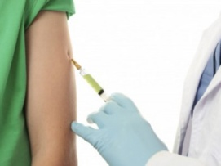 |  | 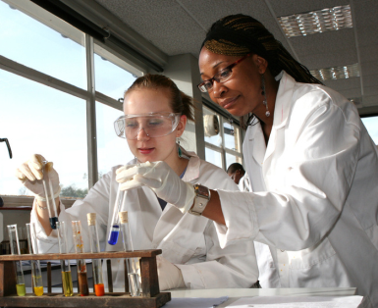 |  | 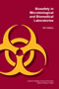 |  | 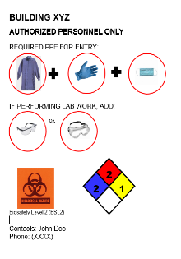 |  | 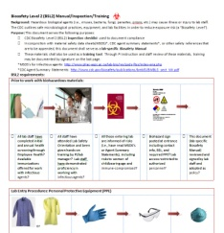
€ | All lab staff have completed health screening through Occupational Health? Available immunizations offered for work with infectious agents? | € | All lab staff have been trained on lab-specific SOPs and been given hands-on training by PI/lab manager? Lab staff have demonstrated proficiency prior to work with infectious agents? | € | All those entering lab are informed of risks (i.e., have reviewed this Biosafety Manual, read PSDSs or CDC Agent Summary Statements), including risks to women of childbearing age and immune-compromised? Staff encouraged to self -identify for counseling? | € | Biohazard sign with contact info, BSL, and required PPE posted at entrance? Lab access restricted to authorized personnel during hazardous work? | € | This document (lab-specific Biosafety Manual and SOPs) reviewed annually and signed by lab staff and adopted as policy?

Laboratory Entry Procedures: Personal Protective Equipment (PPE)
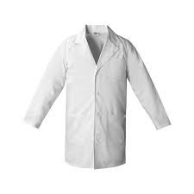or 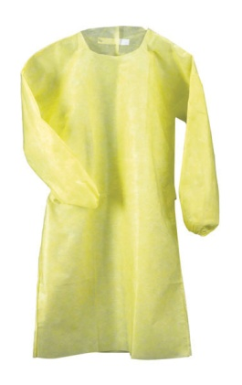 |  | 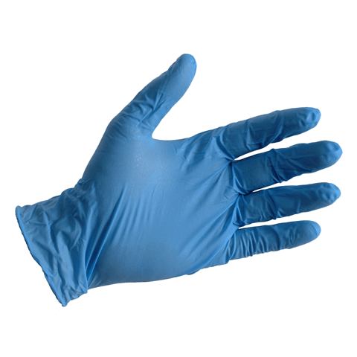 |  | 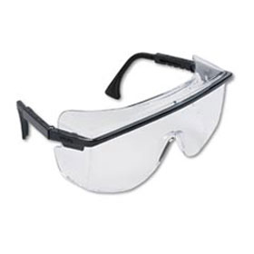 |  |  |  |  | 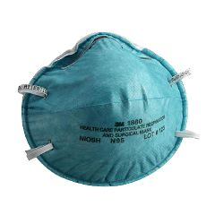
€ | Lab coats worn during lab work? Lab coats removed before leaving for non-lab areas such as cafeteria, break room, library, or office? Reusable lab coats laundered at institution (i.e., not taken home)? Solid-front gowns and cuffed sleeves? | € | Double gloves worn during lab work? Alternatives to latex available for those with allergies? Gloves changed when contaminated or ripped? Disposable gloves not washed and reused? Gloves removed and hands washed before leaving lab? | € | Eye and face protection (goggles, mask, face shield) worn? |  |  |  | € |  | Respiratory protection (i.e., N95 mask) worn as determined by risk assessment (i.e., aerosolizing procedures outside of BSC?
Prohibited Laboratory Practices
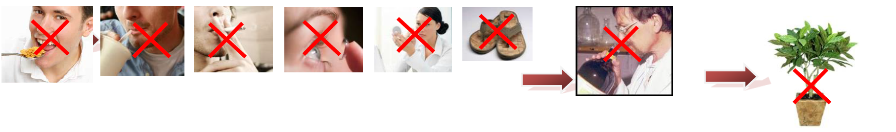
€ | No eating, drinking, smoking, handling contact lenses, applying cosmetics, or storing food in lab areas? No open shoes? No shorts/skirts? |  |  |  |  | € | No sniffing in vitro cultures or mouth pipetting? | € |  | No non-research plants or animals in lab? No carpets, rugs, or fabric-covered chairs in lab?

Safe Laboratory Practices: Sharps Safety (needles, scalpels, Pasteur pipets, broken glassware)

Note: Use of sharps is prohibited in the BSL-2 enhanced laboratory except under special circumstances approved by the Institutional Biosafety Committee

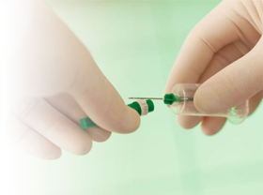 |  | 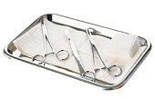 |  | 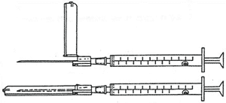 |  |  | 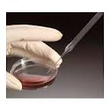  Celltreat® Plasteur™ Plastic Pasteur Pipets |  | 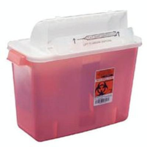
€ | Needles not bent, sheared, broken, recapped, or removed from syringes by hand before disposal? | € | Non-disposable sharps (i.e., scissors) transported for disinfection (i.e., autoclave) within secondary container? | € | Safety-engineered needles or scalpels (i.e., shielded) used where possible? Animals anesthetized or restrained during injection procedures? Annual review of safe sharp devices? | € |  | Plastic substituted for glass (i.e., Pasteur pipettes) wherever possible? Direct handling of broken glassware prohibited (i.e., brush and dustpan used)? | € | Used sharps placed immediately after use into conveniently located sharps container? Sharps lid not removed? Sharps container not overfilled?  Non-infectious tips or glass placed in broken glass box?

Safe Laboratory Practices: Aerosol/Splash Containment
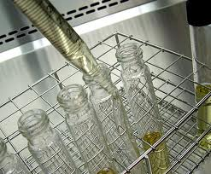 |  | 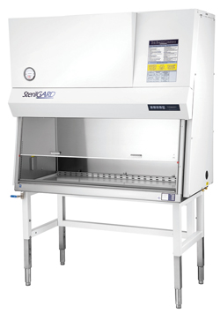 |  | Vacuum flasks filled to 10% (v/v) bleach or 1% (v/v) Wescodyne  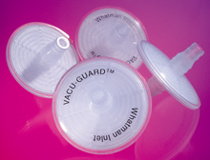  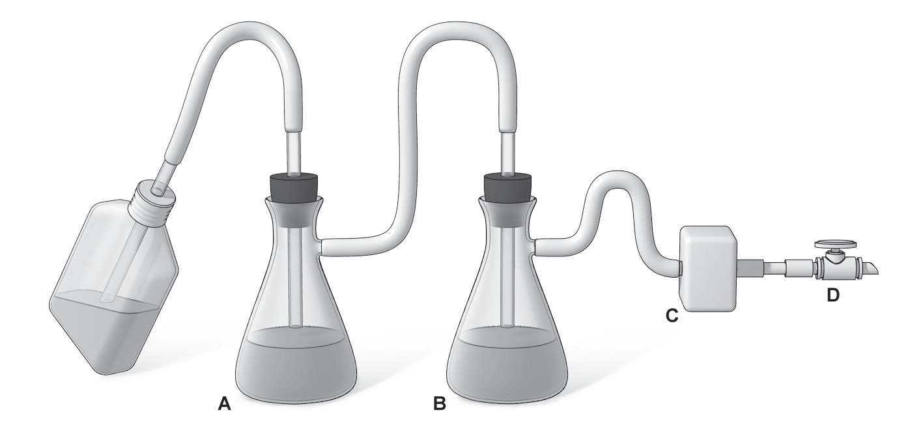  Vacu-guard in-line filter |  | 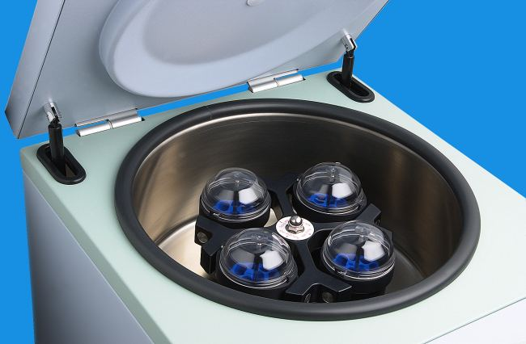
€ | Procedures performed carefully to minimize splashing and aerosols (i.e., pipet fluids down wall of container)? | € | Certified Biosafety Cabinet (BSC) used for high concentrations/large volumes of infectious agents or aerosol producing procedures such as grinding, blending, vortexing, etc.? All open manipulations of infectious agents conducted within BSC? | € | Vacuum lines protected with liquid disinfectant trap/flask? In-line filter used to protect vacuum line from aerosols/ droplets? | € | Sealed rotor, centrifuge safety cups, or other containment (i.e., Biosafety cabinet) used for centrifuge of infectious materials?

Safe Laboratory Practices: Cleanup, Disposal, and Exit Procedures
  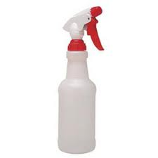 |  | 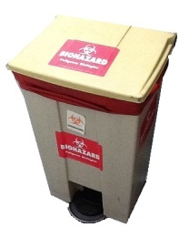 |  | 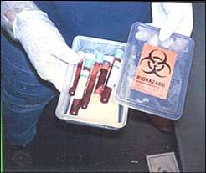  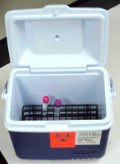 |  | 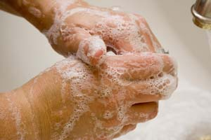  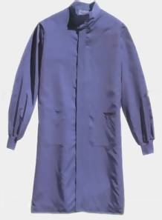
€ | Work surfaces routinely decontaminated with suitable disinfectant, such as 1:10 dilution of bleach, after work and any spills? Liquid biological wastes (i.e., media) disinfected (i.e., final volume 10% bleach or 1% wescodyne) before disposal? Lab equipment (i.e., centrifuge) routinely decontaminated and also before repair, maintenance, or removal from lab? | € | Potentially infectious waste (i.e. plates, tubes, contaminated PPE, etc.) placed into red-bag lined biohazard container? Sharps waste placed into sharps disposal containers? | € | Infectious materials placed in durable leak proof containers during collection, handling, processing, storage, or transport (i.e., sealable secondary container used for transport)? Container labeled with a biohazard symbol, emergency contact, and name of agent? | € | PPE such as gloves and lab coat removed upon exiting lab?  Personnel wash hands after work with hazardous materials, after removing gloves, and before leaving lab?

Emergency Procedures: Accidental Spills and Personnel Contamination/Exposure
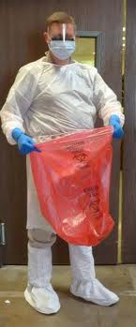 |  | 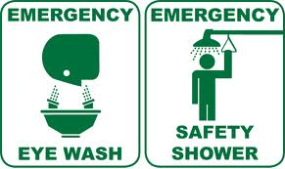
€ | Accidental spill procedure:  - Notify BioSafety Office for assistance (1-6590)  - Cleanup may be conducted only by staff trained and equipped to work with infectious material  - Remove contaminated clothing/PPE  - Notify others around you and restrict access to area; if aerosol, leave room for 20 min. to allow aerosols to settle  - Don lab coat, 2 pairs of gloves, shoe covers, eye/face protection, and safety glasses  - Cover spill with paper towels or other absorbent materials and saturate with freshly prepared 1:10 dilution of bleach  - Allow 20 min. contact time then wipe from perimeter working inwards towards center  - Use forceps or other mechanical device to remove any broken glass; place into sharps container  - Dispose of materials as biohazardous waste  - Remove PPE and wash hands | € | Personnel contamination/exposure procedure:  - Remove any contaminated clothing/PPE  - Wash all affected areas; for eye exposures, rinse 15 min. in eyewash or flush area with water; for needle-stick or other exposures wash wound area with soap and water.  - Report exposure to supervisor immediately  - Seek medical evaluation and treatment ASAP:
€ |  | € | RedMed Employee Health Clinic  200 Central Campus Dr.  Salt Lake City, UT 84112  Phone: (801) 213-3303  Hours: M-TH: 8:00AM – 5:00PM, Friday: 9:00AM – 3:30PM  - Complete Employee Accident Report and Incident Report

Additional Safety Requirements for the laboratory (as determined by risk assessment):

Appendix 17: Useful Websites and Resources

University of Utah Institutional Biosafety Committee (IBC) Website
https://ibc.utah.edu/

University of Utah Biosafety Manual:
https://ibc.utah.edu/biosafety-policies.php

University of Utah Exposure Control Plan:
https://ibc.utah.edu/biosafety-policies.php

NIH Guidelines for Research Involving Recombinant or Synthetic Nucleic Acid Molecules:
https://osp.od.nih.gov/wp-content/uploads/NIH_Guidelines.html

CDC Biosafety in Microbiological and Biomedical Laboratories (BMBL):
https://www.cdc.gov/labs/BMBL.html?CDC_AA_refVal=https%3A%2F%2Fwww.cdc.gov%2Fbiosafety%2Fpublications%2Fbmbl5%2Findex.htm

NIH Office of Science Policy:
https://osp.od.nih.gov/

Public Health Agency of Canada Pathogen Safety Data Sheets and Risk Assessment:
https://www.canada.ca/en/public-health/services/laboratory-biosafety-biosecurity/pathogen-safety-data-sheets-risk-assessment.html

CDC Select Agents Program:
http://www.cdc.gov/od/sap/index.htm

CDC Import Permit Program:
https://www.cdc.gov/cpr/ipp/

USDA/APHIS Permit or the import, transit and release of regulated animals, animal products, veterinary biologics, plants, plant products, pests, organisms, soil, and genetically engineered organisms:
https://www.aphis.usda.gov/aphis/resources/permits

IBC requires review at least every 12 months. If the manual serves as an OSHA compliant ECP, it must be reviewed annually.
PI and IBC should conduct a risk assessment and determine if respiratory protection is required
IBC requires review at least every 12 months

