Principal Investigator: Date Approved:

Biohazardous Animal Handling and Restraint
This SOP applies to administration of biological materials into animals via injection (IV, IP, IM, subcutaneous).

Use of hypodermic needles to administer biological materials into animals increases the handler’s risk for percutaneous exposure. To mitigate risk, safer sharp alternatives (e.g., retractable needle system) must be used when working with animals at ABSL2. Sharps may only be used at ABSL2+ after IBC review and approval: alternatives, such as catheters, must be considered.
Personal Protective Equipment
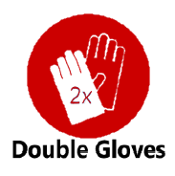
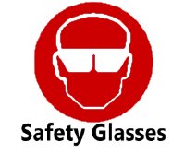
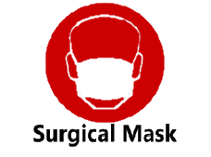
.

Engineering Controls, Equipment, and Materials

Biosafety Cabinet (BSC) | Enclosed, ventilated laboratory workspace that protects the worker from aerosols
Safer Sharp Alternative | Needle devices with built-in safety controls designed to prevent needle sticks
Animal Restrainer | An animal handling device used to secure animal for routine procedures and avoid bites/scratches and accidental needle sticks due to animal movement
Biohazard Sharps Container | A “biohazard”-labeled disposal box for needles, syringes and sharp objects
Disinfectant | Appropriate to the agent(s) (see Decontamination/Disinfection SOP)

Procedures
- Load safe sharp-compatible syringe (e.g., retractable device) with injectate and place in a safe location (e.g., sterile conical tube) without re-capping to avoid accidental exposure
- Position the biohazard sharps waste container in an easy-to-reach location (see Sharps Use SOP)
- Place animal into animal restrainer appropriate for the species and procedure when general anesthesia is not used (see Biohazardous Animal: Handling & Restraint SOP)
- Stabilize animal and prepare injection site
- Insert needle with bevel side up at an angle appropriate for the injection type
- Gently pull back on plunger to verify proper placement (visually observe hub for flash of blood or other fluid)
- Deliver injectate after visual confirmation of needle placement
- Engage sharp safety control and gently apply pressure to injection site to establish hemostasis, as needed
- Dispose of needle and syringe in a biohazard sharps container immediately after use (see Sharps Medical Waste SOP)
- Remove animal from restraint or recover completely from anesthesia and return to the housing location
- Monitor bleeding and anesthetic recovery
Cautions and Considerations

- IBC approval is required for all biohazardous animal procedures performed outside of a BSC, for use of needles and syringes without built-in safety mechanisms, and for use of sharps at ABSL2+
- Restraint devices, including general anesthesia, should be employed whenever possible; if not possible consult with the Office of Comparative Medicine to discuss other options
- Use a “biohazard”-labeled transport container to transfer administration tools and biological materials to the location where materials will be delivered to animals (see Biohazardous Material Transport SOP)
- Do not recap, bend, break or shear needles
- Contact EHS Biosafety at 801-581-6590 within 12 hours of an exposure to biohazardous materials

