# SOP for Autoclaving Infectious Waste: Use and Testing

# Purpose

The purpose of this Standard Operating Procedure (SOP) is to ensure that potentially infectious waste materials are adequately sterilized when subjected to autoclaving (steam sterilization). State law requires that all autoclaves used for decontamination of biohazardous materials be tested monthly for efficacy following the parameters described in these operating procedures.

# Scope

This SOP applies to all University of Utah facilities where autoclaving is used to decontaminate biohazardous materials prior to release to the normal waste streams (sanitary sewer for liquids, permitted landfill for solid wastes).

The Utah Administrative Code, [Rule R315-316](https://rules.utah.gov/publicat/code/r315/r315-316.htm), describes infectious waste treatment and disposal requirements, including those required to use and maintain an autoclave (steam sterilizer).

# Roles and Responsibilities

## Department or Facility “Owners”

1. Departmental or facility “owners” of autoclaves are responsible for maintaining autoclaves in good working order and having the autoclaves tested annually by a qualified technician.

## Supervisor/Operators:

* + 1. All operators of autoclaves are responsible for operating the autoclave in accordance with the parameters defined in this document when that autoclave is being used to decontaminate potentially infectious/biohazardous regulated medical wastes.
    2. Operators are also responsible for running monthly tests in accordance with state regulations
    3. The operator shall have available, and shall certify in writing that he/she understands, written operating procedures for each steam sterilizer, including time, temperature, pressure, type of waste, type of container, closure of container, pattern of loading, water content, and maximum load quantity.
    4. The operator shall ensure that each package of biohazadous waste to be sterilized will have a temperature-sensitive tape or equivalent test material, such as chemical indicators, attached that will indicate if the sterilization temperature and pressure have been reached. Waste shall not be considered sterilized if the tape or equivalent indicator fails to indicate that a temperature of at least 250 degrees Fahrenheit (121 degrees Celsius) was reached and a pressure of at least 15 psi was maintained during the process.
    5. The operator will evaluate each sterilization unit for which they are responsible the effectiveness to kill spores of *Bacillus stearothermophilus* at least once each 40 hours of operation or each week, whichever is less frequent.
    6. The operator will maintain a written log for each load for each sterilization unit, which shall contain at a minimum:
  1. the time of day and the date of each load and the operator's name;
  2. the amount and type of infectious waste placed in the sterilizer; and
  3. the temperature, pressure, and duration of treatment.

## Environmental Health and Safety (EHS):

* + 1. EHS will provide guidance on the testing of autoclaves, including on advice on where and how to buy testing kits.
    2. EHS will provide training and guidance on effective decontamination methods to the research community as needed.

# Definitions:

“Potentially infectious wastes” needing to be autoclaved include the following:

* + 1. “Biological waste”, which includes blood and blood products, excretions, exudates, secretions, suctionings and other body fluids that cannot be directly discarded into a municipal sewer system, and waste materials saturated with blood or body fluids, but does not include diapers soiled with urine or feces.
    2. “Cultures and stocks,” which includes etiologic agents (of disease) and associated biologicals, including specimen cultures and dishes and devices used to transfer, inoculate and mix cultures, wastes from production of biologicals, and serums and discarded live and attenuated vaccines. “Cultures” does not include throat and urine cultures.
    3. Gloves and other disposable personal protective equipment used as barriers when handling biological wastes or cultures and stocks.

# References:

The Utah Administrative Code, [Rule R315-316](https://rules.utah.gov/publicat/code/r315/r315-316.htm). Infectious Waste Requirements.

Rutala, W. A., Stiegel, M. M. and F. A. Sarubbi, Jr. *Decontamination of laboratory microbiological waste by steam sterilization*. App. Env. Microbiol. 43: 1311-1316 (1982).

Lauer, J. L., Battles, J. R. and D. Vesley. *Decontaminating infectious laboratory wastes by autoclaving*. App. Env. Microbiol. 44: 690-694 (1982).

Ozzane, G., Huot, R. and C. Montpetit. *Influence of packaging and processing conditions on decontamination of laboratory biomedical wastes by steam sterilization*. App. Env. Microbiol. 59: 4335-4337 (1993).

Adapted from Oregon State University and University of Nebraska Standard Operating Procedures.

# University of Utah Contacts:

Dr. Neil Bowles Derek Hedquist

Biosafety Officer Assistant Biosafety Officer

James Stubbs

Associate Director

# Procedures:

Autoclaves are used in many areas to sterilize materials. Due to the high heat and pressure created in autoclaves during operation, proper loading, use, and unloading procedures must be followed to prevent burns and other accidents. Burns can result from physical contact with the structure of the autoclave and steam burns can occur from contact with steam leaving the apparatus. Burns can also result from careless handling of vessels containing hot liquids. Explosive breakage of glass vessels during opening and unloading due to temperature stresses can lead to mechanical injury, cuts, and burns. Autoclave performance for sterilization is dependent on proper use. This SOP provides guidance related to prevention of injuries as well as effective sterilization.

## Run Settings

Autoclave manufacturers generally provide several pre-set cycle options.

### Gravity

In this mode, evacuation of air from the autoclave chamber prior to the sterilization portion of the run is accomplished by gravity air purge. A gravity cycle is appropriate for loads where air removal from porous materials or penetration of steam into wrapped or packaged items is not required.

### Vacuum cycle

In this mode, evacuation of air from the autoclave chamber prior to the sterilization portion of the run is accomplished by pulsing between pressure and vacuum. As the number of pulses (prevacs) increases, so does the efficiency of the air removal and subsequent steam penetration. A vacuum mode is suitable for hard goods, with a minimum of 3 prevacs for wrapped or difficult to penetrate hard goods.

### Liquids cycle

This mode is similar to gravity cycles in that air is evacuated from the autoclave chamber by gravity air purge. Pulling a deep vacuum is not conducted since liquids to be autoclaved would be drawn out of their vessels.

Often, the autoclave manufacturer will provide two pre-set cycles for each type of run option presented above (e.g., gravity, vacuum, and liquids). The pre-set cycles for each type of run will vary in the pre-set sterilization temperature, sterilization time, and dry time.

## General Precautions (Do’s and Don’ts)

**Things to do when operating an Autoclave**

* Read and follow the recommendations made by the manufacturer in the owner’s manual. Ensure regular maintenance of autoclaves and ancillary equipment in accordance with the manufacturer’s specifications.
* Understand the temperature and pressure readings on the printed autoclave tape reflect the chamber temperatures, and may not reflect the temperatures achieved in the material that is autoclaved.
  + Most autoclaves are equipped to provide a printed tape documenting the conditions of the run. The chamber temperature and material temperature will correlate only when the ideal run parameters (i.e., pressure, prevac, etc.) have been established for the load conditions (i.e., load size, load distribution and configuration, depth of the autoclave pan, wetness of the load, etc.).
* Use only those types of containers, bags, and lids that are designed for autoclaving. Inspect vessels for cracks or chips. Only use unblemished containers. ***Note: not all biohazard bags are rated for autoclave use. Also, some are rated only to a certain temperature; make sure the bags you use are compatible with your waste cycle.***
* Autoclave disposable plastic labware (e.g., culture plates, petri dishes, pipette tips, etc.), paper and gloves, etc. If autoclaving dry biohazardous waste containing little liquid, add a glove or Ziploc bag containing water when the bag is half-full.
* Place soiled glassware and lab ware in secondary containers and autoclave them in the solids cycle.
* Loosen lids on containers of liquids and closures on autoclave bags.
* Arrange loads to allow free circulation of steam. If items that can hold water are in the load (e.g., trays, pans), place them in such a way to allow for condensed steam to drain (i.e., on their sides).
* Report all malfunctions to your supervisor and clearly tag the equipment as “**Out-of- Service.**”
* ALWAYS use secondary containment when sterilizing or decontaminating. Steel autoclave containers achieve appropriate temperatures quicker than polypropylene containers and thus are recommended. If you use plastic containers, ensure that they are certified for use at the temperatures in the autoclave.
* **Autoclave waste must be clearly marked that it has been sterilized appropriately:**
  + **Use chemical indicator tape, it is very important to use a lead-free tape to avoid potential implications under the hazardous waste regulations.** Examples of lead-free autoclave tape include:
    - Fisher brand, catalog number 15-903
    - VWR brand, catalog numbers 10127-464 and 10127-460
  + Use autoclave bags with sterilization indicator. Examples include:
    - Fisher brand, catalog number 01-814

**Things NOT to do when operating an Autoclave**

* Do not autoclave flammable or corrosive liquids. Never autoclave bleach solutions; this can damage the plumbing of the autoclave.
* Do not place loose sharps (e.g., glass pipettes, broken glass, razors, slides, etc.) in autoclave bags.
* Do not stack items and “stuff” the chamber. There must be sufficient clearance on all sides of the load to allow for steam to circulate.
* Do not autoclave sharps waste containers: arrange for collection through the EHS Lab Management System
* Do not stack or store combustible materials next to an autoclave (cardboard, plastic, volatile or flammable liquids).
* Do not autoclave materials containing hazardous wastes or radioactive materials.
  + Hazardous waste and ionizing radiation regulations pertain to autoclaved waste as well, so it is imperative to consult with EHS if your run contains any agars or other materials that may contain a regulated substance (e.g., heavy metal such as Pb, Hg, Ag, Se, Ba, As, Cd, Cr, or other potentially toxic constituent). Consult with EHS prior to autoclaving radioactive materials.

**DO NOT use an autoclave unless you have received specific operation instructions or are working under the direct supervision of an experienced autoclave worker.**

## Specific Instructions for Autoclaving Contaminated Plant Material and Soil

Autoclaving plant material and soil requires special consideration to the parameters used as the organic nature of the materials can sometimes affect the effectiveness of the sterilization cycle. Soil is often autoclaved prior to use to ensure that it is sterile and no undesired pathogens or pests are present. The parameters discussed below are specifically for treatment of plant and soil waste materials that contain recombinant or synthetic nucleic acid molecules, pathogens or pests, or plants and soil that may be contaminated by these materials.

### Recombinant nucleic acid-containing plant material

* + Standard autoclave parameters should be used (121°C at 15-17psi for 60 minutes)
  + Do not overfill bags

### Contaminated soil (pathogens and/or genetically modified plants)

* + Soil is much denser than mixed soil and plant material so containers must be filled much less than their capacity.
  + EHS has determined through a validation study that the following parameters result in successful decontamination of soil.
    - A maximum depth of 9” in a trash can or similar container.
    - 121°C and 16 psi for 180 minutes or two (2) 90 minute cycles.
  + Soil autoclaved in plastic or metal trays and less than 6” deep, may only require a single cycle of 90 minutes @ 121°C to achieve sterilization. Use of these parameters should be verified by use of biological indicators.
  + Smaller quantities of contaminated soil may, by extrapolation, require shorter autoclave times.
* Consider the materials you are trying to sterilize when selecting the autoclave program parameters.
* Deviation from these parameters should be done in consultation with Environmental Health and Safety (EHS) to ensure that effective decontamination/sterilization is achieved, particularly for waste materials.

### Loading the Autoclave

* Plan the load in accordance with the autoclave settings and load configurations that will ensure proper autoclave performance.
* Use a chemical indicator (e.g., autoclave tape) in every load to demonstrate that the chamber temperature was greater than 121°C. Place autoclave tape in an “X” pattern over the biohazard symbol on waste bags or sharps containers (Figure 1).

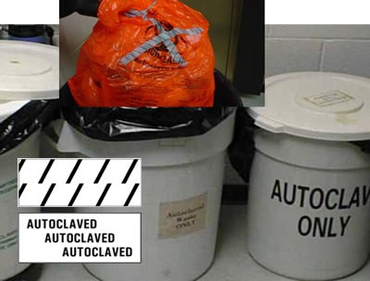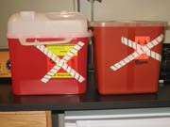

***Figure 1*** *Autoclave tape utilizes a chemical reaction to indicate a temperature of greater than 121°C was achieved. This color change is usually displayed with hash marks or words that appear on the tape when proper temperature is reached.*

* Biohazard waste bags must NEVER be placed directly on the floor. Transfer the waste bag directly to a solid, autoclave compatible pan large enough to contain any leaks.
* Use a cart to transfer items to the autoclave. To avoid overexertion injuries, push the cart up to the autoclave door and gently slide the load into the autoclave.
* Prior to loading the autoclave, visually inspect the drain strainer to ensure it is clean.
* Use the appropriate autoclave setting as described above. Recommended settings for waste are at least 121°C, 15-17 psi for at least 30 minutes.
* Firmly lock autoclave doors prior to starting the run to prevent sudden release of high-pressure steam.

### Unloading the Autoclave

* After the run is completed, check the pressure gauge. If pressure is not released, do not open the door. Contact the Building Maintenance/Facilities Staff for malfunctions; do not use the pressure relief override valve.
* While wearing eye protection and insulated gloves or mitts, carefully open the autoclave using the door to shield your body from the contents of the autoclave. Hot condensate may drip from the door so ensure your feet are protected.
* Use caution when removing liquids. Liquids, especially large volumes, may continue boiling for a time after autoclaving.
* Slide a cart to the opening of the autoclave and pull the autoclave secondary container onto the cart. Place the cart in a low traffic area while additional cooling occurs.

### Disposal of Autoclaved Waste

* Liquids that have been autoclaved may be poured down the sink if all chemical components are listed on the EHS sewer disposal list. If the liquid contains chemicals that are not approved for sewer disposal, the vessel must be tagged for pick-up by EHS.
* 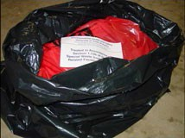Non-toxic solids (including lead-free autoclave tape) that do not contain any chemical constituents regulated under the hazardous waste laws or radioactive material may be disposed in the regular trash following autoclaving and demarcation.
  + Seal the bag by taping or tying the bag shut.
  + Place the autoclaved waste bag in a black (opaque) trash bag. (Figure 2)
  + If any free liquids (i.e., condensate) are present, add sufficient absorbent to the bag.
* Tag autoclaved toxic and/or potentially regulated solids (including autoclave tape containing lead) for collection by EHS.

## Autoclave Performance Checks

Autoclaves that are used to sterilize biohazardous waste must be tested at least weekly to ensure they are functioning correctly:

### Testing Procedure

1. Many companies sell *Bacillus stearothermophilus* or *Geobacillus stearothermophilus* that can be used for verification (e.g. [VWR](https://us.vwr.com/store/product/4780402/sportrol-spore-strips-namsa), and [Fisher Scientific](https://www.fishersci.com/shop/products/thermo-scientific-biological-indicators-incubator-pouches-5/p-2360401)). In most cases, these come in the form of ampoules or paper strips. Follow the manufacturer’s instructions.
2. To perform the test, use the following procedures:
   1. **For dry loads (gravity or vacuum cycle)**, obtain a pipet tip storage box (Figure 3A) and (1) place the ampoule, on its side, or strip inside the box. (2) Use autoclave tape to secure the ampoule. (3) Close the lid of the box and place the box under your load (i.e., under the autoclave waste bag(s)).

**Figure** 3 Autoclave Biological Indicator Testing Methods

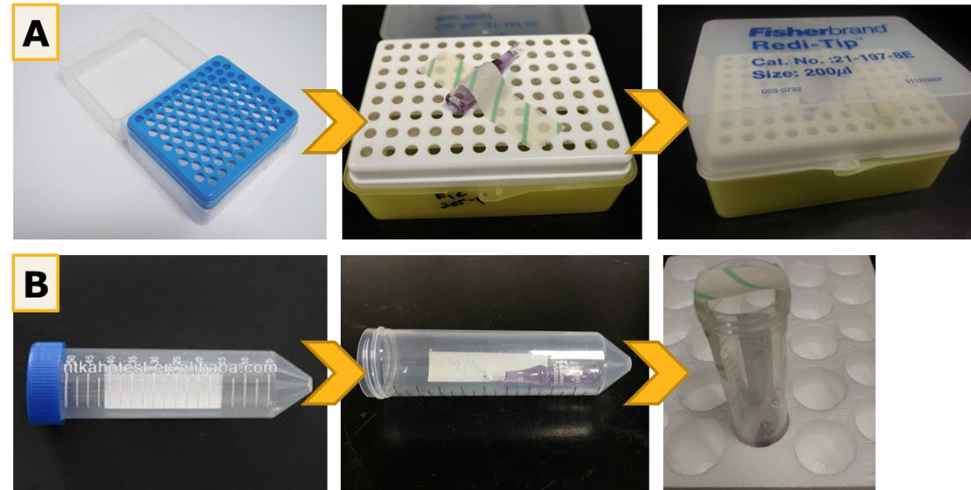

* 1. **For liquid loads**, using a piece of string tied around the ampoule, suspend the ampoule in the liquid and secure it to the outside of the container with autoclave tape.
  2. **For tabletop and top-loading portable autoclave/sterilizers**, (Figure 3B) (1) Obtain a 50 mL conical centrifuge tube. (2) Place the ampoule/strip in the tube. (3) Place one piece of autoclave tape over the mouth of the tube to prevent the ampoule/strip falling out. It is important to allow for steam to enter the tube.

**IMPORTANT**: ***Do not place the lid back on the tube***.

Using another piece of autoclave tape, secure the tube to the bottom of the autoclave bag or simply place the tube under the biohazard bag(s).

* 1. **For plant material and soil in bags**, use either method 4.1 or 4.3 outlined above and shown in Figure 3.

1. Autoclave using the appropriate cycle/settings (*a typical decontamination cycle is 15-60 min at 121°C and 15-17 psi*).
2. Allow time for the autoclave to cool down and for pressure to return to atmospheric.
3. Using insulated gloves or mitts, remove load from autoclave.
4. Remove pipet tip box from bottom of tray and open box to remove ampoule or remove cover from liquid container and retrieve ampoule from liquid.
5. Incubate test ampoules/strips according to the manufacturer’s instructions and check for growth. Typically, these require incubation at 55-50°C for 2 to 7 days. If the autoclave is functioning properly, no growth will be observed. If there are shows signs of growth, the test has failed. Repeat the test to confirm.
6. If the second test also fails, place an “Out of Order, Do Not Use!” sign clearly on the autoclave and submit a repair order. Be sure to indicate an alternate autoclave to use until repairs are made. A sample sign is included in Appendix A of this document.

## Record Keeping

In accordance with State requirements, records must be kept for each autoclave. These records serve two purposes, (1) they aid in autoclave malfunction investigation and (2) they provide documentation to regulatory agencies that materials were properly decontaminated/sterilized prior to disposal. Records should contain the following information:

* On-site maintenance records
* Documentation of testing with spores of *B. stearothermophilus*. An example log can be found in Appendix B of this document
* Log of autoclave use. Each load of material inactivated shall be logged as follows:
  + Date, time, and operator's name
  + Type and approximate amount of waste
  + Confirmation of sterilization
  + Record the temperature, pressure, and length of time the load is sterilized.
  + Save the autoclave printout, if the autoclave has a working printer. An example autoclave use log can be found in Appendix C of this document.

## Routine Maintenance

The best way to ensure effective autoclave operation is regular maintenance. Consult the owner's manual for autoclave-specific maintenance recommendations.

# Appendix A: Out of Order Sign

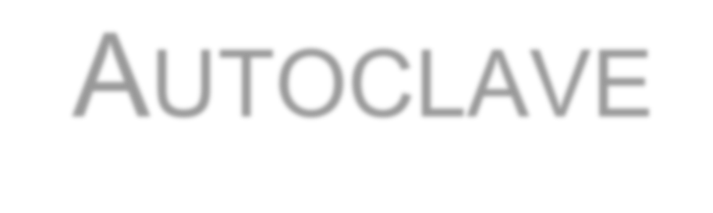

Instructions: Print sign in color, cut out along dotted line and post on autoclave in need of repair.

# Appendix B: Log for testing sterilization efficacy with *B. Stearothermophilus*.

**Test Vial Information**

### Test vial #:

Test vial type: e.g. *BT Sure / Barnstead Thermolyne Test* Vial Lot #:

Expiration Date:

Each vial contains e.g., *2.0 x 105 endospores, Geobacillus stearothermophilus*

### Incubation conditions: e.g.,*55°C for >24 hours*

**Autoclave Information**

Building:

Room: Manufacturer: Model:

Serial:

**Test Conditions**

Time:

Chamber Pressure: Buried in waste bag: Date of test:

**Results**:

**User Information** Department: *Contact* Person:

### Comments:

# Appendix C. Autoclave Use Log

Instructions: Post log by autoclave and record each use of the autoclave.

* Principal Investigator
* Lab Room – indicate in which lab the biohazard waste was generated
* Time at cycle temperature (example: 121°C)
* Chamber temperature – maximum temperature reached
* Cycle Type – list type of cycle (e.g., Gravity, liquid, waste, etc.)
* Operator – indicate person who autoclaved waste
* Comments – list comments

|  |  |  |  |  |  |  |  |  |  |
| --- | --- | --- | --- | --- | --- | --- | --- | --- | --- |
|  | Date | PI | Lab Room | Cycle Time | Max Temp | Press | Cycle Type | Operator | Run (Pass/Fail) |
| 1 |  |  |  |  |  |  |  |  |  |
| 2 |  |  |  |  |  |  |  |  |  |
| 3 |  |  |  |  |  |  |  |  |  |
| 4 |  |  |  |  |  |  |  |  |  |
| 5 |  |  |  |  |  |  |  |  |  |
| 6 |  |  |  |  |  |  |  |  |  |
| 7 |  |  |  |  |  |  |  |  |  |
| 8 |  |  |  |  |  |  |  |  |  |
| 9 |  |  |  |  |  |  |  |  |  |
| 10 |  |  |  |  |  |  |  |  |  |
| 11 |  |  |  |  |  |  |  |  |  |
| 12 |  |  |  |  |  |  |  |  |  |
| 13 |  |  |  |  |  |  |  |  |  |
| 14 |  |  |  |  |  |  |  |  |  |
| 15 |  |  |  |  |  |  |  |  |  |
| 16 |  |  |  |  |  |  |  |  |  |
| 17 |  |  |  |  |  |  |  |  |  |
| 18 |  |  |  |  |  |  |  |  |  |
| 19 |  |  |  |  |  |  |  |  |  |
| 20 |  |  |  |  |  |  |  |  |  |
| 21 |  |  |  |  |  |  |  |  |  |

**Run Comments**: *(be sure to list run #)*