Principal Investigator: Date Approved:

Biohazardous Spill Response
This SOP applies to spills involving biohazardous materials.
Biohazardous material spills inside or outside of containment, such as a Biosafety cabinet, increase the risk of exposure to hazardous materials. It is important to effectively clean and disinfect the contaminated area to reduce the risk of exposure
Personal Protective Equipment
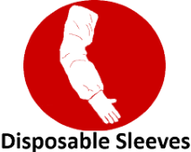
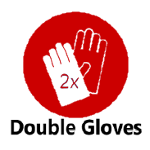
.

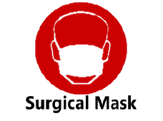
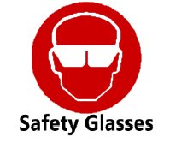

Engineering Controls, Equipment, and Materials
Disinfectant | Appropriate to the agent(s) (see Decontamination/Disinfection SOP)
Absorbent Materials | Sufficient to completely cover spilled liquid and can be disposed (e.g., paper towels)
Tool for Handling Sharps | Physical tools that allow safe handling of sharp materials preventing cuts and exposures (e.g., tongs, forceps, broom/dustpan)
Biohazard Waste Container and Bag | Non-porous, leak-resistant, “biohazard”-labeled container lined with a red biohazard waste bag
Biohazard Sharps Container | A “biohazard”-labeled disposal box for needles, syringes and sharp objects
Warning Sign | To notify others that a spill occurred in the area and “Do Not Enter”

- If the spill is outside of a BSC, notify others to evacuate room for 30 minutes while aerosols settle and room air exchanges, and post “Do Not Enter” signage to restrict access
Procedures
- Don new PPE to proceed with clean up
- Place absorbent materials on and around spill
- Pour disinfectant on paper towels, pouring from the outside in, and wait required contact time (20 minutes for bleach solution)
- Check area around spill and spray disinfectant on any visible contamination
- If sharps are present (e.g., broken glass/sharps) pick up with tongs/forceps or broom and dustpan and dispose as biohazardous sharps
- If sharps are not present dispose of absorbent materials as biohazardous waste
- Spray spill area with disinfectant and allow to air dry
- Wipe up disinfectant residue with water and dispose of absorbent materials as biohazardous waste
- Remove PPE and wash hands with soap and water
- Report all exposures resulting from spills to the supervisor and EHS.
Cautions and Considerations

- Only proceed with biohazardous spill cleanup if you feel comfortable: request assistance from EHS if necessary (801-581-6590)
- Always use physical tools for handling sharps involved in a spill
- Additional PPE may be needed based on the type/extent of the spill and the agent(s) involved
- If bleach is used, a freshly prepared dilution (typically 1:10 with cold water) must be prepared
- Spill kits are available from EHS for purchase (https://oehs.utah.edu/resource-center/forms/spillkitorderform)

