(Lab Name) LABORATORY

EXPOSURE CONTROL PLAN

- Introduction 5
- Roles & Responsibilities 6
- Exposure Determination 7
- Methods of Implementation & Control 7
- Hepatitis B Vaccination 12
- Post Exposure Evaluation & Follow-up 13
- Incident Reporting 15
- Training 16
- Recordkeeping 17

Appendix A. Glossary of Terms 18
Appendix B. Safer Sharps Devices Annual Review Form 22
Appendix C. Spill Cleanup Procedures 24
Appendix D. Sharps Injury Log 29

Delete or edit the following appendices as necessary:

Appendix E. General Laboratory Safety 30
Appendix F. Biosafety Cabinet SOP 33
Appendix G. Use and Disposal of Sharps 39
Appendix H. Disposal of Biohazardous Waste 42
Appendix I. Safe Handling of Cryogenic Liquids 45

Supervisor/Principal Investigators’ Certification

I hereby certify that I have reviewed the contents of this manual and that it reflects my current operating practices. Review must be completed at least annually.

Date Reviewed: | PI Signature:

Signature and Acknowledgement of Risk
We, the undersigned, understand that the agents used in this laboratory and described in this manual are potentially hazardous. We have read and understand this manual and agree to follow the stated policies and procedures. All laboratory personnel are required to review this manual annually and complete training requirements determined by the risk assessment: https://ibc.utah.edu/training.php.

Name | Signature | Date Reviewed Manual | Date completed BBP training

Emergency Phone Numbers

Fire and Medical Emergencies | 911
Police | 911
Laboratory PI Home Phone
Office Phone
Cell Phone
Laboratory Manager Home Phone
Office Phone
Cell Phone
Occupational Medicine | 801-213-9777
Campus Police Department | 801-585-2677
Environmental Health and Safety (Main Number) | 801-581-6590
Biosafety Officer (EHS) | 801-585-9325
Associate Biosafety Officer (EHS) | 801-585-3345

Emergency Assembly Point for Laboratory Personnel:………….

- INTRODUCTION
  - Purpose
This plan is designed to eliminate employee exposure to bloodborne pathogens. All human blood and other potentially infectious materials (OPIM) are considered to be infectious for Human Immunodeficiency Virus (HIV), Hepatitis B virus (HBV), and other bloodborne pathogens, and will be treated as if infectious, i.e. with universal precautions. Since animal blood is not readily distinguished from human blood by appearance, this document's guidance for handling and disposal of human blood and sharps is recommended for all blood. Definitions relevant to this document are found in Appendix A.
  - Scope
This exposure plan is mandatory for all University of Utah laboratory employees who have occupational exposure to human blood and OPIM. This template has been developed by the Department of Environmental Health and Safety (EHS) and the plan must be customized so that it provides lab-specific provisions to identify and protect all personnel who may be at risk of exposure. This plan must be updated at least annually, and whenever there are changes in laboratory procedures that may change a worker’s exposure. A copy of this plan must remain in the lab, and must be accessible to lab personnel. All personnel must review this plan at the time of assignment, whenever changes are made, and at least annually thereafter. The review must be documented by the signature and date of review .
  - Policy
The (Name of Laboratory) laboratory is committed to providing a safe and healthful work environment for our entire staff. In pursuit of this endeavor, the following Exposure Control Plan (ECP) is provided in accordance with OSHA standard 29 CFR 1910.1030, “Occupational Exposure to Bloodborne Pathogens.” This builds on the University of Utah policies and procedures described in the University of Utah Exposure Control Plan.
The ECP is a key document to assist our lab in implementing and ensuring compliance with the standard, thereby protecting our employees. This ECP includes:

- Employee exposure determination
- Methods of control to prevent worker exposure
- Provisions for hepatitis B vaccination
- Post-exposure evaluation & follow-up
- Employee training and hazard communication
- Recordkeeping
Implementation of these elements of the ECP is discussed in the subsequent pages of this document.

- ROLES AND RESPONSIBILITIES
2.1 (Name of Individual) is responsible for the implementation of this ECP.
2.2 (Name of Individual) will maintain, review, and update this ECP at least annually, and whenever necessary to include new or modified tasks and procedures.
2.3 Those employees who have occupational exposure to blood or OPIM must review this plan (at the time of assignment, wherever changes are made and annually thereafter) and comply with the procedures and work practices outlined in this ECP.
2.4 (Name of Individual) will maintain and provide all necessary personal protective equipment (PPE), engineering controls (e.g., sharps containers), labels, and red bags as required by the standard. This will include ensuring that adequate supplies of the aforementioned equipment are available in the appropriate sizes.
2.5 (Name of Individual) will be responsible for ensuring that all medical actions required are performed and that appropriate employee health and OSHA records are maintained.
2.6 (Name of Individual) will be responsible for training, documentation of training, and making the written ECP available to employees, OSHA, and NIOSH representatives.

3. EMPLOYEE EXPOSURE DETERMINATION
3.1 Following is a list of tasks or procedures where exposure to blood or OPIM may occur, and the names of those individuals who have real or potential exposure as a result of performing those tasks:

Task or Procedure | Employees with Real or Potential Exposure | Job Title(s)
Task #1 (Example) Isolating DNA from blood in an open lab | (Employee #1 Name)  (Employee #2 Name) | Phlebotomist  Lab Technician
Task #2 (Example) Human cell culture | (Employee #2 Name)  (Employee #3 Name) | Lab Technician  Lab Technician

- METHODS OF IMPLEMENTATION AND CONTROL
4.1 Universal Precautions
All employees will utilize universal precautions when handling blood and OPIM. For tasks in which differentiation between body fluid types is difficult or impossible, all body fluids will be considered potentially infectious materials.
4.2 Exposure Control Plan
Employees covered by the bloodborne pathogens standard receive an explanation of this ECP during their initial training session. It will also be reviewed in their annual refresher training. Employees will document their review of the ECP. All employees have an opportunity to review this plan at any time during their work shifts. A copy of the plan will be located in the laboratory in the following location: (Location where the ECP will be located in the lab).
  - Engineering Controls, Work Practices, and Personal Protective Equipment (PPE)
    - Engineering Controls. Laboratory personnel will use engineering controls whenever possible to prevent exposure. All aerosol-producing tasks (i.e. sonicating or vortex mixing), or tasks that may result in splashing or spraying, will be conducted in a certified biological safety cabinet. Other engineering controls such as sharps disposal containers, self-sheathing needles, and non-glass capillary tubes will be used as needed depending on the task being performed.
      - Annual consideration and implementation of appropriate engineering controls, including safer sharp alternatives (Appendix B), will be documented by (Name of Individual).
      - Solicitation of non-managerial workers in evaluating and choosing devices will be documented by (Name of Individual).
    - Work Practice Controls. Work practice controls include policies and procedures to minimize exposure, and should be used in conjunction with engineering controls. Work practice controls include hand washing, safe needle practices (no recapping), no eating or drinking in the lab, and no mouth pipetting.
    - Personal Protective Equipment. PPE will be used to prevent or minimize exposure to bloodborne pathogens, but should only be used when exposure remains after all reasonable engineering controls and work practice controls are in place. PPE includes such items as gloves and lab coats. For procedures where splashing may occur (spill cleanup), eye protection and face protection (masks) must be used to prevent exposure. Face shields may be used as an alternative to the safety glasses / mask combination.
  - Following are the specific engineering controls and PPE that will be used by employees to minimize exposure to blood and OPIM for each task outlined in paragraph 3.1 above:

Task #  (See 3.1 Above) | Engineering Control Measures
Task #  (See 3.1 Above) | Bench Top Splash Shield | Biohazard  Waste Bags | Biosafety  Cabinet | HEPA Vacuum Filters | Plastic Transport Containers | Self-Sheathing Needles | Non-Glass Capillary Tubes | Other  (Please Specify)
Task #1 (example) | X | X
Task #2 (example) |  | X | X | X

Task #  (See 3.1 Above) | Required Personal Protective Equipment
Task #  (See 3.1 Above) | Lab Coat | Gloves | Safety Glasses with Side Shields | Surgical Mask | Solid Front Gown | Sleeve Covers | Booties | Respiratory Protection (Contact EHS) | Face Shield | Other (Please Specify)
Task #1 (example) | X | X | X | X
Task #2 (example) | X | X

- Specific Control Measures
Sharps disposal containers are inspected and maintained or replaced by (Name of Individual) whenever necessary to prevent overfilling.
This laboratory identifies the need for changes in engineering control and work practices through our weekly lab meeting.
If needles or syringes are used, we evaluate new procedures or new products regularly to improve safety by searching various venders and asking for samples to try.
Both front line workers and management officials are involved in this process: Employees are involved through our weekly lab meeting where there is an open forum to bring up any issues or potential issues in the lab.
PPE is located (describe locations of PPE in the lab).
All employees using PPE must observe the following precautions:
Wash hands immediately or as soon as feasible after removal of gloves or other PPE.
Remove PPE after it becomes contaminated, and before leaving the work area.
Used PPE may be disposed of (describe method of disposal).
Wear appropriate gloves when it can be reasonably anticipated that there may be hand contact with blood or OPIM, and when handling or touching contaminated items or surfaces; replace gloves if torn, punctured, contaminated, or if their ability to function as a barrier is compromised.
Never wash or decontaminate disposable gloves for reuse.
Wear appropriate face and eye protection when splashes, sprays, spatters, or droplets of blood or OPIM pose a hazard to the eye, nose, or mouth. Appropriate face and eye protection consists of mask & goggles or a face shield.
Remove immediately or as soon as feasible any garment contaminated by blood or OPIM, in such a way as to avoid contact with the outer surface.
4.6 Housekeeping
Spills of blood or OPIM must be cleaned up using an EPA approved disinfectant (https://www.epa.gov/pesticide-registration/selected-epa-registered-disinfectants) following the procedure described in Appendix C.
Regulated waste is placed in containers which are closable, constructed to contain all contents and prevent leakage, appropriately labeled or color-coded (see Labels), and closed prior to removal to prevent spillage or protrusion of contents during handling.
Sharps containers will be disposed of by filling out the on-line pick up request at www.oehs.utah.edu. EHS personnel will pick up full containers and replace them with empty containers.
Other regulated waste must be autoclaved before being disposed of in the municipal waste stream. Alternatively, EHS can dispose of biohazard waste for the lab. EHS can be contacted using the on-line pick up request.
Contaminated sharps are discarded immediately or as soon as possible in containers that are closable, puncture-resistant, leakproof on sides and bottoms, and labeled or color-coded appropriately. Sharps disposal containers are available through the EHS on-line pick up request at www.oehs.utah.edu.
Bins and pails (e.g., wash or emesis basins) are cleaned and decontaminated as soon as feasible after visible contamination.
Broken glassware that may be contaminated is picked up using a mechanical device such as tongs, forceps, or a brush and dustpan.

  - Laundry
The following articles, if contaminated, will require laundering:

The University of Utah Hospital Laundry will be used to clean contaminated clothing and other articles that require laundering.
The following laundering requirements must be met:
- Handle contaminated laundry as little as possible, with minimal agitation.
- Place wet contaminated laundry in leak-proof, labeled or color-coded containers before transport to the University Hospital Laundry.

Labels
The universal biohazard symbol (below)` will be used to mark regulated waste containers, refrigerators containing blood or OPIM, contaminated equipment, specimen containers, and specimen transport containers. The universal biohazard symbol must be located at the entrance to all laboratory rooms where blood or OPIM is used. Red bags can be used as a substitute for bags marked with the universal biohazard symbol for regulated waste only.

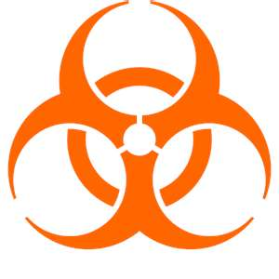
(Name of Individual) will ensure warning labels are affixed or red bags are used as required if regulated waste or contaminated equipment is brought into the facility.

Hepatitis B Vaccination
Information on hepatitis B vaccinations, including safety, benefits, efficacy, methods of administration, and availability, will be provided to employees during annual Bloodborne Pathogens Training.
The hepatitis B vaccination series is available at no cost after training and within 10 days of initial assignment to employees identified in the exposure determination section of this plan (section 3.1). Vaccination is encouraged unless: 1) documentation exists that the employee has previously received the series, 2) antibody testing reveals that the employee is immune, or 3) medical evaluation shows that vaccination is contraindicated.
After completing the BBP training provided by EHS, the employee will be contacted by Occupational Medicine to enroll in their Hepatitis B vaccination program, where they will be able to request vaccination or decline the vaccination. Employees who decline may request and obtain the vaccination at a later date at no cost. Documentation of refusal of the vaccination will be sent to the employee by email and kept in the Occupational Medicine Open Range system: copies of vaccination records and/or declination statements can be obtained by sending an email to occupational.health@hsc.utah.edu
Vaccination will be coordinated and paid for through EHS, as provided by the RedMed Employee Health Clinic.
Following the medical evaluation, a copy of the health care professional's written opinion will be obtained and provided to the employee. It will be limited to whether the employee requires the hepatitis vaccine, and whether the vaccine was administered.

Post-Exposure Evaluation and Follow-Up
Should an exposure incident occur, do the following:
Immediately wash affected areas with soap and water. If eye exposure occurred, immediately flush eyes with water for 10-15 minutes.
Notify lab supervisor or Principal Investigator of the exposure.
Go directly to the RedMed Employee Health Clinic at the Student Union (or the Occupational Medicine Clinic) for medical evaluation and follow-up. Source blood testing will be determined by the physician.

RedMed Employee Health Clinic
200 Central Campus Dr.
Salt Lake City, UT 84112
Phone: (801) 213-3303
Hours: M-TH: 8:00AM – 5:00PM, Friday: 9:00AM – 3:30PM
Closed from 1:30 to 2:00PM
www.hr.utah.edu/RedMed

Redwood Health Center Occupational Medicine Clinic
1525 West 2100 South
Salt Lake City, UT 84119
Phone: (801) 213-9777
Hours: M-F 8:00AM - 5:00PM (last patient accepted at 4:00PM)
http://healthcare.utah.edu/occmed/

After Hours
Redwood Health Center Urgent Care
1525 West 2100 South
Salt Lake City, UT 84119
M-F 5:00PM – 8:30PM
Sat.-Sun.: 9:00AM – 8:30PM
(801) 213-9700

After 8.30 PM
Emergency Department at University Hospital
(main floor northeast side of the hospital)
50 N. Medical Drive
Salt Lake City, UT 84132
(801) 581-2292
Maps of Occupational Medicine Clinics
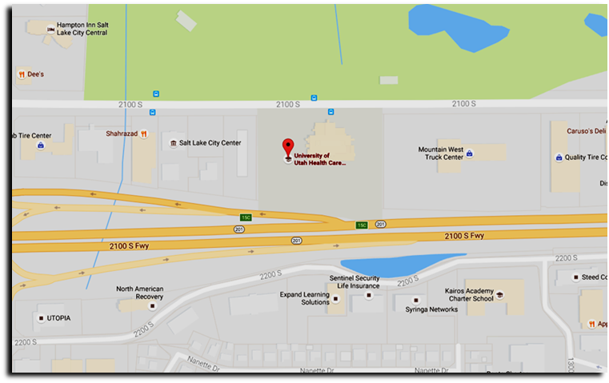
UNIVERSITY OF UTAH REDWOOD HEALTH CENTER OCCUPATIONAL MEDICINE
1525 W. 2100 S. Salt Lake City UT, 84119

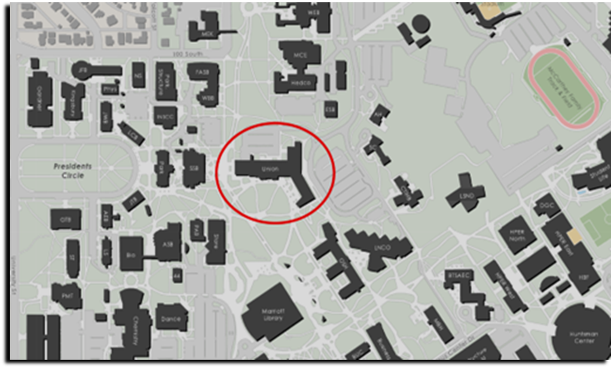
REDMED EMPLOYEE HEALTH CLINIC
200 Central Campus Dr. Salt Lake City, UT 84112

- Incident Reporting
An employee with a work-related injury or illness must complete the Employer’s First Report of Injury or Illness Form, Form 122, and submit it to the Benefits Department within 24 hours. This form can be accessed by clicking https://benefits.utah.edu/work-related-injury-or-illness/ All exposures will be reported to EHS 801- 581-6590. EHS will ensure that all OSHA reportable cases are reported to UOSH.

Complete an Incident report form (https://oehs.utah.edu/incidentnear-miss-report).

Identify and document the source individual (unless it is established that the source is unknown).
After obtaining consent, collect exposed employee's blood as soon as feasible after exposure incident, and test blood for HBV and HIV serological status.
If the employee does not give consent for HIV serological testing during collection of blood for baseline testing, preserve the baseline blood sample for at least 90 days; if the exposed employee elects to have the baseline sample tested during this waiting period, perform testing as soon as feasible.

Training
All employees who have occupational exposure to bloodborne pathogens receive training annually by EHS and in lab-specific procedures by (Name of Individual). Information on classes can be found here https://ibc.utah.edu/training.php and https://ibc.utah.edu/events/index.php

All employees who have occupational exposure to bloodborne pathogens receive training on the epidemiology, symptoms, and transmission of bloodborne pathogen diseases. In addition, the training program covers, at a minimum, the following elements: a copy and explanation of the standard, an explanation of the ECP and how to obtain a copy of the University of Utah ECP, an explanation of methods to recognize tasks and other activities that may involve exposure to blood and OPIM, including what constitutes an exposure incident, an explanation of the use and limitations of engineering controls, work practices, and PPE, an explanation of the types, uses, location, removal, handling, decontamination, and disposal of PPE, an explanation of the basis for PPE selection, information on the hepatitis B vaccine, including information on its efficacy, safety, method of administration, the benefits of being vaccinated, and that the vaccine will be offered free of charge, information on the appropriate actions to take and persons to contact in an emergency involving blood or OPIM, an explanation of the procedure to follow if an exposure incident occurs, including the method of reporting the incident and the medical follow-up that will be made available, information on the post-exposure evaluation and follow-up that the employer is required to provide for the employee following an exposure incident, an explanation of the signs and labels and/or color coding required by the standard and used at this facility, an opportunity for interactive questions and answers with the person conducting the training session.

Training materials for this facility are available through EHS (bldg. 605).

Recordkeeping
9.1 Training Records
EHS training records are completed for each employee upon completion of training. These documents will be kept for at least three years at EHS (Bldg. 605). Lab-specific training records will be maintained for the same period by the Employer/Supervisor.
The training records include: Dates of the training sessions, content of the training sessions, the name of the person(s) conducting the training, and names of all persons attending the training sessions.
EHS training records are provided upon request to the employee or the employee's authorized representative within 15 working days. Such requests should be made to EHS (Bldg. 605).
9.2 Medical Records
Medical records are maintained for each employee with occupational exposure in accordance with 29 CFR 1910.1020, "Access to Employee Exposure and Medical Records." Medical records, under most circumstances, will be maintained at the Employee Health Clinic.
9.3 OSHA Recordkeeping
Human resources will evaluate all incident reports to determine if cases meet OSHA’s Recordkeeping Requirements (29 CFR 1904). All percutaneous injuries from contaminated sharps are also recorded in the Sharps Injury Log (Appendix D).

APPENDIX A

Glossary of Terms

Blood means human or non-human primate blood, blood components, and blood-based products.
Bloodborne Pathogens means pathogenic microorganisms that are present in human or non-human primate blood and can cause disease in humans. Examples include, but are not limited to, hepatitis B virus (HBV), and human immunodeficiency virus (HIV).
Clinical Laboratory means a workplace where diagnostic or other screening procedures are performed on blood or other potentially infectious materials.
Contaminated means the presence or the reasonably anticipated presence of blood or other potentially infectious materials on an item or surface.
Contaminated Laundry means laundry that has been soiled with blood or other potentially infectious materials or may contain sharps.
Contaminated Sharps means any contaminated object that can penetrate the skin including, but not limited to, needles, scalpels, broken glass, and broken capillary tubes.
Decontamination means the use of physical or chemical means to remove, inactivate, or destroy bloodborne pathogens on a surface or item to the point where they are no longer capable of transmitting infectious particles and the surface or item is rendered safe for handling, use, or disposal.
Engineering Controls means controls (e.g., sharps disposal containers, self-sheathing needles, safer medical devices, such as sharps with engineered sharps injury protections and needleless systems) that isolate or remove the bloodborne pathogens hazard from the workplace.
Exposure Incident means a specific eye, mouth, other mucous membrane, non-intact skin, or parenteral contact with blood or other potentially infectious materials that results from the performance of job duties.
Handwashing Facilities means a facility providing an adequate supply of running potable water, soap and single use towels or hot air drying machines.
Licensed Healthcare Professional is a person whose legally permitted scope of practice allows him or her to independently perform the activities required for Hepatitis B Vaccination and Post-exposure Evaluation and Follow-up.
HBV means hepatitis B virus.
HIV means human immunodeficiency virus.
Needleless systems means a device that does not use needles for:
(1) The collection of bodily fluids or withdrawal of body fluids after initial venous or arterial access is established; (2) The administration of medication or fluids; or (3) Any other procedure involving the potential for occupational exposure to bloodborne pathogens due to percutaneous injuries from contaminated sharps.
Occupational Exposure means reasonably anticipated skin, eye, mucous membrane, or parenteral contact with blood or other potentially infectious materials that may result from the performance of job duties.
Other Potentially Infectious Materials means (1) The following human body fluids: semen, vaginal secretions, cerebrospinal fluid, synovial fluid, pleural fluid, pericardial fluid, peritoneal fluid, amniotic fluid, saliva in dental procedures, any body fluid that is visibly contaminated with blood, and all body fluids in situations where it is difficult or impossible to differentiate between body fluids; (2) Any unfixed tissue or organ (other than intact skin) from a human (living or dead); (3) HIV-containing cell or tissue cultures, organ cultures, and HIV- or HBV-containing culture medium or other solutions; and blood, organs, or other tissues from experimental animals infected with HIV or HBV; (4) All primary human and non-human primate cell explants from tissues and subsequent in vitro passages of human or primate tissue explant cultures, unless characterized by documented, reasonable laboratory testing to be free of HIV, HBV, HCV, and other bloodborne pathogens.
Parenteral means piercing mucous membranes or the skin barrier through such events as needlesticks, human/non-human primate bites, cuts, and abrasions.
Personal Protective Equipment is specialized clothing or equipment worn by an employee for protection against a hazard. General work clothes (e.g., uniforms, pants, shirts or blouses) not intended to function as protection against a hazard are not considered to be personal protective equipment.
Production Facility means a facility engaged in industrial-scale, large-volume or high concentration production of HIV or HBV.
Regulated Waste means liquid or semi-liquid blood or other potentially infectious materials; contaminated items that would release blood or other potentially infectious materials in a liquid or semi-liquid state if compressed; items that are caked with dried blood or other potentially infectious materials and are capable of releasing these materials during handling; contaminated sharps; and pathological and microbiological wastes containing blood or other potentially infectious materials.
Research Laboratory means a laboratory producing or using research-laboratory-scale amounts of HIV or HBV. Research laboratories may produce high concentrations of HIV or HBV but not in the volume found in production facilities.
Sharps with engineered sharps injury protections means a nonneedle sharp or a needle device used for withdrawing body fluids, accessing a vein or artery, or administering medications or other fluids, with a built-in safety feature or mechanism that effectively reduces the risk of an exposure incident.
Source Individual means any individual, living or dead, whose blood or other potentially infectious materials may be a source of occupational exposure to the employee. Examples include, but are not limited to, research participants; hospital and clinic patients; clients in institutions for the developmentally disabled; trauma victims; clients of drug and alcohol treatment facilities; residents of hospices and nursing homes; human remains; and individuals who donate or sell blood or blood components.
Sterilize means the use of a physical or chemical procedure to destroy all microbial life including highly resistant bacterial endospores.
Universal Precautions refers to a method of infection control in which all human blood and other potentially infectious materials are treated as if known to be infectious for HIV and HBV. Id does not apply to feces, nasal secretions, sputum, sweat, tears, urine or vomitus unless they contain visible blood.
Work Practice Controls means controls that reduce the likelihood of exposure by altering the manner in which a task is performed (e.g., prohibiting recapping of needles by a two-handed technique).

APPENDIX B

Safer Sharps Devices Annual Review Form

This form (or equivalent) must be completed on an annual basis by any University of Utah Facility/laboratory that performs sharps-related procedures on human samples or other potentially infectious material. Contact the BioSafety Office at (801) 581-6590 if you have questions or need further information.

Reviewer’s Name: Job Title:

Department/Clinic: Date:

Supervisor/PI Name: Telephone #:

In accordance with OSHA’s application of the “Needlestick Safety & Prevention Act”, all sharps that are being used where there is exposure to human blood or OPIM must be reviewed on an annual basis. This includes all needles, syringes with needles, scalpels, capillary tubes, and lancets. During your annual review of devices, you must inquire about new or prospective safer options.

The purpose of this form is to document:
- Sharps devices currently in use;
- The criteria used in the selection of the safer sharps devices in use, and;
- Annual consideration of new safer sharps devices.

Complete the table below as completely as possible to document the sharps devices that are being used. Use multiple pages if necessary.

This review form must be maintained with your safety records.

 | Device #1 | Device #2 | Device #3
Name of Sharps Device

Manufacturer

Model/Size in Use

Procedures Performed

*Safer Sharps Device?
(Y/N)
Description of Safety Feature
Justification for Selection (must consider newly marketed safer sharps devices

*A justification must be documented (below) for any device that does not meet the criteria of a safer sharps device (see Sharps with engineered sharps injury protection definition below). Acceptable justifications include, but are not limited to:
- Use of a safer sharps device will jeopardize patient or employee safety.
- Use of a safer sharps device is medically inadvisable.
- Market unavailability of an appropriate safer sharps device.

Note that cost is not typically an acceptable justification.

Sharps with engineered sharps injury protection: This includes non-needle sharps or needle devices containing built-in safety features that are used for collecting fluids or administering medications or other fluids, or other procedures involving the risk of sharps injury. This description covers a broad array of devices, including:
- Syringes with a sliding sheath that shields the attached needle after use;
- Needles that retract into a syringe after use;
- Shielded or retracting catheters
- Intravenous medication (IV) delivery systems that use a catheter port with a needle housed in a protective covering.
Description of procedure and justification for not using safer sharps device:

APPENDIX C

Spill Clean Up Procedures
All spills or breaks involving Human samples, Recombinant DNA or Synthetic Nucleic Acid Molecules and hazardous biological materials must be cleaned up using appropriate biosafety procedures, described below. If there is any doubt about what to do, call the PI (Telephone #), or the Biosafety Officer 1-6590, or the University’s internal emergency number: 5-2677.

The following items should be included in a biological spill kit:
- Disinfectant – Prepare a fresh 1:10 bleach solution. In other words, a pre-measured amount of bleach in a spray bottle is placed in the spill kit, but the cold water required to dilute the bleach is not added until right before use. Otherwise, use an EPA-registered disinfectant (effective against HIV and HBV) following manufacturer’s instructions. Examples are Cavicide, Cidex OPA and Clidox-S. Note the date of manufacture and/or expiration.
- Absorbent material (paper towel, absorbent powder)
- Personal protective equipment (e.g., disposable gloves (2 pairs), eye protection, face shield or surgical mask, lab coat, shoe covers). It is necessary to review the PPE in the spill kit on a regular basis to verify quality. Gloves can degrade due to exposure to UV or fluorescent lighting, temperature extremes, and the effects of time. At the first sign of degradation (e.g., discoloration, brittleness, stickiness, tearing), replace the gloves in the spill kit with new ones. Likewise, the strap on splash goggles can undergo similar degradative processes.
- Mechanical tools (forceps or tongs, broom and dustpan) – Dispose of biohazardous waste after spill response. Purchase inexpensive plastic tools for this purpose.
- Waste container (biohazard bags) – By assembling all of the spill materials in a bucket or other leak-proof and puncture-proof container, you will have a secondary container readily available for proper containment of your biohazard bag.

Edit/delete the following sections as applicable to your lab

- Spills inside of a Biosafety Cabinet
  - Stop work.
  - If you are splashed by the material, change PPE. Always change gloves.
  - Keep the biosafety cabinet running.
  - Contain the spill by covering with paper towels (to avoid splashes or aerosols).
  - Prepare the disinfectant.
  - Saturate spill with XXXXXXX (fill in the appropriate decontaminant). Let sit for 20 minute exposure time.
    - For large spills (greater than 10ml) use undiluted bleach or disinfectant.
    - In the event of a spill into the drip pan/catch basin, add an equal volume of disinfectant and wait for 20 minutes to clean up the disinfected material.
    - Note: due to its evaporative nature alcohol is not recommended as the primary disinfectant but can be used to remove bleach/disinfectant residue.
    - If working with human blood or OPIM (such as human cell line) spills must be disinfected with an EPA-approved disinfectant (alcohol is not on the approved lists).
  - Wipe up spill, disposing of towels in biohazard bag.
  - Spray spill area with XXXXXXX (fill in the appropriate decontaminant). Allow to air dry.
  - Disinfect all other materials used in the biosafety cabinet by disinfecting the surface with XXXXXXX (fill in the appropriate decontaminant) with a 20 minute contact time. Do not attempt to disinfect contaminated cardboard or other paper items that absorb liquid: contaminated items should be disposed of.
  - If bleach or other corrosive disinfectant used, wipe spill area and disinfected equipment with alcohol or water.
  - Place all towels or absorbent materials into a designated container for biohazardous waste.
  - Remove PPE, discard disposable PPE as biohazardous waste and wash hands.
  - Run the biosafety cabinet for 10 minutes to purge the air before re-starting work.

- Spills outside of a Biosafety Cabinet
  - Stop work.
  - If you are splashed by the material, dispose of PPE and wash hands.
  - Ensure that any other people in the vicinity are notified that a spill has occurred and that the room should be evacuated. Post a “Do Not Enter” notice on the door. Notify the PI or lab supervisor.
  - If you need assistance with the spill clean-up, call OEHS (1-6590).
  - Wait 60 minutes before re-entering the room to allow aerosols to settle.
  - Assemble Spill cleanup materials and don PPE, including lab coat, eye protection and face shield or mask, 2 pair of gloves, shoe covers. If the lab coat does not have cuffed sleeves, disposable sleeve covers should be worn.
  - Contain the spill by covering with paper towels (to avoid splashes or aerosols)
  - Saturate spill with XXXXXXX (fill in the appropriate decontaminant). Let sit for 20 minute exposure time.
    - For large spills (greater than 10ml) use undiluted bleach or disinfectant.
    - Wipe areas around the spill that may have splatter and any reusable equipment with XXXXXXX (fill in the appropriate decontaminant).
    - If working with human blood or OPIM (such as human cell line) spills must be disinfected with an EPA-approved disinfectant (alcohol is not on the approved lists).
  - Wipe up spill, disposing of towels in biohazard bag: if sharps may be present use tongs or a brush and pan and dispose in biohazard sharps container.
    - Work concentrically to clean up the absorbent material. Always work from the outer edge of the spill toward the center.
  - Spray spill area with XXXXXXX (fill in the appropriate decontaminant). Allow to air dry.
  - If bleach or other corrosive disinfectant used, wipe spill area and disinfected equipment with alcohol or water.
  - Remove PPE, discard disposable PPE as biohazardous waste and wash hands.
  - Remove the “Do Not Enter” sign and inform others that it is safe to re-enter the room.
  - Once the spill has been contained, complete the “SPILLS OR EXPOSURE EVENT REPORTING PROCEDURE” form (below) and have the PI send to OEHS.

- Spills Inside of a Centrifuge Contained Within a Closed Cup, Bucket, or Rotor
  - Put on lab coat, gloves, and proper eye protection prior to opening centrifuge. Open carefully to assess the damage.
  - Prepare the disinfectant: consult the instructions of the centrifuge rotor to identify suitable disinfectants.
  - If the spill is contained within a closed cup, bucket, or rotor, spray the exterior with disinfectant and allow at least 20 minutes of contact time. Remove the carrier to the nearest biosafety cabinet (BSC).
    - Note, if possible, avoid using bleach on centrifuge rotors and buckets to avoid damaging the equipment. If bleach is used, ensure all surfaces are wiped down with soap and water after disinfection. Alternatively, use an EPA-registered disinfectant, such as Cidex or Cavicide.
  - Gather supplies needed, such as a sharps container for broken glass and bins filled with disinfectant and place into the BSC.
  - Open the centrifuge rotor or bucket inside of the BSC. Use a mechanical device (forceps, tongs, etc.) to remove broken glass and place directly into sharps container. Carefully remove any unbroken tubes and place into a bin filled with XXXXXXX (fill in the appropriate decontaminant) for at least 20 minutes. Wipe carrier/bucket with disinfectant.
  - After disinfection, carrier, bucket, or rotor must be washed with a mild soap and water.
  - Spray the interior of the centrifuge chamber with XXXXXXX (fill in the appropriate decontaminant), let sit for at least 20 minutes and then wipe down with soap and water.
  - Dispose of all clean-up materials (except sharps) in an appropriate biohazardous waste container. Dispose of sharps in a biohazard sharps container.
  - Remove PPE, discard disposable PPE as biohazardous waste and wash hands.

If you are concerned that the spill is not contained within the rotor or bucket:
    - Ensure that any other people in the vicinity are notified that a spill has occurred and the room should be evacuated. Post a “Do Not Enter” notice on the door. Notify the PI or lab supervisor.
    - If you need assistance with the spill clean-up, call OEHS (801-581-6590)
    - Wait 60 minutes before re-entering the room to allow aerosols to settle.
    - Proceed with clean up as described above.

Note: Many centrifuge rotors can be disinfected by autoclaving. Check the manufacturer’s instructions.

- Exposure to skin or clothing
  - Stop work.
  - Take off contaminated clothing and wash affected area thoroughly with soap and water, but not so hard the skin is abraded.
  - If necessary, exit lab area and immediately take a shower. Wash thoroughly with soap and water, but not so hard the skin is abraded.
  - Notify the lab supervisor or PI.
  - If exposed to BSL-2/RG2 (or above) agent, notify the Biosafety Officer and Proceed directly to RedMed Clinic, Redwood Occupational Medicine Clinic, or the University of Utah Hospital Emergency Room (if after 8pm).

- Penetrating wound
  - Stop Work.
  - Wash immediately with soap and water.
  - Notify lab supervisor or PI, who must notify the Biosafety Officer.
  - Proceed directly to RedMed Clinic, Redwood Occupational Medicine Clinic, or the University of Utah Hospital Emergency Room (if after 8pm).

- Eyes, or mucous membrane exposure
  - Stop work.
  - Immediately flush eyes or mucous membrane with water for 10-15 minutes.
  - Notify lab supervisor or PI, who must notify the Biosafety Officer.
  - Proceed directly to RedMed Clinic, Redwood Occupational Medicine Clinic, or the University of Utah Hospital emergency Room (if after 8pm).

- Emergency Spills: Environmental Risk
  - Stop work.
  - Ensure that any other people in the vicinity are notified that a spill has occurred and that the room should be evacuated. Post a “Do Not Enter” notice on the door. Notify the PI or lab supervisor.
  - Call OEHS (801-581-6590). Provide information on the nature of the material spilled.
  - Take appropriate precautions to limit exposure or spread of spill to other areas.

NOTE: Spill Procedures must be clearly posted in the laboratory
APPENDIX D

Sharps Injury Log

Laboratory Name:________________ Year 2_____

Date | Case/  Report # | Type of Device (e.g. syringe, suture needle) | Brand Name of Device | Work Area where injury occurred (e.g. Clinic, Lab) | Brief description of how incident occurred (i.e., procedure being done, action being performed (disposal, injection, etc.), body part injured)

29 CRF 1910.1030, OSHA’s Blood borne Pathogens Standard, in paragraph (h)(5), requires an employer to establish and maintain a Sharps Injury Log for recording all percutaneous injuries in a facility occurring from contaminated sharps. The purpose of the Log is to aid in the evaluations of devices being used in healthcare and other facilities and to identify problem devices or procedures requiring additional attention or review. This log must be kept in addition to the injury and illness log required by 29 CFR 1904. The Sharps Injury Log should include all sharps injuries occurring in a calendar year. The log must be retained for five years following the end of the year to which it relates. The Log must be kept in a manner that preserves the confidentiality of the affected employee.
APPENDIX E
General Laboratory Safety

Practices must adhere to the standards described in the University of Utah Biosafety Manual and University Exposure Control Plan (https://ibc.utah.edu/biosafety-policies.php). These include:

- Laboratory employees must immediately notify the laboratory manager or PI in case of an accident, injury, illness, or overt exposure associated with laboratory activities.
- No eating, chewing gum, drinking, smoking, handling contact lenses, or applying cosmetics in the lab at any time.
- No use of headphones and/or cell phones/iPODs etc., while in the lab.
- No animals (pets) or non-research plants will be allowed in the lab at any time.
- Food, medications, or cosmetics should not be brought into the lab for storage or later use. Food is stored outside in areas designated specifically for that purpose.
- No open shoes or sandals are allowed in the laboratory: the entire foot must be covered up to the ankle.
- No bare legs, ankles or arms.
- Personnel must wear a lab coat (or gown), gloves and other PPE as determined by the risk assessment: eye and face protection (safety glasses goggles, and/or mask) is used for anticipated splashes or sprays of infectious or other hazardous materials when the materials are handled outside of a Biosafety Cabinet (BSC) or containment device, such as transferring samples to an incubator or emptying waste traps. Lab coats must be left in the lab. Lab coats with cuffed sleeves or disposable sleeve covers with tight cuffs are recommended.
- All skin defects such as cuts, abrasions, ulcers, areas of dermatitis, etc. should be covered with an occlusive bandage.
- Mouth pipetting is prohibited; mechanical pipetting devices are to be used at all times.
- All procedures are to be performed carefully to minimize the creation of splashes or aerosols.
- Wipe work surfaces with an EPA-registered disinfectant after experiments and immediately after spills.
- Decontaminate all contaminated or potentially contaminated materials by appropriate methods before disposal.
- Follow all manufacturer’s instructions and SOPs when using any of the laboratory equipment.
- Hand washing with soap is required (i) after handling materials involving organisms containing recombinant or synthetic nucleic acid molecules including bacteria and viruses, (ii) after handling animals, (iii) after removing PPE, and (iv) whenever exiting the laboratory.
- All sharps must be placed in a rigid, puncture resistant, closable and leakproof container, which is labeled with the word "Sharps" and the biohazard symbol. Food containers (e.g., empty coffee cans) are not permissible as sharps containers. All sharps must be handled with extreme caution. The clipping, breaking, and recapping of needles is not permitted. Plastic pipettes and pipette tips are considered puncture hazards and should be treated as sharps. Sharps containers should not be filled more than 2/3.
- All cultures, stocks, and other regulated wastes are decontaminated by autoclaving or disinfection before disposal. NOTE: No untreated or non-disinfected biological agent-containing material should be allowed into any drain connected to the sanitary sewer system (e.g., from a sink) Materials to be decontaminated outside of the immediate laboratory are placed in a durable, leakproof container and closed for transport from the laboratory.
- Liquid waste, decontaminated with bleach for at least 20 minutes, from humans or animals can be disposed of directly by flushing down a sanitary sewer. Liquid waste decontaminated with alternative chemicals, such as ZZZ or Vesphene III se, may have to be disposed of as hazardous waste: contact the Biosafety Officer for advice. Pick up for hazardous waste can be arranged through the Lab Management System.
- Contaminated solid waste includes cloth, plastic and paper items that have been exposed to agents infectious or hazardous to humans, animals, shall be placed in biohazard bags and decontaminated by autoclaving. After autoclaving the waste can be disposed in the regular trash: please ensure that there is clear indication that the material has been autoclaved, such as using autoclave tape.
- Alternatively, EHS can dispose of biohazard waste for the lab. EHS can be contacted using the on-line pick up request via the Lab Management System (SAM). All contaminated waste shall be placed in a biohazard bag inside of a leak proof, puncture resistant, sealable biohazard waste container. The container must be labeled with a biohazard symbol. Double or triple bagging may be required to avoid rupture or puncture of the bags. Contaminated Pasteur pipettes and plastic pipette tips are considered sharps and need to be disposed of in a sharps container. Do not overfill the container. Biohazard waste containers should not be filled more than 2/3 full.

APPENDIX F

Biological Safety Cabinets SOP
OSHA has specific requirements for the training of personnel using a Biosafety Cabinet (https://www.osha.gov/sites/default/files/publications/OSHAfactsheet-laboratory-safety-biosafety-cabinets.pdf). These can largely be met by using the following SOP as a training tool.

Diagram of airflow in a Biosafety Cabinet (Keep the image of the type of cabinet(s) you use)
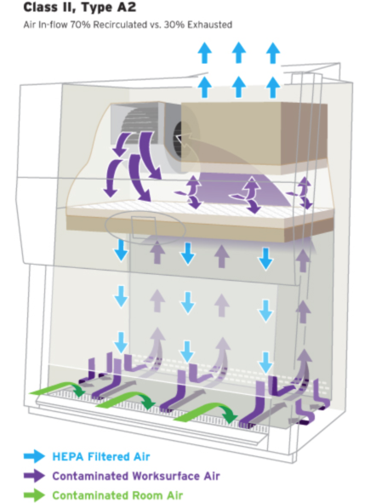
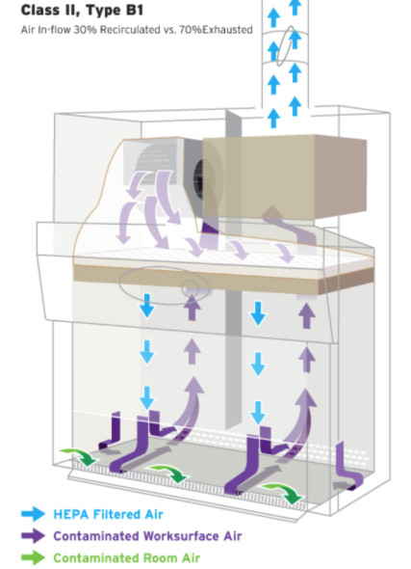

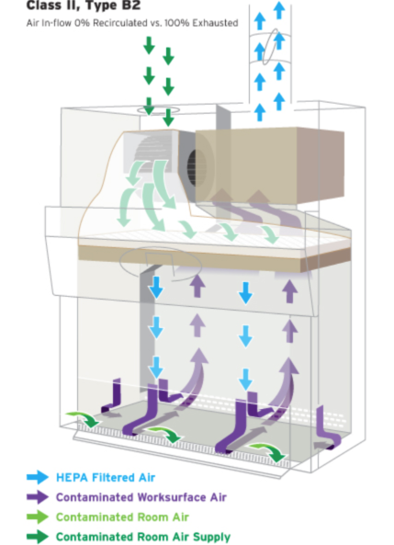
Note the flow of air. Do not block air vents

            - Reserve time in advance to have priority for use of the Biosafety Cabinet (BSC). (If you use sign-up sheets, describe the process here)

            - Prepare a written checklist of materials necessary for a particular activity and place only necessary materials in the BSC before beginning work.

            - Turn on the blower in the cabinet at least 10 minutes before placing infectious materials into the hood.

            - Check the certification sticker and all biosafety cabinet monitors to verify that the biosafety cabinet is working properly. Biosafety cabinets must be certified prior to use. An NSF-certified contractor must certify these cabinets annually. Check the certification sticker on the front of the unit to verify your biosafety cabinet’s condition. If the re-certification date has passed contact EHS.

            - The biosafety cabinet air flow monitor should be checked to assure proper operation of the cabinet before placing any materials into it. Readings indicate relative pressure drop across the HEPA filter. Higher readings may, therefore, indicate filter clogging. Zero readings may indicate loss of filter integrity. In either of these cases, notify the Laboratory Manager or PI and EHS. University of Utah Facilities Management do not perform maintenance on biological safety cabinets. If the BSC needs to be serviced, contact EHS.

            - Adjust the stool height so that armpits are level with the bottom of the view screen or sash.

            - PPE must be worn at all times.

            - Prior to beginning work, the BSC should be decontaminated. Don appropriate PPE (fluid resistant lab coat, gloves, eye protection). Clean the inside surfaces of the BSC with (name of disinfectant) and follow with water or 70% ethanol (if using bleach or other EPA-approved disinfectant). DO NOT put head inside the cabinet. To reach the back of the cabinet use an extension, such as a Swiffer handle.
Note: due to its evaporative nature alcohol is not recommended as the primary disinfectant but can be used to wipe down previously disinfected surfaces or remove bleach/disinfectant residue.
Note: deionized water can cause stainless steel to corrode. Use distilled water instead.

            - Let blower run for 10 min to purge the cabinet air of any particulates.

            - DO NOT disrupt the airflow through the hood by placing ANY item, including arms, on the grills or by opening the door to the corridor. Disrupting the airflow into the front grill allows contaminated air from inside the cabinet to blow into the lab or directly at the person sitting at the cabinet. It also allows non-sterile air from the room to blow into the biosafety cabinet over the experiments. Move arms in and out of the cabinet slowly, perpendicular to the face opening, to limit disruption of the air curtain.

              - Manipulation of materials inside the cabinet should be delayed for 1 minute after placing hands/arms inside the cabinet to allow the air to stabilize and to “air sweep” arms.

            - Organize the work surface for a clean-to-dirty work flow. Place clean pipets, flasks, and sterile media bottles at one side of the cabinet; place discard or kill pans containing disinfectant, biohazard waste containers, used flasks, spent cultures, and other wastes on the other side.

            - While working, keep all material and perform work at least 4 inches back from the front opening of the cabinet, and minimize rapid movements or activity.

            - In general, the interior of the hood should be considered to be a contaminated zone, even though every effort is made to keep the surfaces clean, as is consistent with accepted good microbiological practice and sterile technique.

            - Use the aseptic techniques below to reduce splatter and aerosol generation: • Opened bottles or tubes should not be held in a vertical position.

              - Hold the lid above open sterile surfaces to minimize direct impact of downward air.
              - Open flames should not be used because they create turbulence that disrupts the pattern of air supplied to the work surface. If absolutely necessary to do so, touch plate microburners that provide a flame on demand or electric furnaces are available and should be placed in the back third of the BSC. All flames must be turned off before disinfectants are used. After manipulating infectious agents, make sure all containers are tightly closed.

            - Plastic pipettes with a cotton plug shall be used for pipetting liquids containing viral particles. The electric pipettor shall be fitted with a 0.2 µm filter to prevent aerosol-based contamination.
            - A beaker or discard pan, containing a freshly prepared 1:10 solution of commercial bleach, shall be placed inside the biosafety cabinet during the cell culture work.
            - After pipetting liquid containing viral particles, the dilute bleach solution in the beaker shall be pipetted up and down the full length of the pipette or left in the pan. Serological pipettes and tips should be placed in a in a puncture resistant sharps container or other approved receptacle.
            - After decontamination, pipette tips shall be removed from the pipettor and temporarily left in the beaker containing bleach in the biosafety cabinet.
            - At the completion of the work, all materials will be removed from the biosafety cabinet: all items must be decontaminated prior to removal. Describe methods for decontamination.
            - At the completion of the work, the beaker containing the plastic tip pipettes shall be removed from the biosafety cabinet. Pipettes tips shall be lifted out of the beaker, the bleach solution allowed to drain back into the beaker, and the pipette tips placed in a puncture resistant sharps container or other approved receptacle. NOTE plastic pipette tips and serological pipettes are treated as sharps.
            - Small volumes of liquid waste containing viral particles shall be collected in a beaker containing undiluted bleach inside the biosafety cabinet. The final concentration of bleach should be at least 10% of the final volume (>0.5% hypochlorite). After completing work, wait at least 30 minutes before disposing down the drain.
            - Large volumes should be collected by vacuum aspiration into a flask containing an appropriate disinfectant, such as ZZZ, Vesphene III se or bleach, up to 1%, 1%, or 10% of the volume of the flask, respectively. NOTE: No untreated or non-disinfected biological agent-containing material should be allowed into any drain connected to the sanitary sewer system (e.g., from a sink).
              - Bleach in the vacuum traps must be changed at least twice per week or when the flask is half full. Wait at least 20 minutes after finishing work to discard waste.
              - ZZZ- or Vesphene III se- treated waste must be transferred to a sealed container marked “Unwanted materials”. When full or 6 months after your start date (whichever happens first), arrange pickup by EHS through the SAM website. NO DRAIN DISPOSAL unless approved by EHS.
              - The flask should be placed in a secondary container to prevent it from tipping over, be labeled with a biohazard sticker and the vacuum line should be protected by a hydrophobic (HEPA) filter. The vacuum filters must be replaced if clogged or if liquid makes contact with the filter. Examples include Whatman Vacu-guard and Pall Gelman Vacushield in-line disk filters. Used filters should be placed in the biohazard waste.
            - Turn off the house vacuum when not in use.
            - Clean the inside surfaces of the BSC with (name of disinfectant) after completion of work, and follow with water (if using bleach).
Note: alcohol should not be used as the primary disinfectant but can be used to remove bleach/disinfectant residue. If working with blood or OPIM, alcohol is not an EPA-approved disinfectant.
            - Allow the blower to run for at least 10 minutes following use.
            - The drip pan under the work surface must be cleaned at least monthly, or after spills, with (name of disinfectant).
            - The UV light is turned on between procedures (at least 30 minutes). UV lights must be turned off before work begins in the hood. Do not look directly at UV lights as this can cause eye damage.
During decontamination, a sign shall be placed stating that the biosafety cabinet is being decontaminated and shall not be used. Also, it shall be stated that the user (with contact information) shall be contacted if there are any questions or concerns.

UV light is effective only for decontaminating clean, solid surfaces with which it comes in contact. It is not effective in decontaminating the cabinet air flow. UV light is not effective against bacterial spores. UV germicidal light tubes should be replaced frequently (at least every 6 months for biosafety cabinets in use on a daily basis) to assure that they are emitting light at 254 nm and at an intensity appropriate for decontamination. Due to concerns over the effectiveness of these lights and the risks to individuals in the room, some Institutions, such as the NIH, have banned their use in BSCs. The University of Utah IBC strongly recommends that UV lights are not used as a method of decontamination: see Fact Sheet here.

NOTE: Any use of volatile solvents, such as absolute ethanol, should be kept to a minimum or done elsewhere. Dangerously high levels of volatile vapors can accumulate inside the cabinet and pose a threat of fire or explosion.

APPENDIX G
Use and Disposal of Sharps

To prevent needle stick injuries:

- Do not recap needles by hand. RECAPPING OF NEEDLES IS PROBHIBETED.
- Do not remove needles from syringes by hand.
- Do not bend, break, or otherwise manipulate needles by hand.
- Avoid using needles whenever possible.
- Replace glass materials with plastic (such as Pasteur pipettes)
- Immediately after use, discard needle and syringe (whether contaminated or not) into puncture resistant sharps containers. RECAPPING OF NEEDLES IS PROHIBITED.
- Use a Food and Drug Administration (FDA)-cleared sharps container if you generate sharps waste (pictured below). A description of FDA-Cleared Sharps containers can be found here. FDA-cleared sharps disposal containers are made from rigid plastic, come marked with a line that indicates when the container should be considered full, which means it’s time to dispose of the container, and have the Universal Biohazard symbol.
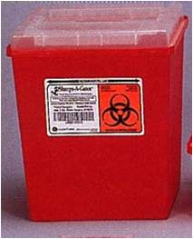
- Never discard sharps into regular trash.
- Never discard sharps into bags of biological waste.
- Use care and caution when cleaning up after procedures that require the use of syringes and needles.
- Do not overfill sharps containers. Close completely when 3/4 full, request pickup from the EHS through the Safety Administrative Management System (SAM) webpage at https://ehs.utah.edu/research-safety/lab-management-system.
- Locate sharps containers in areas in which needles are commonly used. Make containers easily accessible.
- Replacement sharps containers may be obtained through the SAM or can be from laboratory supply distributors such as VWR and ThermoFisher. Be sure to select sharps containers that withstand autoclaving.

In the event of a needle stick injury:

Wash the area thoroughly with soap and water. Notify supervisor immediately, report to the RedMed Employee Health Center and fill out an Incident Report Form, as soon as possible.

Contaminated Serological Pipets and Pipet Tips
Serological pipets (glass and plastic) and disposable pipet tips are considered puncture hazards and should be disposed of as sharps. Contaminated pipets and tips should be discarded in approved sharps containers, as described above.

Due to the large size of serological pipets, investigators disposing of large numbers of these can request 20 gallon hard-sided biohazard waste containers (pictured below) from EHS through the SAM. These will be picked up by EHS staff as for other biohazardous waste.

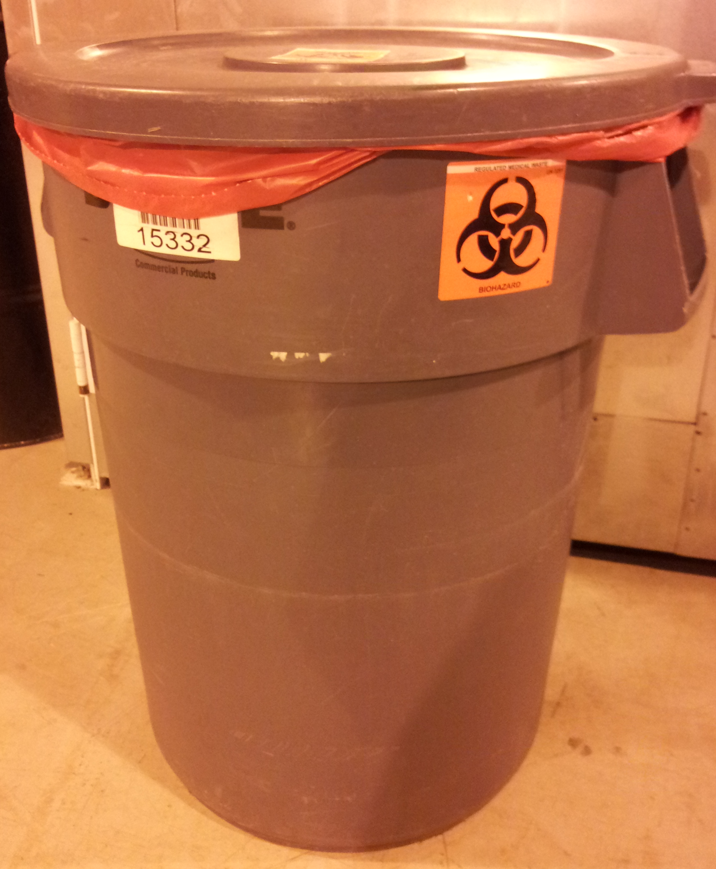
20 Gallon Waste Container

Decontaminated Serological Pipets and Pipet Tips
It is possible to decontaminate serological pipets and tips prior to disposal. Ensure that both the inside and outside of the pipets or tips are exposed to the approved disinfectant (e.g. a freshly prepared 1:10 dilution of bleach) for at least 20 minutes. However, serological pipets and disposable tips are still considered puncture hazards. Therefore, after removing the disinfectant, they can be disposed of in a Broken Glass box (rigid puncture resistant boxes lined with a plastic bag and labeled “Broken Glass”: pictured below), which can be obtained from your custodial staff or from EHS. Once they are 2/3 full they should closed with tape and disposed as regular trash by your custodians.
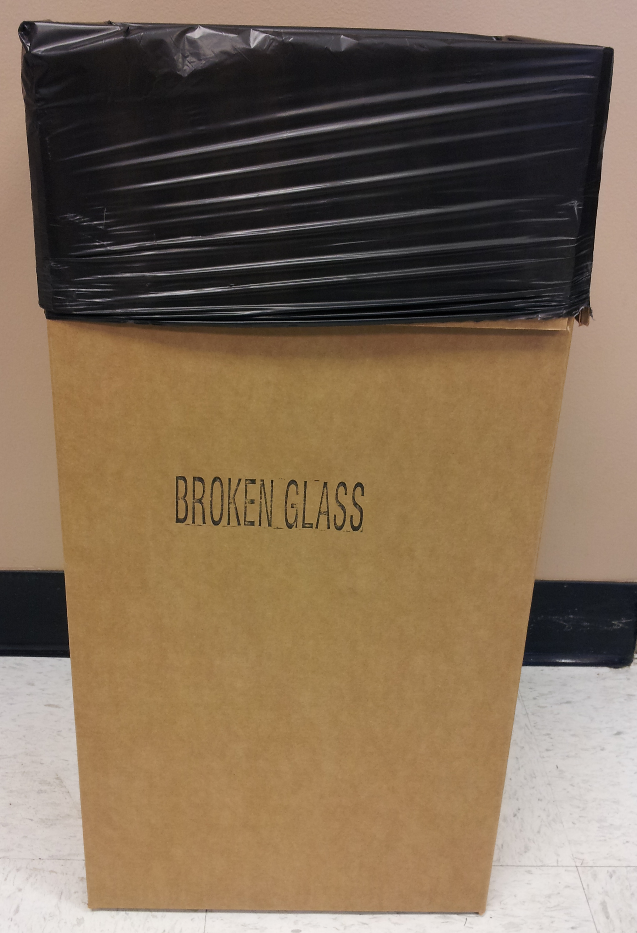
Broken Glass Box
APPENDIX H
Disposal of Biohazardous Waste

Per the NIH Guidelines for Research Involving Recombinant or Synthetic Nucleic Acid Molecules, all contaminated liquid or solid wastes are decontaminated before disposal, including materials handled at BSL-1.

Biowaste Disposal – Solids
Environmental Health and Safety (EHS) Safety Administrative Management System (SAM) allows research investigators to request hazardous material pickups by EHS staff and request empty containers. Please visit the SAM website for information.

Waste containers obtained from EHS are solid sided, leak proof, lined with red biohazard bags, and labeled with a biohazard symbol. Keep the container lid closed unless someone is working nearby and regularly adding waste to the container.

When the red bag is ¾ full, loosely tie or tape the bag closed. Secure the lid on the waste container and move it to a convenient storage location or transport it to a biohazardous waste storage room, if available. Before the container is removed from the room, decontaminate the exterior with an appropriate disinfectant. Biohazardous waste must be moved or transported inside a rigid, leak- resistant, labeled container with the lid closed. Request a pickup from your lab using the SAM.

If you have an autoclave available for disinfection of biohazardous waste, place a red biohazard bag in a solid puncture resistant container. Place a Ziploc bag or balloon containing water in the bag when it is about half full to generate steam during autoclaving. When the red bag is full, tie or tape the bag closed. Secure the lid on the waste container and move it to the autoclave room.

The bag should be removed and placed in a solid autoclave resistant tray: the bag should NEVER be placed directly on the floor. After the cycle, the bag may be disposed of as regular trash: indicators that the contents have been autoclaved must be present.

Biowaste Disposal – Liquids
Aspirated tissue culture media, or other liquid waste generated from BSL-1 experiments must be disinfected and then disposed. Bleach is typically used to disinfect liquids, but other agents, such as ZZZ or Vesphene III se, may be used if effective.

If you use bleach:
- Ensure the final concentration exceeds 0.5% sodium hypochlorite (no less than one part bleach to 9 parts liquid).
- Ensure the bleach is fresh: in tissue culture media traps change at least twice weekly.
- Ensure the media is exposed to disinfectant for at least 20 minutes prior to disposal.
- Dispose down the sink

If you use ZZZ or Vesphene:
- Ensure the final concentration exceeds 400ppm (one part disinfectant to 99 parts water).
- In tissue culture media traps change at least every 3 months (indicate the date of the last change on the flask).
- Ensure the media is exposed to disinfectant for at least 20 minutes prior to disposal.
- Collect waste into containers marked “Unwanted Materials” and date when you start collecting. When full or 6 months after your start date (whichever happens first), arrange pickup by EHS through the SAM website. NO DRAIN DISPOSAL unless approved by EHS.
If the container will be unattended (outside of your immediate control) then label it with the date, time and the words “Biohazardous liquid” and keep it in a secondary container (for example, a plastic tub) while it is disinfecting.

If you use other agents to decontaminate liquid cultures follow the instructions on the packaging. Contact the Biosafety Officer (801-581-6590) for advice on appropriate disinfectants and procedures for disposal of treated waste.

Mixed liquid and solid biohazardous waste
Mixed liquid and solid waste should be separated in a biosafety cabinet (decant the liquid from the solid). Manage the liquids and solids separately as detailed above.

APPENDIX I
Safe Handling of Cryogenic Liquids

Danger! Vials immersed in liquid nitrogen may explode violently when removed! Wear face and eye protection! Plastic vials (even Nunc vials with silicon O-rings) used for storing cells in liquid nitrogen are designed to be used in the liquid nitrogen vapor phase. When immersed in the liquid phase, the liquid nitrogen frequently enters vials around the cold O-ring. When vials are removed to room temperature, the liquid nitrogen in the vial immediately begins to boil. Usually it escapes harmlessly past the seal. Occasionally (about 1 out of 1000 vials), the seal is too tight, and the pressure causes a violent rupturing of the vial, sending shards of sharp plastic rocketing in unpredictable directions with sufficient energy to lacerate the face and cause severe eye injury. When removing vials from liquid nitrogen, it is mandatory that you wear full face shields, pulled in to touch your chin so that shards can't fly under the shield. If they fit, wear goggles underneath the face shield.

